Statistics with R programming

Assignment 2

STATISTICS WITH R PROGRAMMING

ASSIGNMENT 2

CO2: Implement looping constructs, control structures, and recursive functions in R to solve computational problems with efficient program logic.
Nature of Assignment : Individual
Duration : 1 Week
Total Marks : 50
Submission Date : 12/11/2026
Code of Conduct:
I RAKSHITH R.R (192324156) (Name / Reg No) certify that this submission is my original work and that I have adhered to the guidelines specified for this assessment.
I understand that any violation of academic integrity rules will result in disciplinary action.
Signature of the student:


Assignment Title: Evaluation and Engineering of Computational Solutions Using Loops, Control Structures, Functions and Recursion in R (Total Marks - 50)
Duration:1week
Scenario — Assessment Design Philosophy

This alternative set follows the reference assignment's evaluation-oriented approach. Students are expected to formulate decision logic, construct challenging test conditions, implement solutions using required R constructs, collect quantitative evidence, identify limitations, compare alternatives, and defend engineering decisions.

The assessment follows: Understand → Predict → Design → Implement → Test → Measure → Analyse → Evaluate → Validate.

Q1 – Engineer a Multi-Factor Wildfire Readiness Alert 8 Marks
Problem Context
A regional monitoring team combines wind speed, relative humidity, recent rainfall, and vegetation-dryness index to assign readiness levels to monitored zones. A weighted average can conceal a dangerous combination, and threshold-only rules can over-alert when indicators disagree. The team requires a transparent rule-based classification program.
Assessment Challenge
- Design justified rules for LOW, MODERATE, HIGH, and EXTREME readiness using arithmetic, relational, and Boolean operators.
- Use a for() or while() loop and if–else logic to process records, with explicit handling for missing measurements.
- Construct four adversarial datasets: ordinary conditions, conflicting indicators, threshold boundaries, and combined extreme indicators. Predict results before execution and compare with actual outputs.
- Record iterations and condition evaluations; identify where a weighted average alone would give a misleading classification.
- Changed condition: process 25,000 zones and guarantee that very high wind plus very low humidity triggers EXTREME regardless of the average score. Revise and validate the rule hierarchy.
Evidence Expected: Decision rules, R code, four test groups, prediction/observation table, counts, changed-condition tests, and evidence-based evaluation.

Q2 – Design a Scholarship Eligibility and Exception Engine 7 Marks
Problem Context
A scholarship office processes applications using household-income band, academic average, attendance, required-document status, and a formally approved special-category provision. A high academic average cannot compensate for missing mandatory documents, and an approved provision may waive only the conditions explicitly named in policy.
Assessment Challenge
- Build a rule hierarchy using if–else and relational, arithmetic, AND, OR, and NOT operators.
- Implement a reusable function and use a loop to evaluate application records, returning both status and a reason.
- Test at least six conflicting profiles, including exact income/mark thresholds, missing documents, low attendance, overlapping provisions, and a clearly ineligible case.
- Predict and trace each decision; show at least one result that changes when condition order is altered.
- Introduce a policy change that waives the attendance threshold for one approved category but never waives document verification. Modify the design without duplicating the full decision engine.
Evidence Expected: Priority rules, function, batch processing, six or more adversarial tests, reason codes, condition traces, and before/after policy evaluation.

Q3 – Build a Menu-Driven Online Order Analytics Utility 7 Marks
Problem Context
An online retailer needs a small R utility to analyse order amounts and quantities. Analysts should be able to select several operations in one session and extend the tool later. Real data may contain missing values, repeated amounts, refunds represented by negative values, and empty subsets.
Assessment Challenge
- Write modular functions for at least five operations selected from total revenue, mean/median order value, range, standard deviation, count of refunds, count above a threshold, and number of missing values.
- Use switch() or an equivalent selection structure and a loop for repeated menu requests and exit.
- Test repeated values, negative/refund amounts, outliers, missing data, one observation, empty input, and invalid menu options.
- Predict outputs and function paths before running the program; compare expected and observed results.
- Add two new operations and evaluate whether the function design avoids unnecessary duplication. Record function calls or menu iterations.
Evidence Expected: Modular functions, menu control, correct operations, edge-case handling, predicted/observed results, counts, and maintainability evaluation.

Q4 – Create an Iterative Package-Dimension Validation Routine 6 Marks
Problem Context
A parcel-sorting system accepts package length in centimetres. For this assignment, valid lengths are 1.0 cm through 120.0 cm inclusive. Sensor records can be blank, non-numeric, outside limits, or repeated due to communication retries. The routine must avoid infinite loops and distinguish correction from rejection.
Assessment Challenge
- Implement a validation/recovery loop using while(), if–else, and Boolean/relational checks.
- Define the permitted interval, retry limit, and final disposition after repeated failures.
- Test at least five sequences: valid first reading, invalid then valid, exact endpoints, alternating invalid/valid records, and repeated missing or non-numeric values.
- Predict final status, attempts, and failures before execution; then measure iterations and condition evaluations.
- Redesign the order of checks to reduce unnecessary evaluations while preserving the same accept/reject outcomes.
Evidence Expected: Correct validation logic, declared limits/retry policy, five sequences, prediction-versus-observation evidence, operation counts, and validation-order analysis.

Q5 – Recursively Analyse a Nested File-and-Folder Structure 7 Marks
Problem Context
A digital archive is represented as nested R lists containing folders and file identifiers. Folder depth varies; some folders are empty, while others contain subfolders several levels deep. The archive team needs to count files, not folder containers.
Assessment Challenge
- Represent an irregular archive structure as nested lists and define what counts as a file leaf.
- Implement a recursive function with explicit base and recursive cases, including safe handling of empty folders.
- Test shallow, deeply nested, unequal-depth, empty-folder, and single-file structures.
- Predict file counts and recursive-call counts, then verify outputs.
- Discuss the effects of depth and branching and compare recursion with an iterative stack-based approach.
Evidence Expected: Nested-list model, correct recursive count, base/recursive cases, five test structures, predicted/observed results, call counts, and comparison.

Q6 – Compare Iterative and Recursive Evaluation of a Geometric Series 7 Marks
Problem Context
A scientific calculation repeatedly adds terms of a geometric series for a selected number of terms. A programmer proposes iterative and recursive implementations. The solution must be mathematically consistent, terminate for valid inputs, and be evaluated as input size grows.
Assessment Challenge
- State the recurrence, initial term, common ratio assumptions, and base cases.
- Implement iterative and recursive functions that compute the same partial sum.
- Test at least four increasing term counts, including zero or the minimum valid count and a boundary case for the chosen ratio.
- Compare outputs, loop iterations/recursive calls, and optional elapsed time using stated conditions.
- Explain recursion depth, numerical/termination considerations, and maintainability; recommend an approach based on evidence rather than timing alone.
Evidence Expected: Mathematical definition, two implementations, four or more test sizes, correctness comparison, call/iteration counts, and reasoned recommendation.

Q7 – Integrated Diagnose–Redesign–Validate Design Review 8 Marks
Problem Context
Choose one implementation from Q1–Q6 and conduct an engineering review after discovering a reproducible limitation. Examples include a misclassified boundary case, invalid-input failure, redundant condition checks, duplicated functions, or unsafe recursive depth. Your redesign must be tied to measured evidence.
Assessment Challenge
- A. Diagnose the limitation (2 marks): identify the root cause and reproduce the defect or bottleneck.
- B. Establish evaluation criteria (1 mark): choose measurable correctness, operation-count, scalability, or maintainability criteria.
- C. Propose and implement a redesign (2 marks): show pseudocode/design logic, implement the change, and explain one trade-off.
- D. Validate and compare (2 marks): test both versions with equivalent inputs and report quantitative results.
- E. Defend the final engineering judgment (1 mark): determine whether the redesign met its objective and identify when the original design may remain useful.
Evidence Expected: Reproducible diagnosis, measurable criteria, redesigned logic, equivalent-condition test evidence, trade-off, and final justified judgment.

Submission Requirements
Submit:
- Assignment report containing evidence for Q1–Q7.
- R source code for all implemented solutions.
- Student-designed datasets and adversarial test cases.
- Raw experimental data and program outputs.
- Prediction-versus-observation comparisons.
- Tables/graphs wherever they strengthen the evaluation.
- Iteration, condition-evaluation, function-call, and recursive-call counts where applicable.
- Pseudocode/design representation for redesigned solutions.
Execution time may be reported as supporting evidence, but conclusions should not rely solely on timing; program-specific measures and logical correctness should form the primary evidence.

Assessment Verification / Viva
Students may be asked to explain and defend decision rules, loop selection, Boolean expressions, switch structure, function decomposition, arguments and return values, recursive base and recursive cases, adversarial test design, measured results, redesign choices, and final engineering judgments.

Overall Assessment Expectation
The assignment assesses computational solutions under non-trivial conditions: Problem Interpretation → Prediction → Design → Implementation → Adversarial Testing → Measurement → Analysis → Evaluation → Validation → Engineering Judgment.

SOLUTION REPORT - ASSIGNMENT 2
Statistics with R Programming: Control-Flow Design, Prediction, Measurement and Evaluation
Every question follows the chain on the assignment sheet: understand the problem, design the logic, predict before running, implement, test, measure, analyse and evaluate. Each section therefore shows the design (with a diagram), the predictions, the R code, the captured output, a prediction-versus-observation comparison and a critical evaluation.

Conventions and execution environment
- All code was run in R 4.3.3 with base R only (no add-on packages). Questions 1 to 6 are independent; Question 7 reuses the functions of Question 5, so run Q5 before Q7.
- Predictions were written into each program before its first run. Where a prediction was wrong, the comparison table says so and the section explains why. These misses are reported, not hidden.
- Counts (iterations, recursive calls, condition evaluations) are the main evidence. Elapsed times are supporting evidence only: they come from one machine and will differ on another.
- Random data uses fixed seeds, so all counts can be reproduced exactly. The raw datasets are included as CSV files (see Appendix A).

Question map
Q | Task | Marks | Main evidence in this report
1 | Multi-factor wildfire readiness alert | 8 | Rule diagram, 28 adversarial zones, 25,000-zone changed condition
2 | Scholarship eligibility and exception engine | 7 | Priority diagram, 12 profiles, order experiment, one-line policy change
3 | Menu-driven order analytics utility | 7 | 63 predicted values, 4 menu sessions, extension and refactor
4 | Iterative package-length validation | 6 | 11 sequences, v1 versus v2 counts, 45,000-sequence simulation
5 | Recursive file counter for nested folders | 7 | 7 structures, formulas, depth sweep, recursion versus stack
6 | Geometric series: iteration versus recursion | 7 | 12 test cases, boundary ratios, depth limit, timing
7 | Diagnose, redesign and validate one implementation | 8 | Two reproduced defects, 5 criteria, 300 random trees, scorecard

Prediction scorecard
Q | Predictions made before running | Matched | Misses and the reason
1 | Class of 28 zones under 3 classifiers (84 values) | 84 / 84 | None
2 | Status and reason of 12 profiles under 2 policies (24); reason under a changed order (3) | 26 / 27 | P9 with documents moved last: I forgot that P9 also has attendance 50, so the first failing check changed
3 | 9 statistics on 7 datasets (63); 4 menu sessions | 63 / 63; 4 / 4 | None
4 | Status, attempts, failures of 11 sequences (33 values) | 33 / 33 | None (my hand estimate of the v1/v2 crossover, 0.83, was wrong: measured 0.67)
5 | Files, calls and depth of 7 structures (21); 7 complete-tree formulas | 26 / 28 | Depth of T3 and T4 predicted 6 and 4, observed 5 and 3: I counted one level too many
6 | Sum, iterations and calls for 12 cases (36) | 34 / 36 | n = 1000: recursion fails with a C stack error, so its sum and call count do not exist
7 | Failure threshold and quadratic growth expected from Q5/Q6 | Confirmed | Exact depth limit depends on calling context (800 safe, 900 fails here)

QUESTION 1 - Multi-Factor Wildfire Readiness Alert (8 Marks)

1.1 Problem understanding and rule design
Each zone reports wind speed (km/h), relative humidity (%), rainfall in the last 72 hours (mm) and a vegetation dryness index (0 to 100). The task is to classify every zone as LOW, MODERATE, HIGH or EXTREME using arithmetic, relational and Boolean operators, handle missing data explicitly, and then add a safety override.
Step | Operators used | Definition
Indicator scores (0-100 danger scale) | arithmetic | wind = min(wind, 100); humidity = 100 - RH; rain = max(0, 100 - 10 x mm); dryness as given
Weighted average | arithmetic | 0.25 wind + 0.25 humidity + 0.125 rain + 0.375 dryness. Weights are powers of 1/2, so averages at the cut points are exact in binary arithmetic and boundary tests are not spoiled by rounding
Severe indicator | relational | score >= 80; the count of severe indicators is used so one extreme indicator cannot be averaged away
Class from the average and the count | relational + OR | EXTREME if average >= 75 OR severe >= 3; HIGH if average >= 55 OR severe >= 2; MODERATE if average >= 35 OR severe >= 1; otherwise LOW
Missing data | NOT / any() | any NA gives INCOMPLETE; values outside their range give INVALID; neither is silently turned into a class
Changed condition (v2) | AND | wind >= 80 AND humidity <= 15 gives EXTREME first, whatever the average

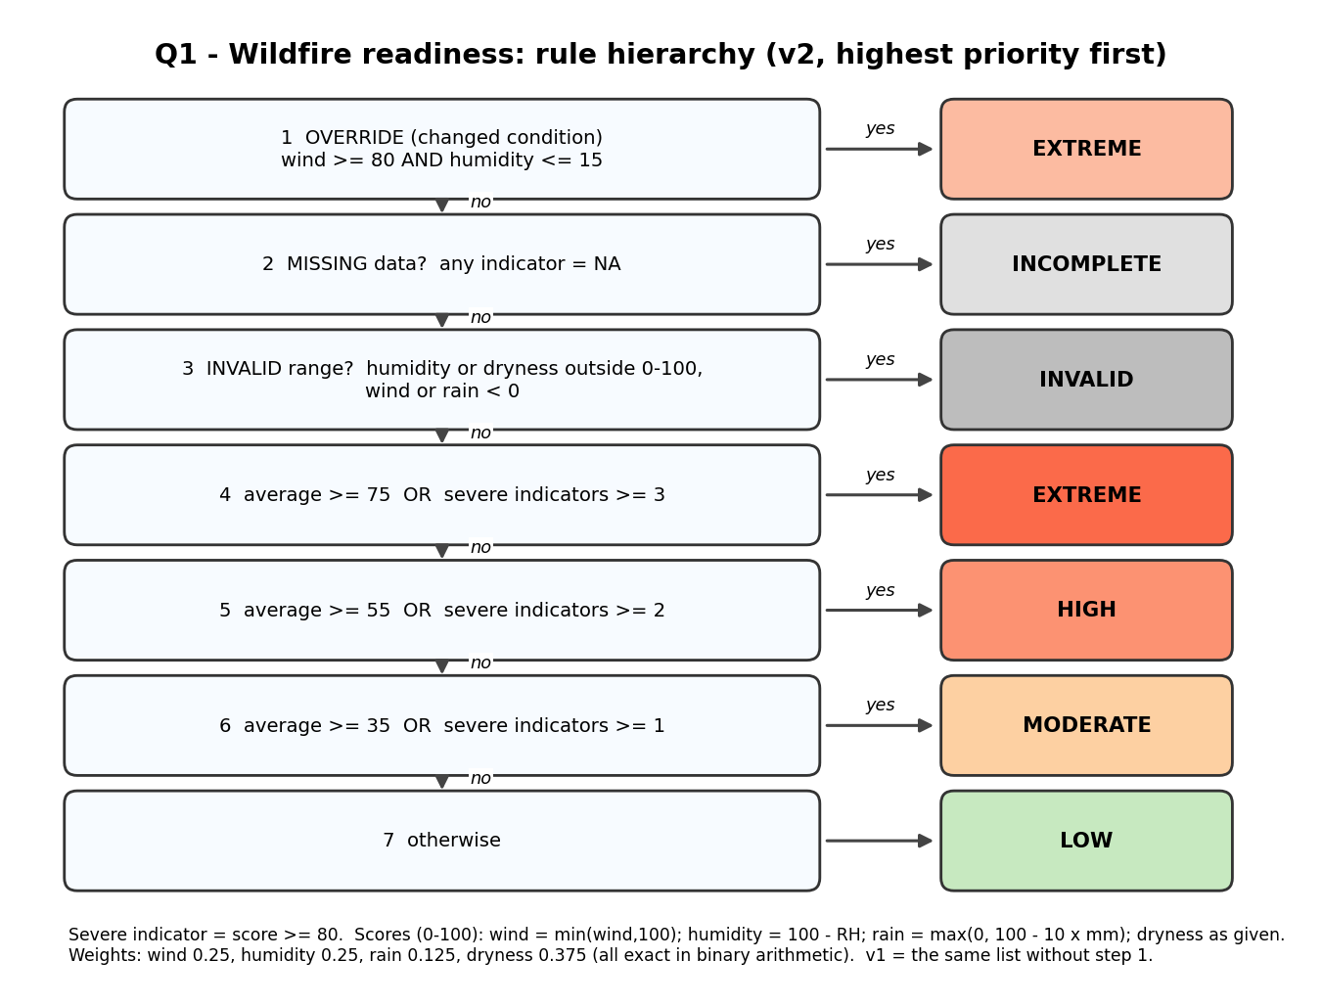
Figure 1: Rule hierarchy of version 2. Version 1 is the same list without step 1
Why the order matters. The override is tested first because it is a safety rule that must win over every other rule, including a missing rain or dryness value. The missing-data and range gates come before the average so that a number is never computed from unusable inputs. The severity counts come after the average so that the average still decides the ordinary cases.

1.2 Adversarial datasets and hand predictions
Group | Purpose | Zones
A ordinary | Typical conditions plus one missing wind value | A1-A7
B conflicting | Indicators disagree: the weighted average hides a dangerous combination (and one zone has missing rain and dryness) | B1-B7
C boundary | Averages of exactly 35, 55 and 75, just below 35 and 55, wind 80 with humidity 15, wind 79.9 with humidity 15.1, humidity 100.5 | C1-C8
D combined extreme | All indicators extreme, wind above the 100 cap, and extreme indicators offset by a calm one | D1-D6

Prediction worksheet (inputs, hand-calculated average and severe count, predicted classes)
Zone | Wind | Hum | Rain | Dry | Avg | Severe | Average only | v1 | v2
A1 | 10 | 70 | 5 | 20 | 23.75 | 0 | LOW | LOW | LOW
A2 | 30 | 50 | 2 | 50 | 48.75 | 1 | MODERATE | MODERATE | MODERATE
A3 | 50 | 35 | 0.5 | 70 | 66.875 | 1 | HIGH | HIGH | HIGH
A4 | 70 | 20 | 0 | 90 | 83.75 | 3 | EXTREME | EXTREME | EXTREME
A5 | 5 | 90 | 12 | 5 | 5.625 | 0 | LOW | LOW | LOW
A6 | 25 | 60 | 3 | 40 | 40 | 0 | MODERATE | MODERATE | MODERATE
A7 | NA | 70 | 5 | 20 | - | - | INCOMPLETE | INCOMPLETE | INCOMPLETE
B1 | 95 | 10 | 10 | 5 | 48.125 | 2 | MODERATE | HIGH | EXTREME
B2 | 5 | 90 | 0 | 100 | 53.75 | 2 | MODERATE | HIGH | HIGH
B3 | 90 | 12 | 8 | 10 | 50.75 | 2 | MODERATE | HIGH | EXTREME
B4 | 60 | 80 | 0 | 90 | 66.25 | 2 | HIGH | HIGH | HIGH
B5 | 100 | 5 | 0 | 0 | 61.25 | 3 | HIGH | EXTREME | EXTREME
B6 | 0 | 100 | 0 | 100 | 50 | 2 | MODERATE | HIGH | HIGH
B7 | 95 | 8 | NA | NA | - | - | INCOMPLETE | INCOMPLETE | EXTREME
C1 | 40 | 60 | 7 | 30 | 35 | 0 | MODERATE | MODERATE | MODERATE
C2 | 40 | 60 | 7 | 29 | 34.625 | 0 | LOW | LOW | LOW
C3 | 60 | 40 | 5 | 50 | 55 | 0 | HIGH | HIGH | HIGH
C4 | 60 | 40 | 5 | 49 | 54.625 | 0 | MODERATE | MODERATE | MODERATE
C5 | 70 | 30 | 2 | 80 | 75 | 2 | EXTREME | EXTREME | EXTREME
C6 | 80 | 15 | 5 | 10 | 51.25 | 2 | MODERATE | HIGH | EXTREME
C7 | 79.9 | 15.1 | 5 | 10 | 51.2 | 1 | MODERATE | MODERATE | MODERATE
C8 | 40 | 100.5 | 7 | 30 | - | - | INVALID | INVALID | INVALID
D1 | 100 | 0 | 0 | 100 | 100 | 4 | EXTREME | EXTREME | EXTREME
D2 | 120 | 0 | 0 | 100 | 100 | 4 | EXTREME | EXTREME | EXTREME
D3 | 85 | 10 | 0 | 95 | 91.875 | 4 | EXTREME | EXTREME | EXTREME
D4 | 75 | 12 | 1 | 85 | 83.875 | 3 | EXTREME | EXTREME | EXTREME
D5 | 100 | 0 | 15 | 0 | 50 | 2 | MODERATE | HIGH | EXTREME
D6 | 90 | 14 | 9.9 | 100 | 81.625 | 3 | EXTREME | EXTREME | EXTREME

Worked examples. B1 (95, 10, 10, 5): scores 95, 90, 0, 5; average 0.25(95) + 0.25(90) + 0.125(0) + 0.375(5) = 48.125, which the average alone calls MODERATE. Two indicators are severe, so v1 predicts HIGH, and the override makes v2 EXTREME. C1 (40, 60, 7, 30): scores 40, 40, 30, 30; average exactly 35, so MODERATE because the cut point is inclusive. C7 (79.9, 15.1, 5, 10): just outside the override, one severe indicator, so MODERATE in both versions.

1.3 Implementation
R code
# Q1: Multi-factor wildfire readiness alert
options(width = 85)
set.seed(2026)

# ---- Rule parameters (weights are powers of 1/2 so boundary arithmetic is exact) ----
w <- c(wind = 0.25, humidity = 0.25, rain = 0.125, dryness = 0.375)
SEV <- 80 # indicator score at or above this is "severe"
CUT <- c(MODERATE = 35, HIGH = 55, EXTREME = 75) # average-score cut points
OVR_WIND <- 80; OVR_HUM <- 15 # changed condition: very high wind + very low humidity

cnt <- new.env(); cnt$evals <- 0
chk <- function(cond) { cnt$evals <- cnt$evals + 1; cond } # counts each condition tested

indicator_scores <- function(wind, hum, rain, dry) # each on a 0-100 danger scale
c(wind = min(wind, 100), humidity = 100 - hum,
rain = max(0, 100 - 10 * rain), dryness = dry)

classify_zone <- function(wind, hum, rain, dry, version = "v2") {
cnt$evals <- 0
if (version == "v2") { # priority 1: override rule (needs only wind + humidity)
if (chk(!is.na(wind)) && chk(!is.na(hum)) && chk(wind >= OVR_WIND) && chk(hum <= OVR_HUM))
return(list(class = "EXTREME", avg = NA_real_, n_sev = NA_integer_, evals = cnt$evals, rule = "OVERRIDE"))
}
if (chk(any(is.na(c(wind, hum, rain, dry))))) # explicit missing-data handling
return(list(class = "INCOMPLETE", avg = NA_real_, n_sev = NA_integer_, evals = cnt$evals, rule = "MISSING"))
if (chk(wind < 0 || hum < 0 || hum > 100 || rain < 0 || dry < 0 || dry > 100))
return(list(class = "INVALID", avg = NA_real_, n_sev = NA_integer_, evals = cnt$evals, rule = "RANGE"))
s <- indicator_scores(wind, hum, rain, dry)
avg <- sum(w * s); n_sev <- sum(s >= SEV)
cl <- if (chk(avg >= CUT["EXTREME"]) || chk(n_sev >= 3)) "EXTREME"
else if (chk(avg >= CUT["HIGH"]) || chk(n_sev >= 2)) "HIGH"
else if (chk(avg >= CUT["MODERATE"]) || chk(n_sev >= 1)) "MODERATE"
else "LOW"
list(class = cl, avg = avg, n_sev = n_sev, evals = cnt$evals, rule = "HIERARCHY")
}

avg_only <- function(wind, hum, rain, dry) { # baseline: weighted average alone
if (any(is.na(c(wind, hum, rain, dry)))) return("INCOMPLETE")
if (wind < 0 || hum < 0 || hum > 100 || rain < 0 || dry < 0 || dry > 100) return("INVALID")
a <- sum(w * indicator_scores(wind, hum, rain, dry))
if (a >= 75) "EXTREME" else if (a >= 55) "HIGH" else if (a >= 35) "MODERATE" else "LOW"
}

process_zones <- function(df, version) { # for loop over records
n <- nrow(df); cls <- character(n); ev <- integer(n); avg <- numeric(n); ns <- integer(n); rl <- character(n)
iterations <- 0
for (i in seq_len(n)) {
iterations <- iterations + 1
r <- classify_zone(df$wind[i], df$hum[i], df$rain[i], df$dry[i], version)
cls[i] <- r$class; ev[i] <- r$evals; avg[i] <- r$avg; ns[i] <- r$n_sev; rl[i] <- r$rule
}
list(data = data.frame(zone = df$zone, class = cls, avg = avg, n_sev = ns, rule = rl, evals = ev,
stringsAsFactors = FALSE), iterations = iterations)
}

# ---- Four adversarial datasets (zone, wind km/h, humidity %, rain mm/72h, dryness 0-100) ----
zones <- data.frame(
zone = c(paste0("A", 1:7), paste0("B", 1:7), paste0("C", 1:8), paste0("D", 1:6)),
wind = c(10, 30, 50, 70, 5, 25, NA, 95, 5, 90, 60, 100, 0, 95,
40, 40, 60, 60, 70, 80, 79.9, 40, 100, 120, 85, 75, 100, 90),
hum = c(70, 50, 35, 20, 90, 60, 70, 10, 90, 12, 80, 5, 100, 8,
60, 60, 40, 40, 30, 15, 15.1, 100.5, 0, 0, 10, 12, 0, 14),
rain = c(5, 2, 0.5, 0, 12, 3, 5, 10, 0, 8, 0, 0, 0, NA,
7, 7, 5, 5, 2, 5, 5, 7, 0, 0, 0, 1, 15, 9.9),
dry = c(20, 50, 70, 90, 5, 40, 20, 5, 100, 10, 90, 0, 100, NA,
30, 29, 50, 49, 80, 10, 10, 30, 100, 100, 95, 85, 0, 100))
zones$group <- c(rep("A ordinary", 7), rep("B conflicting", 7), rep("C boundary", 8), rep("D combined extreme", 6))

# ---- PREDICTIONS written by hand BEFORE running (see report for the arithmetic) ----
pred_v1 <- c("LOW","MODERATE","HIGH","EXTREME","LOW","MODERATE","INCOMPLETE",
"HIGH","HIGH","HIGH","HIGH","EXTREME","HIGH","INCOMPLETE",
"MODERATE","LOW","HIGH","MODERATE","EXTREME","HIGH","MODERATE","INVALID",
"EXTREME","EXTREME","EXTREME","EXTREME","HIGH","EXTREME")
pred_v2 <- c("LOW","MODERATE","HIGH","EXTREME","LOW","MODERATE","INCOMPLETE",
"EXTREME","HIGH","EXTREME","HIGH","EXTREME","HIGH","EXTREME",
"MODERATE","LOW","HIGH","MODERATE","EXTREME","EXTREME","MODERATE","INVALID",
"EXTREME","EXTREME","EXTREME","EXTREME","EXTREME","EXTREME")
pred_avg <- c("LOW","MODERATE","HIGH","EXTREME","LOW","MODERATE","INCOMPLETE",
"MODERATE","MODERATE","MODERATE","HIGH","HIGH","MODERATE","INCOMPLETE",
"MODERATE","LOW","HIGH","MODERATE","EXTREME","MODERATE","MODERATE","INVALID",
"EXTREME","EXTREME","EXTREME","EXTREME","MODERATE","EXTREME")

r1 <- process_zones(zones, "v1"); r2 <- process_zones(zones, "v2")
obs_avg <- mapply(avg_only, zones$wind, zones$hum, zones$rain, zones$dry)

cat("=== Prediction vs observation: 28 adversarial zones ===\n")
cmp <- data.frame(zone = zones$zone, v1_pred = pred_v1, v1_obs = r1$data$class,
v2_pred = pred_v2, v2_obs = r2$data$class, avg_pred = pred_avg, avg_obs = obs_avg)
cmp$ok <- ifelse(cmp$v1_pred == cmp$v1_obs & cmp$v2_pred == cmp$v2_obs & cmp$avg_pred == cmp$avg_obs, "yes", "NO")
print(cmp, row.names = FALSE)
cat("\nMatches v1:", sum(cmp$v1_pred == cmp$v1_obs), "/ 28 | v2:", sum(cmp$v2_pred == cmp$v2_obs),
"/ 28 | average-only:", sum(cmp$avg_pred == cmp$avg_obs), "/ 28\n")

cat("\n=== Details: average score, severe-indicator count and rule that fired (v2) ===\n")
det <- data.frame(zone = zones$zone, avg = round(r1$data$avg, 3), n_severe = r1$data$n_sev, rule_v2 = r2$data$rule)
print(det, row.names = FALSE)

cat("\n=== Iterations and condition evaluations (28 zones) ===\n")
cat("v1: iterations =", r1$iterations, "| condition evaluations =", sum(r1$data$evals), "\n")
cat("v2: iterations =", r2$iterations, "| condition evaluations =", sum(r2$data$evals), "\n")
by_grp <- aggregate(cbind(v1 = r1$data$evals, v2 = r2$data$evals) ~ group, data = zones, FUN = sum)
print(by_grp, row.names = FALSE)

cat("\n=== Where the weighted average alone misleads (average-only vs hierarchy) ===\n")
rank <- c(INCOMPLETE = 0, INVALID = 0, LOW = 1, MODERATE = 2, HIGH = 3, EXTREME = 4)
mis <- cmp$avg_obs != cmp$v2_obs & rank[cmp$avg_obs] < rank[cmp$v2_obs]
print(data.frame(zone = cmp$zone[mis], average_only = cmp$avg_obs[mis], v1 = cmp$v1_obs[mis], v2 = cmp$v2_obs[mis]), row.names = FALSE)
cat("Zones under-classified by the average alone:", sum(mis), "of 28\n")

# ---- Changed condition: 25,000 zones ----
cat("\n=== CHANGED CONDITION: 25,000 zones ===\n")
n <- 25000
big <- data.frame(zone = sprintf("Z%05d", 1:n),
wind = pmax(0, rnorm(n, 35, 22)), hum = pmin(100, pmax(0, rnorm(n, 50, 22))),
rain = rexp(n, 1 / 4), dry = pmin(100, pmax(0, rnorm(n, 50, 25))))
inj <- sample(n, 1000) # force 1,000 dangerous wind + humidity cases
big$wind[inj] <- runif(1000, 80, 110); big$hum[inj] <- runif(1000, 0, 15)
big$rain[sample(n, 500)] <- NA; big$dry[sample(n, 500)] <- NA # missing measurements
big$wind[sample(n, 250)] <- NA; big$hum[sample(n, 250)] <- NA
t1 <- system.time(b1 <- process_zones(big, "v1"))[["elapsed"]]
t2 <- system.time(b2 <- process_zones(big, "v2"))[["elapsed"]]
cat("Loop iterations: v1 =", b1$iterations, "| v2 =", b2$iterations, "\n")
cat("Elapsed (s): v1 =", round(t1, 2), "| v2 =", round(t2, 2), "(supporting evidence only)\n")
cat("Total condition evaluations: v1 =", sum(b1$data$evals), "| v2 =", sum(b2$data$evals),
"| mean per zone: v1 =", round(mean(b1$data$evals), 2), "v2 =", round(mean(b2$data$evals), 2), "\n")
lv <- c("LOW", "MODERATE", "HIGH", "EXTREME", "INCOMPLETE", "INVALID")
dist <- rbind(v1 = table(factor(b1$data$class, lv)), v2 = table(factor(b2$data$class, lv)))
cat("\nClass counts:\n"); print(dist)
trig <- which(!is.na(big$wind) & !is.na(big$hum) & big$wind >= OVR_WIND & big$hum <= OVR_HUM)
cat("\nZones meeting the override condition (wind >= 80 and humidity <= 15):", length(trig), "\n")
cat(" classified EXTREME by v1:", sum(b1$data$class[trig] == "EXTREME"), "\n")
cat(" classified EXTREME by v2:", sum(b2$data$class[trig] == "EXTREME"), "(guarantee requires all)\n")
cat(" of those, with a missing rain or dryness value:", sum(is.na(big$rain[trig]) | is.na(big$dry[trig])), "\n")
upgraded <- which(b1$data$class != b2$data$class)
cat("Zones whose class changed from v1 to v2:", length(upgraded), "\n")
print(table(from = b1$data$class[upgraded], to = b2$data$class[upgraded]))
cat("Zones downgraded by v2 (rank lower than v1):", sum(rank[b2$data$class] < rank[b1$data$class]), "\n")
nonov <- setdiff(seq_len(n), trig)
cat("Zones outside the override region: identical class in v1 and v2:", all(b1$data$class[nonov] == b2$data$class[nonov]), "\n")

png("fig/fig_q1_alert.png", width = 1800, height = 900, res = 170)
par(mfrow = c(1, 2), mar = c(5, 5, 4, 1))
pal <- c(LOW = "#a1d99b", MODERATE = "#fdd0a2", HIGH = "#fc9272", EXTREME = "#cb181d", INCOMPLETE = "grey70", INVALID = "grey40")
s <- sample(n, 4000)
plot(big$wind[s], big$hum[s], col = pal[b2$data$class[s]], pch = 16, cex = 0.6, xlab = "Wind speed (km/h)", ylab = "Relative humidity (%)",
main = "v2 classes; override region boxed", xlim = c(0, 115), ylim = c(0, 100))
rect(OVR_WIND, 0, 115, OVR_HUM, border = "black", lwd = 2, lty = 2)
legend("topright", legend = names(pal)[1:4], col = pal[1:4], pch = 16, cex = 0.7, bty = "n")
barplot(dist[, 1:4], beside = TRUE, col = c("#9ecae1", "#3182bd"), xlab = "Readiness level", ylab = "Number of zones",
main = "25,000 zones: v1 vs v2")
legend("topright", legend = c("v1 (no override)", "v2 (override)"), fill = c("#9ecae1", "#3182bd"), bty = "n", cex = 0.8)
dev.off()

Output (captured from running the code above)
=== Prediction vs observation: 28 adversarial zones ===
zone v1_pred v1_obs v2_pred v2_obs avg_pred avg_obs ok
A1 LOW LOW LOW LOW LOW LOW yes
A2 MODERATE MODERATE MODERATE MODERATE MODERATE MODERATE yes
A3 HIGH HIGH HIGH HIGH HIGH HIGH yes
A4 EXTREME EXTREME EXTREME EXTREME EXTREME EXTREME yes
A5 LOW LOW LOW LOW LOW LOW yes
A6 MODERATE MODERATE MODERATE MODERATE MODERATE MODERATE yes
A7 INCOMPLETE INCOMPLETE INCOMPLETE INCOMPLETE INCOMPLETE INCOMPLETE yes
B1 HIGH HIGH EXTREME EXTREME MODERATE MODERATE yes
B2 HIGH HIGH HIGH HIGH MODERATE MODERATE yes
B3 HIGH HIGH EXTREME EXTREME MODERATE MODERATE yes
B4 HIGH HIGH HIGH HIGH HIGH HIGH yes
B5 EXTREME EXTREME EXTREME EXTREME HIGH HIGH yes
B6 HIGH HIGH HIGH HIGH MODERATE MODERATE yes
B7 INCOMPLETE INCOMPLETE EXTREME EXTREME INCOMPLETE INCOMPLETE yes
C1 MODERATE MODERATE MODERATE MODERATE MODERATE MODERATE yes
C2 LOW LOW LOW LOW LOW LOW yes
C3 HIGH HIGH HIGH HIGH HIGH HIGH yes
C4 MODERATE MODERATE MODERATE MODERATE MODERATE MODERATE yes
C5 EXTREME EXTREME EXTREME EXTREME EXTREME EXTREME yes
C6 HIGH HIGH EXTREME EXTREME MODERATE MODERATE yes
C7 MODERATE MODERATE MODERATE MODERATE MODERATE MODERATE yes
C8 INVALID INVALID INVALID INVALID INVALID INVALID yes
D1 EXTREME EXTREME EXTREME EXTREME EXTREME EXTREME yes
D2 EXTREME EXTREME EXTREME EXTREME EXTREME EXTREME yes
D3 EXTREME EXTREME EXTREME EXTREME EXTREME EXTREME yes
D4 EXTREME EXTREME EXTREME EXTREME EXTREME EXTREME yes
D5 HIGH HIGH EXTREME EXTREME MODERATE MODERATE yes
D6 EXTREME EXTREME EXTREME EXTREME EXTREME EXTREME yes

Matches v1: 28 / 28 | v2: 28 / 28 | average-only: 28 / 28

=== Details: average score, severe-indicator count and rule that fired (v2) ===
zone avg n_severe rule_v2
A1 23.750 0 HIERARCHY
A2 48.750 1 HIERARCHY
A3 66.875 1 HIERARCHY
A4 83.750 3 HIERARCHY
A5 5.625 0 HIERARCHY
A6 40.000 0 HIERARCHY
A7 NA NA MISSING
B1 48.125 2 OVERRIDE
B2 53.750 2 HIERARCHY
B3 50.750 2 OVERRIDE
B4 66.250 2 HIERARCHY
B5 61.250 3 OVERRIDE
B6 50.000 2 HIERARCHY
B7 NA NA OVERRIDE
C1 35.000 0 HIERARCHY
C2 34.625 0 HIERARCHY
C3 55.000 0 HIERARCHY
C4 54.625 0 HIERARCHY
C5 75.000 2 HIERARCHY
C6 51.250 2 OVERRIDE
C7 51.200 1 HIERARCHY
C8 NA NA RANGE
D1 100.000 4 OVERRIDE
D2 100.000 4 OVERRIDE
D3 91.875 4 OVERRIDE
D4 83.875 3 HIERARCHY
D5 50.000 2 OVERRIDE
D6 81.625 3 OVERRIDE

=== Iterations and condition evaluations (28 zones) ===
v1: iterations = 28 | condition evaluations = 139
v2: iterations = 28 | condition evaluations = 190
group v1 v2
A ordinary 39 58
B conflicting 34 42
C boundary 45 64
D combined extreme 21 26

=== Where the weighted average alone misleads (average-only vs hierarchy) ===
zone average_only v1 v2
B1 MODERATE HIGH EXTREME
B2 MODERATE HIGH HIGH
B3 MODERATE HIGH EXTREME
B5 HIGH EXTREME EXTREME
B6 MODERATE HIGH HIGH
B7 INCOMPLETE INCOMPLETE EXTREME
C6 MODERATE HIGH EXTREME
D5 MODERATE HIGH EXTREME
Zones under-classified by the average alone: 8 of 28

=== CHANGED CONDITION: 25,000 zones ===
Loop iterations: v1 = 25000 | v2 = 25000
Elapsed (s): v1 = 0.24 | v2 = 0.28 (supporting evidence only)
Total condition evaluations: v1 = 152236 | v2 = 224093 | mean per zone: v1 = 6.09 v2 = 8.96

Class counts:
LOW MODERATE HIGH EXTREME INCOMPLETE INVALID
v1 2496 13083 7021 936 1464 0
v2 2496 13083 6661 1331 1429 0

Zones meeting the override condition (wind >= 80 and humidity <= 15): 1011
classified EXTREME by v1: 616
classified EXTREME by v2: 1011 (guarantee requires all)
of those, with a missing rain or dryness value: 35
Zones whose class changed from v1 to v2: 395
to
from EXTREME
HIGH 360
INCOMPLETE 35
Zones downgraded by v2 (rank lower than v1): 0
Zones outside the override region: identical class in v1 and v2: TRUE
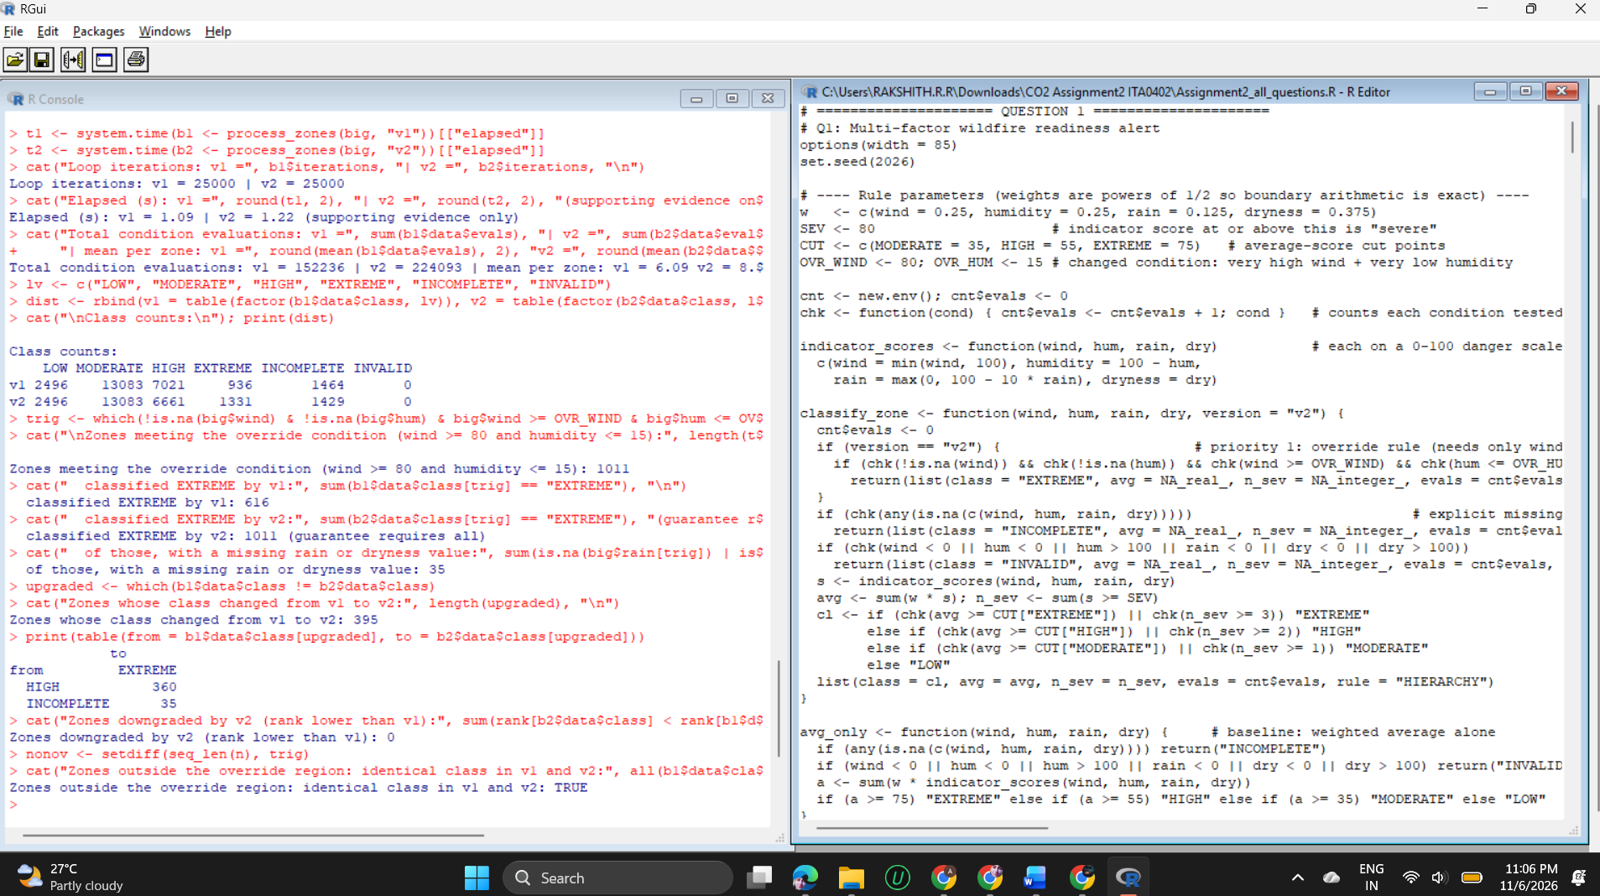

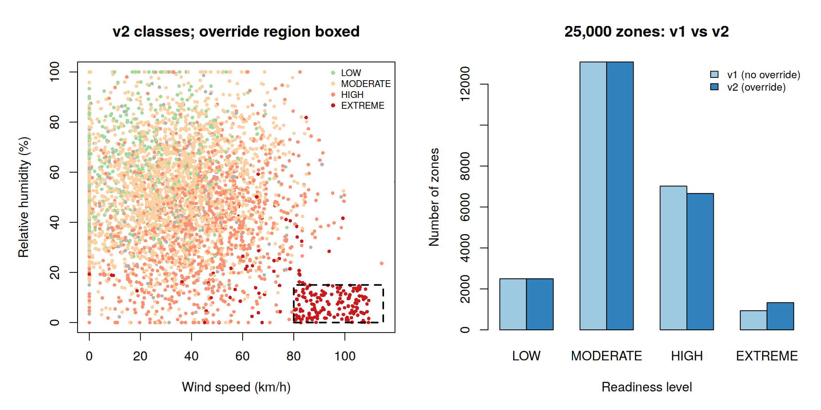
Figure 2: Left: 4,000 sampled zones coloured by their v2 class with the override region boxed. Right: class counts for 25,000 zones, v1 against v2

1.4 Prediction versus observation
- 28 of 28 predictions matched for each of the three classifiers (84 of 84), including every boundary: average 35 gave MODERATE, 34.625 gave LOW, average 55 gave HIGH, 54.625 gave MODERATE, average 75 gave EXTREME, wind 80 with humidity 15 triggered the override, and 79.9 with 15.1 did not.
- Loop and condition counts (28 zones): 28 iterations in each version. Condition evaluations were 139 for v1 and 190 for v2. The override adds up to four tests per zone before the normal hierarchy starts.
- Where the weighted average alone misleads: 8 of 28 zones were classified lower by the average than by the hierarchy (B1, B2, B3, B5, B6, B7, C6, D5). For example D5 (wind 100, humidity 0, rain 15, dryness 0) averages exactly 50 because wet, green vegetation pulls it down, although wind and humidity are both at the worst possible score.
- The hierarchy also guards against the opposite error. B2 and B6 have two severe indicators (very dry vegetation, no rain) but low wind and high humidity; a rule such as 'any severe indicator means EXTREME' would over-alert, whereas the hierarchy gives HIGH.

1.5 Changed condition at scale (25,000 zones)
- 1,011 zones met the override condition. v1 classified only 616 of them EXTREME; v2 classified all 1,011.
- 395 zones changed class from v1 to v2: 360 went from HIGH to EXTREME and 35 from INCOMPLETE to EXTREME. These 35 had a missing rain or dryness value, so the guarantee holds even with incomplete data.
- No zone was downgraded, and every zone outside the override region kept exactly the same class in v1 and v2.
- Cost: mean condition evaluations per zone rose from 6.09 to 8.96 (about 47% more); the loop time moved from 0.24 s to 0.28 s (supporting evidence only).

1.6 Evaluation and limitations
- Strength: the weighted average gives a smooth ranking, the severity count protects against averaging away a dangerous indicator, and the override encodes the one case that must never be missed.
- Limitation 1: the override is tested before the range check, so an impossible humidity such as -5 would raise an EXTREME alert. A production version should add a range test inside the override.
- Limitation 2: the weights, cut points and the severity score of 80 are chosen for the exercise and are not calibrated on real fire data.
- Limitation 3: a faulty wind or humidity sensor can now trigger EXTREME on its own. This is a deliberate safety-first trade-off: a false alarm is cheaper than a missed one.

QUESTION 2 - Scholarship Eligibility and Exception Engine (7 Marks)

2.1 Problem understanding and design
A scholarship decision depends on a household-income band (1 lowest to 5), the academic average, attendance, document status and any approved special provision. The design rule is that priority and waiver logic live in a policy table, and the decision function only reads it. Changing the policy is then a data edit, not a code change.
Condition | Rule (policy v1) | Reason code on failure | May a provision waive it?
Data validity | no missing values; average and attendance within 0-100 | REVIEW / DATA_INVALID | No
Documents | status is VERIFIED | DOC_MISSING | Never (safeguard in the engine)
Income | band <= 3 | INCOME_ABOVE_LIMIT | SINGLE_PARENT
Academic average | >= 60 | LOW_AVERAGE | SPORTS
Attendance | >= 75 | LOW_ATTENDANCE | None in v1; DISABILITY in v2

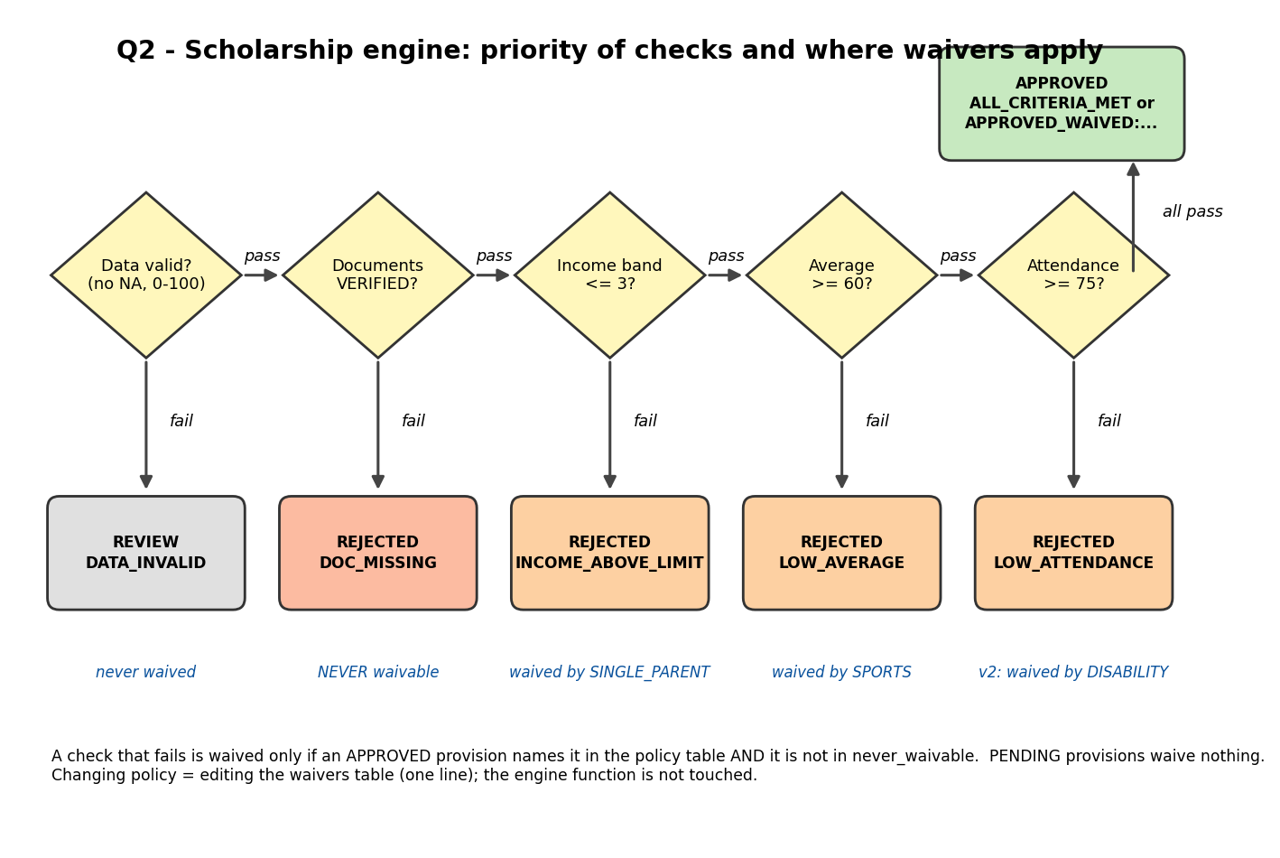
Figure 3: Order of the checks. A failed check is waived only by an APPROVED provision that the policy names for it
- First failure decides: checks run in the order documents, income, average, attendance, so the reason code is the first failed condition.
- Waivers are specific: a provision waives only the condition named for it; an unlisted provision waives nothing; a PENDING provision waives nothing; overlapping provisions each act on their own condition.
- NOT logic: the waivable set is the named conditions minus never_waivable, so documents can never be waived even if someone types it into the table by mistake (tested below).
- Arithmetic: thresholds are compared with relational operators; the loop over application records is a for loop.

2.2 Test profiles and predictions
ID | What the profile tests
P1 | Every value exactly on its threshold (band 3, average 60.0, attendance 75.0)
P2 | Average 59.99, just below the threshold
P3 | Excellent academics (98) but documents missing, with an approved SPORTS provision
P4 | Attendance 74.9, just below the threshold
P5 | Overlapping provisions SPORTS and SINGLE_PARENT: band 4 and average 55 both need a waiver
P6 | Clearly ineligible on every condition
P7 | SPORTS provision still PENDING, average 55
P8 | Approved DISABILITY provision with attendance 60
P9 | Approved DISABILITY provision, attendance 50, documents missing
P10 | Missing academic average
P11 | SPORTS and DISABILITY together: average 55, attendance 60
P12 | Income band 4, no provision

2.3 Implementation
R code
# Q2: Scholarship eligibility and exception engine
options(width = 85)

# ---- Policy as DATA (the engine below never changes when the policy changes) ----
policy_v1 <- list(
min_avg = 60, min_att = 75, max_band = 3,
waivers = list(SPORTS = "average", SINGLE_PARENT = "income"), # provision -> the ONLY condition it waives
never_waivable = "documents",
order = c("documents", "income", "average", "attendance")) # priority order of the checks

check_defs <- list( # relational operators on the application record
documents = function(a, p) a$docs == "VERIFIED",
income = function(a, p) a$income_band <= p$max_band,
average = function(a, p) a$avg >= p$min_avg,
attendance = function(a, p) a$att >= p$min_att)
fail_code <- c(documents = "DOC_MISSING", income = "INCOME_ABOVE_LIMIT",
average = "LOW_AVERAGE", attendance = "LOW_ATTENDANCE")

evaluate_application <- function(app, policy) {
trace <- character()
bad <- is.na(app$avg) || is.na(app$att) || is.na(app$income_band) || is.na(app$docs) ||
app$avg < 0 || app$avg > 100 || app$att < 0 || app$att > 100
if (bad) return(list(status = "REVIEW", reason = "DATA_INVALID", trace = "data:INVALID"))
provs <- if (app$prov_status == "APPROVED" && nzchar(app$prov)) strsplit(app$prov, ";")[[1]] else character()
waived <- unique(unlist(policy$waivers[intersect(provs, names(policy$waivers))]))
waived <- setdiff(waived, policy$never_waivable) # NOT/AND logic: documents can never be waived
used <- character()
for (ck in policy$order) {
passed <- check_defs[[ck]](app, policy)
if (!passed && (ck %in% waived)) { trace <- c(trace, paste0(ck, ":WAIVED")); used <- c(used, ck); next }
if (!passed) {
trace <- c(trace, paste0(ck, ":FAIL"))
return(list(status = "REJECTED", reason = unname(fail_code[ck]), trace = paste(trace, collapse = " | ")))
}
trace <- c(trace, paste0(ck, ":PASS"))
}
list(status = "APPROVED",
reason = if (length(used) == 0) "ALL_CRITERIA_MET" else paste0("APPROVED_WAIVED:", paste(used, collapse = "+")),
trace = paste(trace, collapse = " | "))
}

evaluate_all <- function(apps, policy) { # loop over application records
n <- nrow(apps); st <- re <- tr <- character(n)
for (i in seq_len(n)) {
r <- evaluate_application(as.list(apps[i, ]), policy)
st[i] <- r$status; re[i] <- r$reason; tr[i] <- r$trace
}
data.frame(id = apps$id, status = st, reason = re, trace = tr, stringsAsFactors = FALSE)
}

# ---- Twelve adversarial profiles ----
apps <- data.frame(stringsAsFactors = FALSE,
id = paste0("P", 1:12),
income_band = c(3, 2, 1, 2, 4, 5, 2, 2, 2, NA, 2, 4),
avg = c(60.0, 59.99, 98, 80, 55, 35, 55, 80, 85, 80, 55, 70),
att = c(75.0, 90, 95, 74.9, 80, 40, 85, 60, 50, 80, 60, 80),
docs = c("VERIFIED", "VERIFIED", "MISSING", "VERIFIED", "VERIFIED", "MISSING", "VERIFIED", "VERIFIED", "MISSING", "VERIFIED", "VERIFIED", "VERIFIED"),
prov = c("", "", "SPORTS", "", "SPORTS;SINGLE_PARENT", "", "SPORTS", "DISABILITY", "DISABILITY", "", "SPORTS;DISABILITY", ""),
prov_status = c("NONE", "NONE", "APPROVED", "NONE", "APPROVED", "NONE", "PENDING", "APPROVED", "APPROVED", "NONE", "APPROVED", "NONE"))
apps$income_band[10] <- 3; apps$avg[10] <- NA # P10: missing academic average
cat("--- Applications ---\n"); print(apps, row.names = FALSE)

# ---- PREDICTIONS (hand-traced before execution) ----
pred_v1 <- data.frame(id = apps$id, stringsAsFactors = FALSE,
status = c("APPROVED","REJECTED","REJECTED","REJECTED","APPROVED","REJECTED","REJECTED","REJECTED","REJECTED","REVIEW","REJECTED","REJECTED"),
reason = c("ALL_CRITERIA_MET","LOW_AVERAGE","DOC_MISSING","LOW_ATTENDANCE","APPROVED_WAIVED:income+average","DOC_MISSING",
"LOW_AVERAGE","LOW_ATTENDANCE","DOC_MISSING","DATA_INVALID","LOW_ATTENDANCE","INCOME_ABOVE_LIMIT"))
pred_v2 <- pred_v1
pred_v2[8, c("status", "reason")] <- c("APPROVED", "APPROVED_WAIVED:attendance")
pred_v2[11, c("status", "reason")] <- c("APPROVED", "APPROVED_WAIVED:average+attendance")

v1 <- evaluate_all(apps, policy_v1)
cat("\n=== Baseline policy v1: prediction vs observation ===\n")
cmp1 <- data.frame(id = v1$id, predicted = paste(pred_v1$status, pred_v1$reason, sep = "/"),
observed = paste(v1$status, v1$reason, sep = "/"),
ok = ifelse(pred_v1$status == v1$status & pred_v1$reason == v1$reason, "yes", "NO"))
cmp1$predicted <- sub("APPROVED_WAIVED:", "WAIVED:", cmp1$predicted); cmp1$observed <- sub("APPROVED_WAIVED:", "WAIVED:", cmp1$observed)
print(cmp1, row.names = FALSE)
cat("Matches:", sum(cmp1$ok == "yes"), "/ 12\n")

cat("\n=== Condition traces (v1) ===\n")
for (i in seq_len(nrow(v1))) cat(sprintf("%-4s %-9s %-30s %s\n", v1$id[i], v1$status[i], v1$reason[i], v1$trace[i]))
cat("Conditions evaluated per profile:", paste(sapply(strsplit(v1$trace, " \\| "), length), collapse = " "), "\n")

# ---- Effect of CONDITION ORDER ----
cat("\n=== Condition-order experiment ===\n")
pol_rev <- policy_v1; pol_rev$order <- c("attendance", "average", "income", "documents")
ord_tab <- data.frame(id = c("P3", "P6", "P9"),
docs_first = evaluate_all(apps[c(3, 6, 9), ], policy_v1)$reason,
docs_last = evaluate_all(apps[c(3, 6, 9), ], pol_rev)$reason,
steps_docs_first = sapply(strsplit(evaluate_all(apps[c(3, 6, 9), ], policy_v1)$trace, " \\| "), length),
steps_docs_last = sapply(strsplit(evaluate_all(apps[c(3, 6, 9), ], pol_rev)$trace, " \\| "), length))
ord_tab$predicted_docs_last <- c("DOC_MISSING", "LOW_ATTENDANCE", "DOC_MISSING") # written before running
ord_tab$prediction_ok <- ifelse(ord_tab$predicted_docs_last == ord_tab$docs_last, "yes", "NO")
print(ord_tab[, c("id", "docs_first", "docs_last", "predicted_docs_last", "prediction_ok")], row.names = FALSE)
cat("Steps (conditions evaluated): docs first =", paste(ord_tab$steps_docs_first, collapse = " "), "| docs last =", paste(ord_tab$steps_docs_last, collapse = " "), "\n")

naive_provision_first <- function(app, policy) { # FLAWED ordering: an approved provision short-circuits everything
if (app$prov_status == "APPROVED" && nzchar(app$prov)) return(list(status = "APPROVED", reason = "PROVISION_APPROVED"))
evaluate_application(app, policy)
}
nv <- sapply(seq_len(nrow(apps)), function(i) naive_provision_first(as.list(apps[i, ]), policy_v1)$status)
chg <- which(nv != v1$status)
cat("\nFlawed 'provision first' ordering changes the STATUS of", length(chg), "profiles:\n")
print(data.frame(id = apps$id[chg], correct = v1$status[chg], provision_first = nv[chg]), row.names = FALSE)

# ---- POLICY CHANGE: waive attendance for DISABILITY only; documents never waived ----
policy_v2 <- policy_v1
policy_v2$waivers$DISABILITY <- "attendance" # the ONLY edit: one line of policy data
v2 <- evaluate_all(apps, policy_v2)
cat("\n=== Policy v2 (DISABILITY waives attendance): prediction vs observation ===\n")
cmp2 <- data.frame(id = v2$id, predicted = paste(pred_v2$status, pred_v2$reason, sep = "/"),
observed = paste(v2$status, v2$reason, sep = "/"),
ok = ifelse(pred_v2$status == v2$status & pred_v2$reason == v2$reason, "yes", "NO"))
cmp2$predicted <- sub("APPROVED_WAIVED:", "WAIVED:", cmp2$predicted); cmp2$observed <- sub("APPROVED_WAIVED:", "WAIVED:", cmp2$observed)
print(cmp2, row.names = FALSE)
cat("Matches:", sum(cmp2$ok == "yes"), "/ 12\n")
cat("\n=== Before / after the policy change ===\n")
ba <- data.frame(id = apps$id, before = sub("APPROVED_WAIVED:", "WAIVED:", v1$reason), after = sub("APPROVED_WAIVED:", "WAIVED:", v2$reason))
ba$changed <- ifelse(v1$status != v2$status | v1$reason != v2$reason, "CHANGED", "")
print(ba, row.names = FALSE)
cat("Profiles changed:", sum(ba$changed == "CHANGED"), "of 12 | approvals before:", sum(v1$status == "APPROVED"),
"after:", sum(v2$status == "APPROVED"), "\n")
cat("Edits needed: engine functions changed = 0; policy lines added = 1\n")

cat("\n=== Safeguard: even a mistaken policy entry cannot waive documents ===\n")
policy_bad <- policy_v2; policy_bad$waivers$DISABILITY <- c("attendance", "documents")
sg <- evaluate_all(apps[c(9), ], policy_bad)
cat("P9 (DISABILITY, documents MISSING) under the mistaken policy ->", sg$status, sg$reason, "\n")

png("fig/fig_q2_policy.png", width = 1700, height = 850, res = 170)
par(mfrow = c(1, 2), mar = c(5, 5, 4, 1))
tb <- rbind(v1 = table(factor(v1$status, c("APPROVED", "REJECTED", "REVIEW"))), v2 = table(factor(v2$status, c("APPROVED", "REJECTED", "REVIEW"))))
barplot(tb, beside = TRUE, col = c("#9ecae1", "#3182bd"), ylab = "Number of profiles", xlab = "Final status", main = "Outcomes before and after the change")
legend("topleft", legend = c("policy v1", "policy v2"), fill = c("#9ecae1", "#3182bd"), bty = "n", cex = 0.8)
len1 <- sapply(strsplit(v1$trace, " \\| "), length)
barplot(len1, names.arg = apps$id, col = "#a1d99b", ylab = "Conditions evaluated (same in v1 and v2)", xlab = "Application profile", main = "Condition trace length", las = 2, cex.names = 0.8)
dev.off()

Output (captured from running the code above)
--- Applications ---
id income_band avg att docs prov prov_status
P1 3 60.00 75.0 VERIFIED NONE
P2 2 59.99 90.0 VERIFIED NONE
P3 1 98.00 95.0 MISSING SPORTS APPROVED
P4 2 80.00 74.9 VERIFIED NONE
P5 4 55.00 80.0 VERIFIED SPORTS;SINGLE_PARENT APPROVED
P6 5 35.00 40.0 MISSING NONE
P7 2 55.00 85.0 VERIFIED SPORTS PENDING
P8 2 80.00 60.0 VERIFIED DISABILITY APPROVED
P9 2 85.00 50.0 MISSING DISABILITY APPROVED
P10 3 NA 80.0 VERIFIED NONE
P11 2 55.00 60.0 VERIFIED SPORTS;DISABILITY APPROVED
P12 4 70.00 80.0 VERIFIED NONE

=== Baseline policy v1: prediction vs observation ===
id predicted observed ok
P1 APPROVED/ALL_CRITERIA_MET APPROVED/ALL_CRITERIA_MET yes
P2 REJECTED/LOW_AVERAGE REJECTED/LOW_AVERAGE yes
P3 REJECTED/DOC_MISSING REJECTED/DOC_MISSING yes
P4 REJECTED/LOW_ATTENDANCE REJECTED/LOW_ATTENDANCE yes
P5 APPROVED/WAIVED:income+average APPROVED/WAIVED:income+average yes
P6 REJECTED/DOC_MISSING REJECTED/DOC_MISSING yes
P7 REJECTED/LOW_AVERAGE REJECTED/LOW_AVERAGE yes
P8 REJECTED/LOW_ATTENDANCE REJECTED/LOW_ATTENDANCE yes
P9 REJECTED/DOC_MISSING REJECTED/DOC_MISSING yes
P10 REVIEW/DATA_INVALID REVIEW/DATA_INVALID yes
P11 REJECTED/LOW_ATTENDANCE REJECTED/LOW_ATTENDANCE yes
P12 REJECTED/INCOME_ABOVE_LIMIT REJECTED/INCOME_ABOVE_LIMIT yes
Matches: 12 / 12

=== Condition traces (v1) ===
P1 APPROVED ALL_CRITERIA_MET documents:PASS | income:PASS | average:PASS | attendance:PASS
P2 REJECTED LOW_AVERAGE documents:PASS | income:PASS | average:FAIL
P3 REJECTED DOC_MISSING documents:FAIL
P4 REJECTED LOW_ATTENDANCE documents:PASS | income:PASS | average:PASS | attendance:FAIL
P5 APPROVED APPROVED_WAIVED:income+average documents:PASS | income:WAIVED | average:WAIVED | attendance:PASS
P6 REJECTED DOC_MISSING documents:FAIL
P7 REJECTED LOW_AVERAGE documents:PASS | income:PASS | average:FAIL
P8 REJECTED LOW_ATTENDANCE documents:PASS | income:PASS | average:PASS | attendance:FAIL
P9 REJECTED DOC_MISSING documents:FAIL
P10 REVIEW DATA_INVALID data:INVALID
P11 REJECTED LOW_ATTENDANCE documents:PASS | income:PASS | average:WAIVED | attendance:FAIL
P12 REJECTED INCOME_ABOVE_LIMIT documents:PASS | income:FAIL
Conditions evaluated per profile: 4 3 1 4 4 1 3 4 1 1 4 2

=== Condition-order experiment ===
id docs_first docs_last predicted_docs_last prediction_ok
P3 DOC_MISSING DOC_MISSING DOC_MISSING yes
P6 DOC_MISSING LOW_ATTENDANCE LOW_ATTENDANCE yes
P9 DOC_MISSING LOW_ATTENDANCE DOC_MISSING NO
Steps (conditions evaluated): docs first = 1 1 1 | docs last = 4 1 1

Flawed 'provision first' ordering changes the STATUS of 4 profiles:
id correct provision_first
P3 REJECTED APPROVED
P8 REJECTED APPROVED
P9 REJECTED APPROVED
P11 REJECTED APPROVED

=== Policy v2 (DISABILITY waives attendance): prediction vs observation ===
id predicted observed ok
P1 APPROVED/ALL_CRITERIA_MET APPROVED/ALL_CRITERIA_MET yes
P2 REJECTED/LOW_AVERAGE REJECTED/LOW_AVERAGE yes
P3 REJECTED/DOC_MISSING REJECTED/DOC_MISSING yes
P4 REJECTED/LOW_ATTENDANCE REJECTED/LOW_ATTENDANCE yes
P5 APPROVED/WAIVED:income+average APPROVED/WAIVED:income+average yes
P6 REJECTED/DOC_MISSING REJECTED/DOC_MISSING yes
P7 REJECTED/LOW_AVERAGE REJECTED/LOW_AVERAGE yes
P8 APPROVED/WAIVED:attendance APPROVED/WAIVED:attendance yes
P9 REJECTED/DOC_MISSING REJECTED/DOC_MISSING yes
P10 REVIEW/DATA_INVALID REVIEW/DATA_INVALID yes
P11 APPROVED/WAIVED:average+attendance APPROVED/WAIVED:average+attendance yes
P12 REJECTED/INCOME_ABOVE_LIMIT REJECTED/INCOME_ABOVE_LIMIT yes
Matches: 12 / 12

=== Before / after the policy change ===
id before after changed
P1 ALL_CRITERIA_MET ALL_CRITERIA_MET
P2 LOW_AVERAGE LOW_AVERAGE
P3 DOC_MISSING DOC_MISSING
P4 LOW_ATTENDANCE LOW_ATTENDANCE
P5 WAIVED:income+average WAIVED:income+average
P6 DOC_MISSING DOC_MISSING
P7 LOW_AVERAGE LOW_AVERAGE
P8 LOW_ATTENDANCE WAIVED:attendance CHANGED
P9 DOC_MISSING DOC_MISSING
P10 DATA_INVALID DATA_INVALID
P11 LOW_ATTENDANCE WAIVED:average+attendance CHANGED
P12 INCOME_ABOVE_LIMIT INCOME_ABOVE_LIMIT
Profiles changed: 2 of 12 | approvals before: 2 after: 4
Edits needed: engine functions changed = 0; policy lines added = 1

=== Safeguard: even a mistaken policy entry cannot waive documents ===
P9 (DISABILITY, documents MISSING) under the mistaken policy -> REJECTED DOC_MISSING
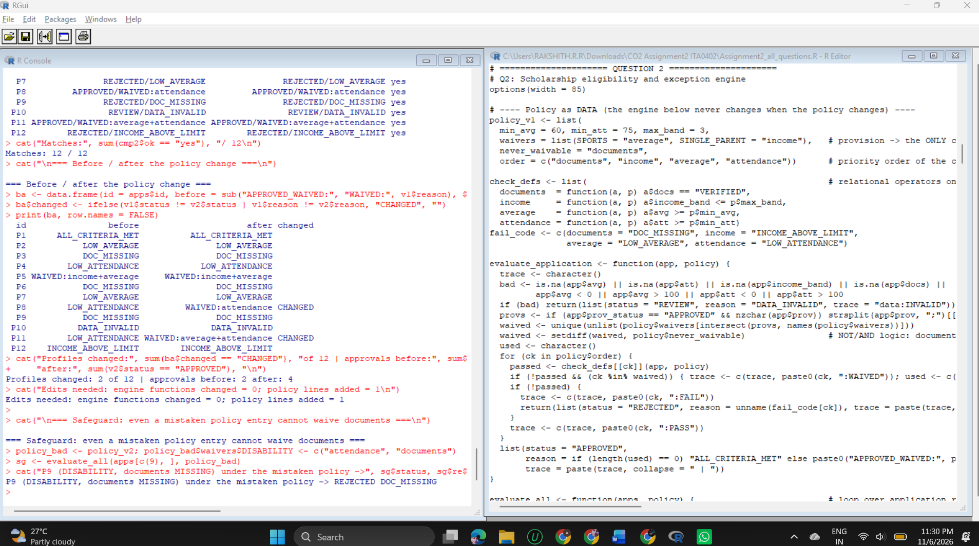
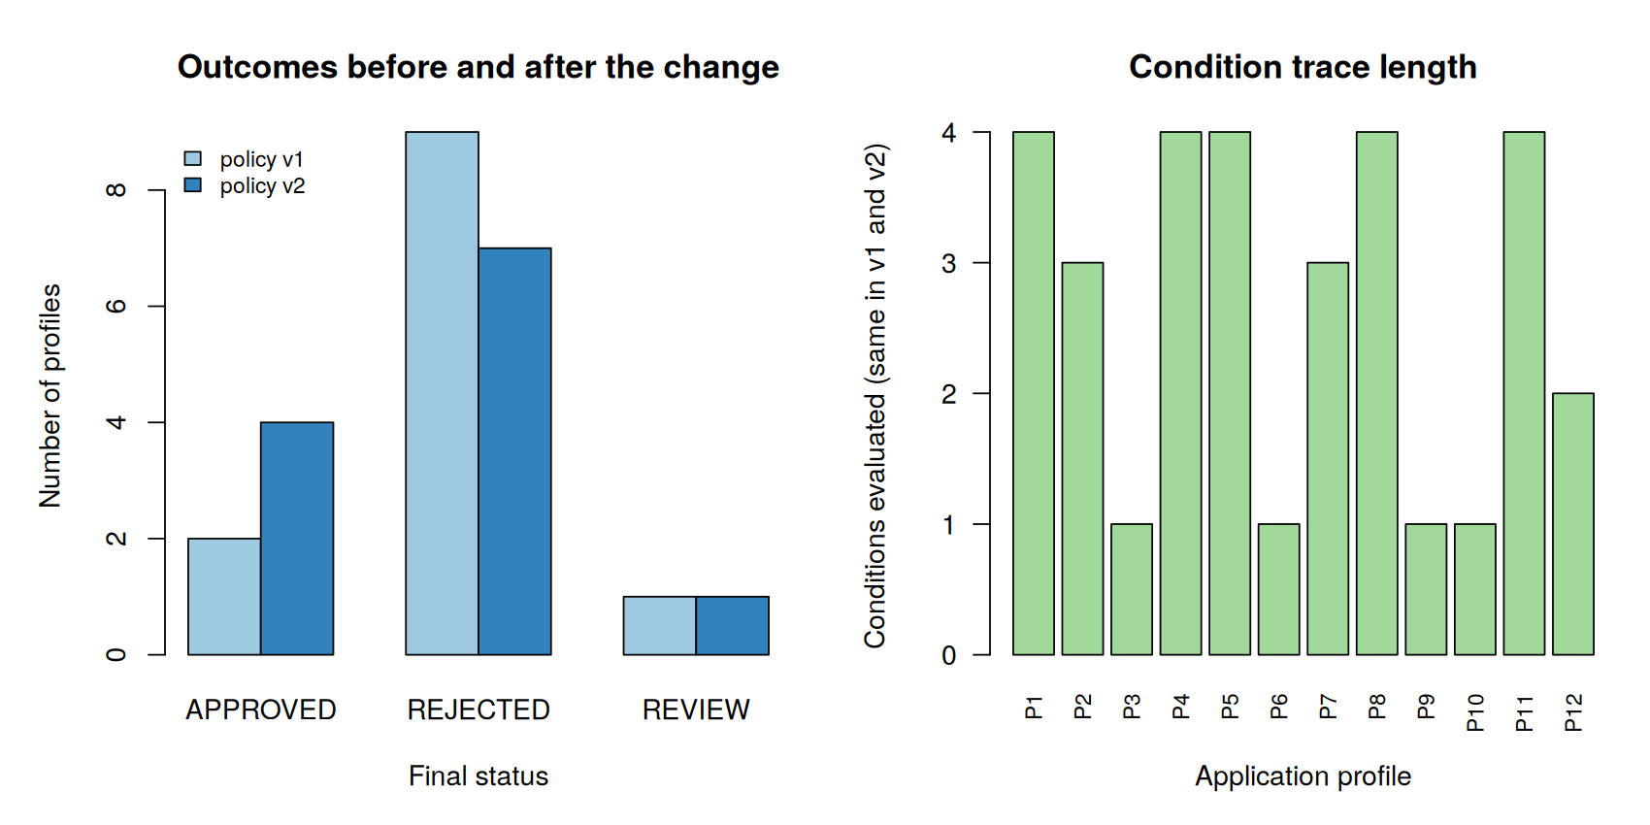
Figure 4: Left: outcomes before and after the policy change. Right: number of conditions evaluated per profile

2.4 Analysis
- Prediction versus observation: 12 of 12 for policy v1 and 12 of 12 for policy v2 (status and reason code both matched). Exact thresholds behaved as designed: P1 was approved and P2 and P4 were rejected by 0.01 and 0.1 respectively.
- Condition traces: each decision lists the checks in order (for example documents:PASS | income:PASS | average:WAIVED | attendance:FAIL). Evaluation stops at the first unwaived failure, so rejected profiles evaluate between 1 and 4 conditions.
- Effect of condition order (one prediction missed): moving documents last changed the reason code for P6 (DOC_MISSING became LOW_ATTENDANCE) and for P9 (DOC_MISSING became LOW_ATTENDANCE), and made P3 evaluate 4 conditions instead of 1. I predicted that P9 would keep DOC_MISSING; I had overlooked its attendance of 50, so my prediction was wrong and the observation is correct. In the engine the order never changes the final status, because every condition must pass.
- A badly ordered design does change the status: the flawed rule 'an approved provision approves the application at once' changed the status of 4 profiles (P3, P8, P9 and P11) from REJECTED to APPROVED, although two of them have missing documents and the other two fail the attendance rule. This is why provisions are applied as waivers on named conditions after the mandatory checks, not as a shortcut.
- Policy change: adding DISABILITY = "attendance" to the waiver table changed 2 of 12 profiles (P8 and P11) and raised approvals from 2 to 4. Engine functions changed: 0. Policy lines added: 1. P9 stayed REJECTED because its documents are missing.
- Safeguard test: a mistaken policy entry that lists documents as waivable for DISABILITY still left P9 REJECTED with DOC_MISSING.

2.5 Evaluation and limitations
- Only the first failed condition is reported. This is simple and fast, but an applicant who fails two conditions learns about them one at a time. A complete report would evaluate all checks and cost more conditions.
- REVIEW is used for invalid data so that a missing average is never read as a failure; a person must decide.
- Provision conflicts (two provisions competing for the same budget) are outside this policy and would need a ranking rule.

QUESTION 3 - Menu-Driven Order Analytics Utility (7 Marks)

3.1 Design
The utility analyses a vector of order amounts. Refunds are negative amounts, so total revenue is net (sales minus refunds). All missing-value and type handling sits in one helper, clean_amounts(), so no operation repeats it. Each operation is its own function, and a repeat loop with switch() selects them.
Option | Operation | Rule for unusual input
1 | Total revenue (net) | empty or all NA gives 0
2 / 3 | Mean / median order value | empty gives NA
4 | Range (min, max) | empty gives NA, NA
5 | Standard deviation | fewer than 2 values gives NA (undefined)
6 | Count of refunds (amounts below 0) | NA values are removed first
7 | Count above a threshold | threshold supplied by the caller
8 | Number of missing values | counts NA only
9 / 10 | Added later: total refund value / 10% trimmed mean | same helper, same rules
0 | Exit | also ends when scripted input runs out

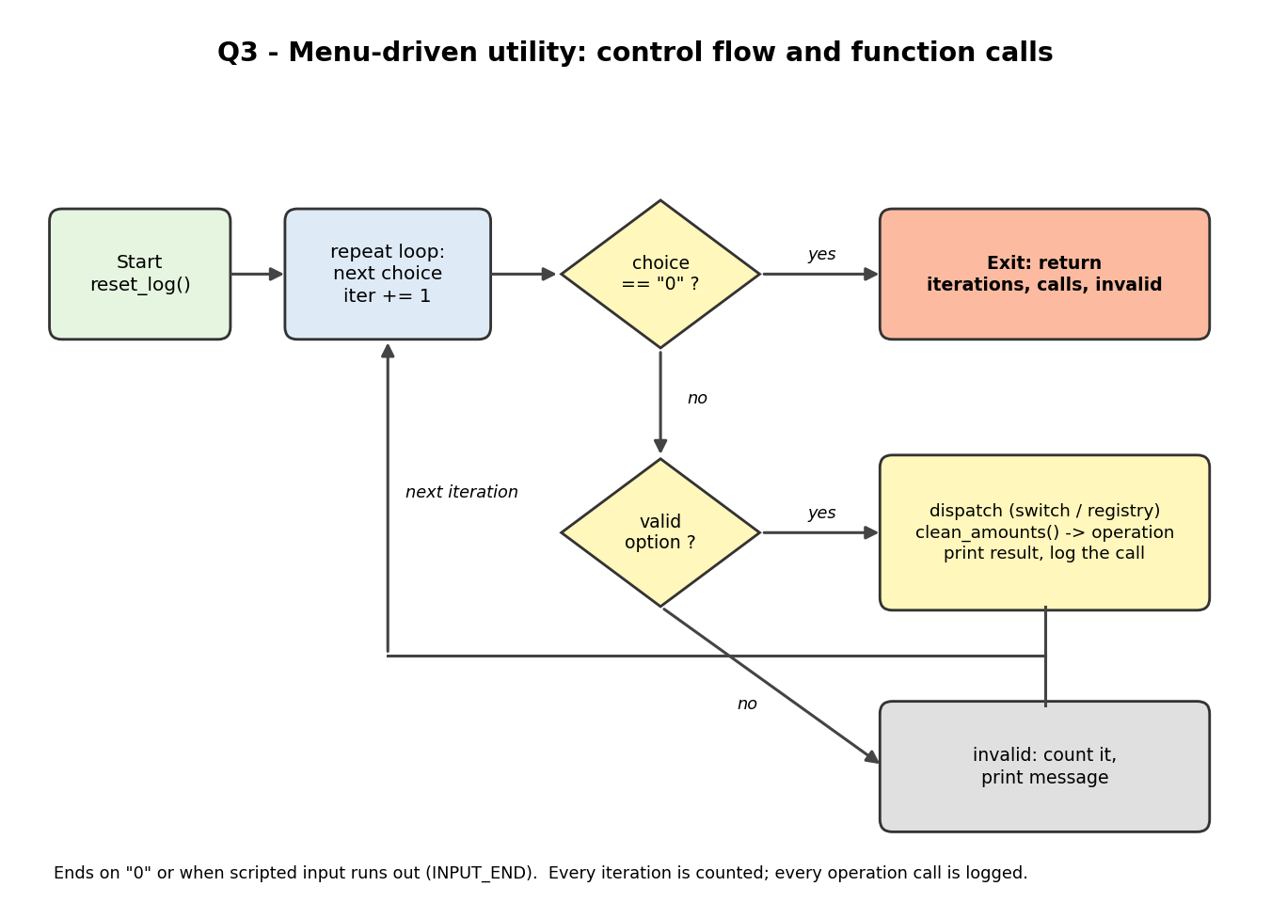
Figure 5: Menu control flow: repeat, read a choice, validate, dispatch, log

3.2 Predictions
Results for seven edge-case datasets (repeated identical amounts, refunds, an extreme outlier, missing values, one observation, empty input, all NA) and the path of four menu sessions were calculated by hand before running. Example: for the refunds dataset (100, -20, 50, -5, 30) the net total is 155, the mean 31, the median 30, the standard deviation sqrt(9020/4) = 47.4868, there are 2 refunds and 2 values above the threshold of 40.

3.3 Implementation
R code
# Q3: Menu-driven online order analytics utility
options(width = 85)

log_env <- new.env()
reset_log <- function() { log_env$calls <- character(); log_env$helper <- 0 }
reset_log()
log_call <- function(name) log_env$calls <- c(log_env$calls, name)

# ---- Shared helper: ALL missing-value / type handling lives here (no duplication) ----
clean_amounts <- function(x, na.rm = TRUE) {
log_env$helper <- log_env$helper + 1
if (!is.numeric(x)) stop("amounts must be numeric")
if (na.rm) x <- x[!is.na(x)]
x
}

# ---- Modular operations (net revenue: refunds are negative amounts and reduce the total) ----
total_revenue <- function(x, na.rm = TRUE) { log_call("total_revenue"); sum(clean_amounts(x, na.rm)) }
mean_order <- function(x, na.rm = TRUE) { log_call("mean_order"); v <- clean_amounts(x, na.rm); if (length(v) == 0) NA_real_ else mean(v) }
median_order <- function(x, na.rm = TRUE) { log_call("median_order"); v <- clean_amounts(x, na.rm); if (length(v) == 0) NA_real_ else median(v) }
order_range <- function(x, na.rm = TRUE) { log_call("order_range"); v <- clean_amounts(x, na.rm); if (length(v) == 0) c(NA_real_, NA_real_) else range(v) }
sd_order <- function(x, na.rm = TRUE) { log_call("sd_order"); v <- clean_amounts(x, na.rm); if (length(v) < 2) NA_real_ else sd(v) }
count_refunds <- function(x, na.rm = TRUE) { log_call("count_refunds"); sum(clean_amounts(x, na.rm) < 0) }
count_above <- function(x, thr, na.rm = TRUE) { log_call("count_above"); sum(clean_amounts(x, na.rm) > thr) }
count_missing <- function(x) { log_call("count_missing"); sum(is.na(x)) }

# ---- Menu, version 1: switch() selection ----
menu_labels_v1 <- c("1" = "Total revenue (net)", "2" = "Mean order value", "3" = "Median order value",
"4" = "Range", "5" = "Standard deviation", "6" = "Count of refunds",
"7" = "Count above threshold", "8" = "Number of missing values", "0" = "Exit")
dispatch_v1 <- function(choice, x, thr)
switch(choice, "1" = total_revenue(x), "2" = mean_order(x), "3" = median_order(x), "4" = order_range(x),
"5" = sd_order(x), "6" = count_refunds(x), "7" = count_above(x, thr), "8" = count_missing(x), NULL)

run_menu <- function(x, choices = NULL, thr = 40, dispatch = dispatch_v1, labels = menu_labels_v1, verbose = TRUE) {
reset_log(); iter <- 0; invalid <- 0; exit_reason <- "INPUT_END"; outputs <- list()
repeat { # loop for repeated menu requests
if (is.null(choices)) { ch <- readline("Choose an option: ") }
else { if (iter >= length(choices)) break; ch <- as.character(choices[iter + 1]) }
iter <- iter + 1
if (is.na(ch) || !nzchar(ch)) { invalid <- invalid + 1; if (verbose) cat("[", iter, "] invalid (empty)\n"); next }
if (ch == "0") { exit_reason <- "USER_EXIT"; if (verbose) cat("[", iter, "] exit\n"); break }
res <- dispatch(ch, x, thr)
if (is.null(res)) { invalid <- invalid + 1; if (verbose) cat("[", iter, "] invalid option:", ch, "\n"); next }
outputs[[length(outputs) + 1]] <- res
if (verbose) cat("[", iter, "]", labels[ch], "->", paste(round(res, 4), collapse = " "), "\n")
}
list(iterations = iter, invalid = invalid, calls = log_env$calls, helper_calls = log_env$helper,
exit = exit_reason, outputs = outputs)
}

# ---- Edge-case datasets with PREDICTED results (hand-calculated before running; threshold = 40) ----
ds <- list(
repeated = c(50, 50, 50, 50),
refunds = c(100, -20, 50, -5, 30),
outliers = c(20, 25, 22, 24, 5000),
missing = c(10, NA, 30, NA, 50),
one_obs = c(75),
empty = numeric(0),
all_na = c(NA_real_, NA_real_))
pred <- list( # total, mean, median, min, max, sd, refunds, above 40, missing
repeated = c(200, 50, 50, 50, 50, 0, 0, 4, 0),
refunds = c(155, 31, 30, -20, 100, 47.4868, 2, 2, 0),
outliers = c(5091, 1018.2, 24, 20, 5000, 2225.9, 0, 1, 0),
missing = c(90, 30, 30, 10, 50, 20, 0, 1, 2),
one_obs = c(75, 75, 75, 75, 75, NA, 0, 1, 0),
empty = c(0, NA, NA, NA, NA, NA, 0, 0, 0),
all_na = c(0, NA, NA, NA, NA, NA, 0, 0, 2))
obs_row <- function(x) { r <- order_range(x); c(total_revenue(x), mean_order(x), median_order(x), r[1], r[2],
sd_order(x), count_refunds(x), count_above(x, 40), count_missing(x)) }
op_names <- c("total", "mean", "median", "min", "max", "sd", "refunds", ">40", "missing")
cat("=== Predicted vs observed results for 7 edge-case datasets (9 values each) ===\n")
tab <- do.call(rbind, lapply(names(ds), function(nm) {
o <- obs_row(ds[[nm]]); p <- pred[[nm]]
same <- (is.na(o) & is.na(p)) | (!is.na(o) & !is.na(p) & abs(o - p) <= 0.05)
data.frame(dataset = nm, matched = sum(same), of = 9, mismatches = if (all(same)) "-" else paste(op_names[!same], collapse = ","))
}))
print(tab, row.names = FALSE)
cat("Total matched:", sum(tab$matched), "of", sum(tab$of), "\n")
cat("\nDetail for the refunds dataset (observed): "); print(round(setNames(obs_row(ds$refunds), op_names), 4))
cat("Detail for the outliers dataset (observed): "); print(round(setNames(obs_row(ds$outliers), op_names), 2))
cat("Observed vs predicted for empty / one-observation / all-NA inputs follow the documented rules:\n")
print(rbind(empty = setNames(obs_row(ds$empty), op_names), one_obs = setNames(obs_row(ds$one_obs), op_names),
all_na = setNames(obs_row(ds$all_na), op_names)))
bad <- tryCatch(total_revenue(c("a", "b")), error = function(e) conditionMessage(e))
cat("\nNon-numeric input -> error:", bad, "\n")

# ---- Menu sessions: predicted path vs observed ----
cat("\n=== Menu sessions (predicted before running) ===\n")
sessA <- c("1", "3", "x", "5", "", "0")
cat("Session A:", paste(shQuote(sessA), collapse = " "), "\n")
rA <- run_menu(ds$refunds, sessA)
cat("Predicted: iterations 6, calls 3 (total_revenue, median_order, sd_order), invalid 2, exit USER_EXIT\n")
cat("Observed : iterations", rA$iterations, ", calls", length(rA$calls), "(", paste(rA$calls, collapse = ", "), "), invalid", rA$invalid, ", exit", rA$exit, "\n")
sessB <- c("9", "10", "0")
cat("\nSession B before extension:", paste(shQuote(sessB), collapse = " "), "\n")
rB <- run_menu(ds$refunds, sessB)
cat("Predicted: iterations 3, calls 0, invalid 2\n")
cat("Observed : iterations", rB$iterations, ", calls", length(rB$calls), ", invalid", rB$invalid, "\n")
sessC <- c("2", "6")
cat("\nSession C (no exit option typed):\n")
rC <- run_menu(ds$missing, sessC)
cat("Predicted: iterations 2, calls 2, exit INPUT_END\n")
cat("Observed : iterations", rC$iterations, ", calls", length(rC$calls), ", exit", rC$exit, "\n")
sessD <- c("-1", "2.5", "abc", "08", " ")
rD <- run_menu(ds$repeated, sessD, verbose = FALSE)
cat("\nSession D invalid-only", paste(shQuote(sessD), collapse = " "), ": predicted invalid 5, calls 0; observed invalid", rD$invalid, ", calls", length(rD$calls), "\n")

# ---- Extension: add two operations and evaluate duplication ----
cat("\n=== Extension: two new operations (9 refund value, 10 trimmed mean) ===\n")
refund_value <- function(x, na.rm = TRUE) { log_call("refund_value"); v <- clean_amounts(x, na.rm); sum(v[v < 0]) }
trimmed_mean <- function(x, na.rm = TRUE, trim = 0.1) { log_call("trimmed_mean"); v <- clean_amounts(x, na.rm); if (length(v) == 0) NA_real_ else mean(v, trim = trim) }
before_lines <- length(deparse(dispatch_v1)) + length(menu_labels_v1)
dispatch_v1b <- function(choice, x, thr)
switch(choice, "1" = total_revenue(x), "2" = mean_order(x), "3" = median_order(x), "4" = order_range(x),
"5" = sd_order(x), "6" = count_refunds(x), "7" = count_above(x, thr), "8" = count_missing(x),
"9" = refund_value(x), "10" = trimmed_mean(x), NULL)
labels_v1b <- c(menu_labels_v1, "9" = "Total refund value", "10" = "Trimmed mean (10%)")
cat("Places edited per new operation in the switch design: 3 (function, switch case, menu label)\n")
rB2 <- run_menu(ds$refunds, sessB, dispatch = dispatch_v1b, labels = labels_v1b)
cat("Session B after extension -> iterations", rB2$iterations, ", calls", length(rB2$calls), ", invalid", rB2$invalid, "\n")

# ---- Maintainability v2: registry-driven menu (the loop and dispatcher never change) ----
registry <- list(
"1" = list(label = "Total revenue (net)", fun = function(x, thr) total_revenue(x)),
"2" = list(label = "Mean order value", fun = function(x, thr) mean_order(x)),
"3" = list(label = "Median order value", fun = function(x, thr) median_order(x)),
"4" = list(label = "Range", fun = function(x, thr) order_range(x)),
"5" = list(label = "Standard deviation", fun = function(x, thr) sd_order(x)),
"6" = list(label = "Count of refunds", fun = function(x, thr) count_refunds(x)),
"7" = list(label = "Count above threshold", fun = function(x, thr) count_above(x, thr)),
"8" = list(label = "Number of missing values", fun = function(x, thr) count_missing(x)),
"9" = list(label = "Total refund value", fun = function(x, thr) refund_value(x)),
"10" = list(label = "Trimmed mean (10%)", fun = function(x, thr) trimmed_mean(x)))
dispatch_reg <- function(choice, x, thr) { e <- registry[[choice]]; if (is.null(e)) NULL else e$fun(x, thr) }
labels_reg <- c(setNames(sapply(registry, function(e) e$label), names(registry)), "0" = "Exit")
same <- sapply(names(ds), function(nm) {
a <- run_menu(ds[[nm]], as.character(1:10), dispatch = dispatch_v1b, labels = labels_v1b, verbose = FALSE)$outputs
b <- run_menu(ds[[nm]], as.character(1:10), dispatch = dispatch_reg, labels = labels_reg, verbose = FALSE)$outputs
isTRUE(all.equal(a, b)) })
cat("Registry menu gives identical outputs for all 10 operations on all 7 datasets:", all(same), "\n")
registry[["11"]] <- list(label = "Largest order", fun = function(x, thr) { log_call("max_order"); max(clean_amounts(x)) })
r11 <- run_menu(ds$refunds, c("11", "0"), dispatch = dispatch_reg, labels = c(labels_reg, "11" = "Largest order"))
cat("Adding operation 11 to the registry: 1 registry entry, 0 changes to run_menu() or dispatch_reg(); result:", r11$outputs[[1]], "\n")

ops <- list(total_revenue, mean_order, median_order, order_range, sd_order, count_refunds, count_above, count_missing, refund_value, trimmed_mean)
nm <- c("total_revenue", "mean_order", "median_order", "order_range", "sd_order", "count_refunds", "count_above", "count_missing", "refund_value", "trimmed_mean")
src <- sapply(ops, function(f) paste(deparse(f), collapse = " "))
dup <- data.frame(operation = nm, uses_clean_amounts = grepl("clean_amounts\\(", src), own_is_na_handling = grepl("is\\.na", src),
own_empty_check = grepl("length\\(v\\)", src))
print(dup, row.names = FALSE)
cat("Operations with their own NA-handling code:", sum(dup$own_is_na_handling), "(count_missing needs is.na by definition)\n")

# ---- Session with call and iteration log ----
set.seed(5)
long <- c(sample(as.character(1:8), 25, TRUE), "x", "99", "0")
rL <- run_menu(ds$refunds, long, verbose = FALSE)
cat("\nLong scripted session: iterations =", rL$iterations, "| operation calls =", length(rL$calls),
"| invalid =", rL$invalid, "| helper (clean_amounts) calls =", rL$helper_calls, "| exit =", rL$exit, "\n")
cc <- table(factor(rL$calls, levels = c("total_revenue", "mean_order", "median_order", "order_range", "sd_order", "count_refunds", "count_above", "count_missing")))
print(cc)
png("fig/fig_q3_calls.png", width = 1700, height = 850, res = 170)
par(mar = c(8, 5, 4, 1))
barplot(cc, las = 2, col = "#6baed6", ylab = "Function calls", main = "Function calls in a 28-iteration scripted session", cex.names = 0.8)
dev.off()

Output (captured from running the code above)
=== Predicted vs observed results for 7 edge-case datasets (9 values each) ===
dataset matched of mismatches
repeated 9 9 -
refunds 9 9 -
outliers 9 9 -
missing 9 9 -
one_obs 9 9 -
empty 9 9 -
all_na 9 9 -
Total matched: 63 of 63

Detail for the refunds dataset (observed): total mean median min max sd refunds >40 missing
155.0000 31.0000 30.0000 -20.0000 100.0000 47.4868 2.0000 2.0000 0.0000
Detail for the outliers dataset (observed): total mean median min max sd refunds >40 missing
5091.00 1018.20 24.00 20.00 5000.00 2225.89 0.00 1.00 0.00
Observed vs predicted for empty / one-observation / all-NA inputs follow the documented rules:
total mean median min max sd refunds >40 missing
empty 0 NA NA NA NA NA 0 0 0
one_obs 75 75 75 75 75 NA 0 1 0
all_na 0 NA NA NA NA NA 0 0 2

Non-numeric input -> error: amounts must be numeric

=== Menu sessions (predicted before running) ===
Session A: '1' '3' 'x' '5' '' '0'
[ 1 ] Total revenue (net) -> 155
[ 2 ] Median order value -> 30
[ 3 ] invalid option: x
[ 4 ] Standard deviation -> 47.4868
[ 5 ] invalid (empty)
[ 6 ] exit
Predicted: iterations 6, calls 3 (total_revenue, median_order, sd_order), invalid 2, exit USER_EXIT
Observed : iterations 6 , calls 3 ( total_revenue, median_order, sd_order ), invalid 2 , exit USER_EXIT

Session B before extension: '9' '10' '0'
[ 1 ] invalid option: 9
[ 2 ] invalid option: 10
[ 3 ] exit
Predicted: iterations 3, calls 0, invalid 2
Observed : iterations 3 , calls 0 , invalid 2

Session C (no exit option typed):
[ 1 ] Mean order value -> 30
[ 2 ] Count of refunds -> 0
Predicted: iterations 2, calls 2, exit INPUT_END
Observed : iterations 2 , calls 2 , exit INPUT_END

Session D invalid-only '-1' '2.5' 'abc' '08' ' ' : predicted invalid 5, calls 0; observed invalid 5 , calls 0

=== Extension: two new operations (9 refund value, 10 trimmed mean) ===
Places edited per new operation in the switch design: 3 (function, switch case, menu label)
[ 1 ] Total refund value -> -25
[ 2 ] Trimmed mean (10%) -> 31
[ 3 ] exit
Session B after extension -> iterations 3 , calls 2 , invalid 0
Registry menu gives identical outputs for all 10 operations on all 7 datasets: TRUE
[ 1 ] Largest order -> 100
[ 2 ] exit
Adding operation 11 to the registry: 1 registry entry, 0 changes to run_menu() or dispatch_reg(); result: 100
operation uses_clean_amounts own_is_na_handling own_empty_check
total_revenue TRUE FALSE FALSE
mean_order TRUE FALSE TRUE
median_order TRUE FALSE TRUE
order_range TRUE FALSE TRUE
sd_order TRUE FALSE TRUE
count_refunds TRUE FALSE FALSE
count_above TRUE FALSE FALSE
count_missing FALSE TRUE FALSE
refund_value TRUE FALSE FALSE
trimmed_mean TRUE FALSE TRUE
Operations with their own NA-handling code: 1 (count_missing needs is.na by definition)

Long scripted session: iterations = 28 | operation calls = 25 | invalid = 2 | helper (clean_amounts) calls = 23 | exit = USER_EXIT

total_revenue mean_order median_order order_range sd_order count_refunds
4 3 5 1 3 3
count_above count_missing
4 2
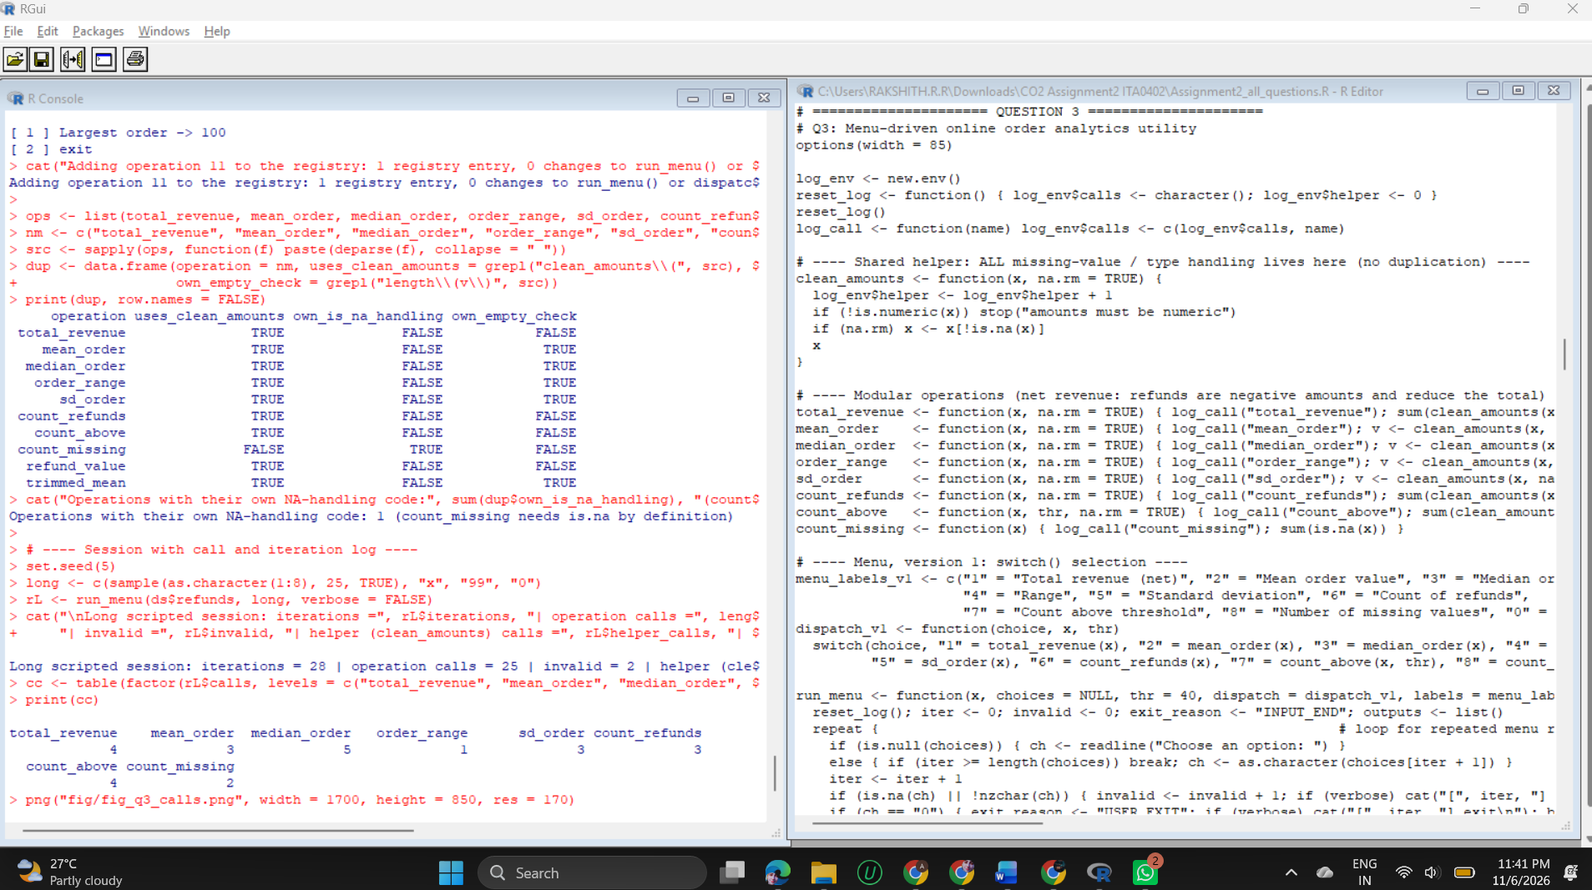
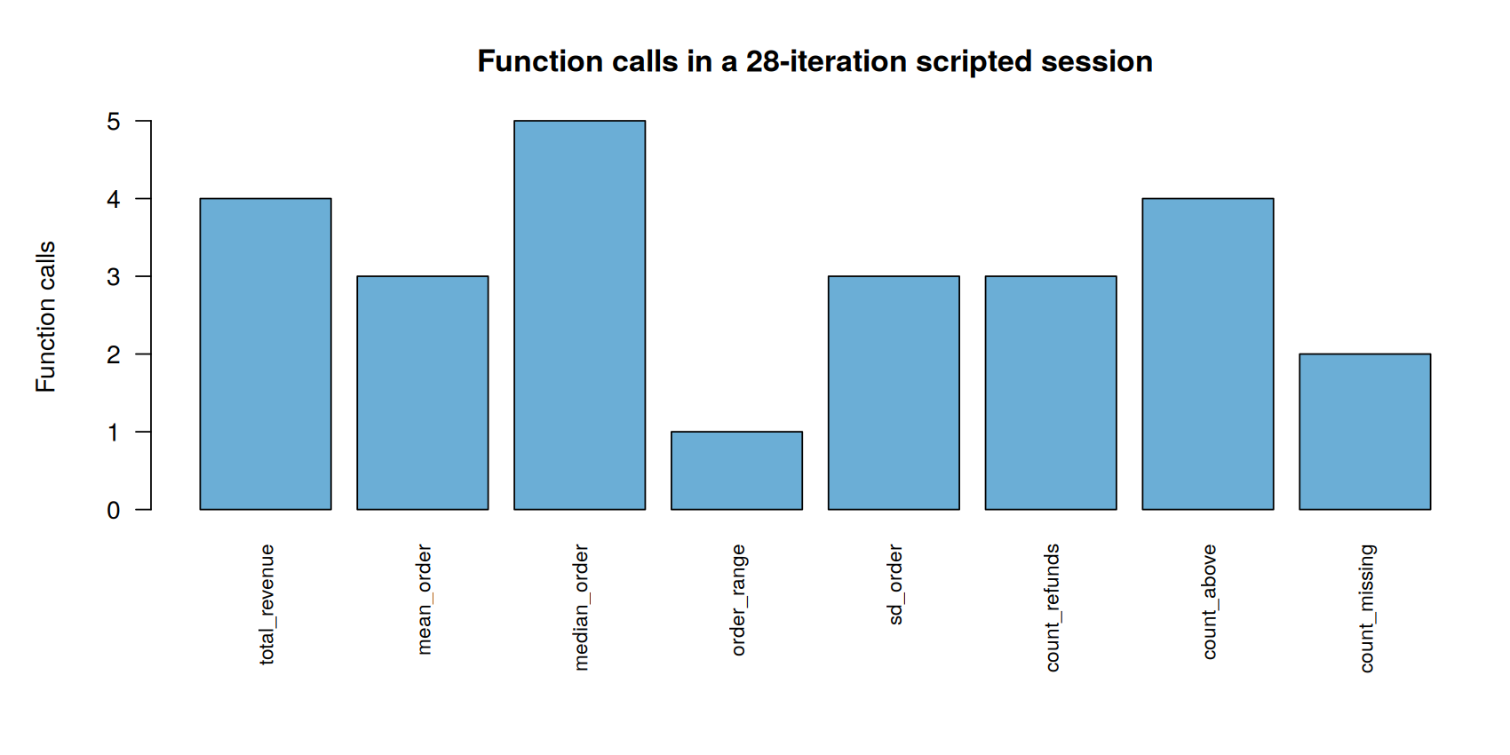
Figure 6: Function calls recorded in a scripted session of 28 menu iterations

3.4 Analysis
- Prediction versus observation: 63 of 63 statistics matched (7 datasets x 9 values) and all four menu sessions matched. For the outlier dataset the mean (1,018.2) is far above the median (24), and the standard deviation (2,225.9) shows the outlier's influence.
- Session counts: session A (1 3 x 5 (blank) 0) made 6 iterations, 3 function calls and 2 invalid entries, and ended by user exit; session C ended by input exhaustion after 2 calls; session D (-1, 2.5, abc, 08, blank) was 5 invalid entries and 0 calls. A longer session of 28 iterations produced 25 operation calls, 2 invalid entries and 23 calls of the shared helper (the 2 count_missing calls do not use it).
- Invalid input: an unknown option, empty text or a non-numeric string never stops the loop; it is counted and the menu continues. Non-numeric amounts stop with a clear error (amounts must be numeric).
- Edge cases are documented, not accidental: an empty vector gives total 0 but mean NA, because an average of nothing is undefined; one observation gives standard deviation NA for the same reason.

3.5 Extension and duplication evaluation
Design | Places to edit for one new operation | Evidence
switch() version (v1) | 3: the function, a case in switch(), a label in the menu text | Two new operations (9 and 10) needed 6 edits; before the edit, options 9 and 10 were invalid (2 invalid, 0 calls); after it they ran (0 invalid, 2 calls)
Registry version (v2) | 1: one entry holding the label and the function | Identical outputs for all 10 operations on all 7 datasets; an 11th operation (largest order) was added as 1 entry with no change to run_menu() or dispatch_reg()

- Duplication check: 9 of 10 operations use clean_amounts() and none repeats the NA-removal code; only count_missing has its own is.na call, which is its definition.
- Remaining duplication: five functions (mean, median, range, standard deviation, trimmed mean) each repeat the 'empty or too few values' rule. A further step would move that rule into a second helper.

QUESTION 4 - Iterative Package-Length Validation (6 Marks)

4.1 Design
A reading is valid when it lies in 1.0 to 120.0 cm inclusive. Sensors may retransmit, so up to 3 attempts are allowed. The routine must distinguish a package that was corrected (an invalid reading followed by a valid one) from one that was rejected (no valid reading within the limit or no data left).
Disposition | Meaning
ACCEPTED | first reading valid; later retransmissions are ignored as duplicates
ACCEPTED_AFTER_CORRECTION | a valid reading arrived after one or two invalid ones
REJECTED_RETRY_LIMIT | three invalid readings used up the attempts, even if a valid reading follows
REJECTED_NO_DATA | the readings ran out before three attempts (including an empty sequence)

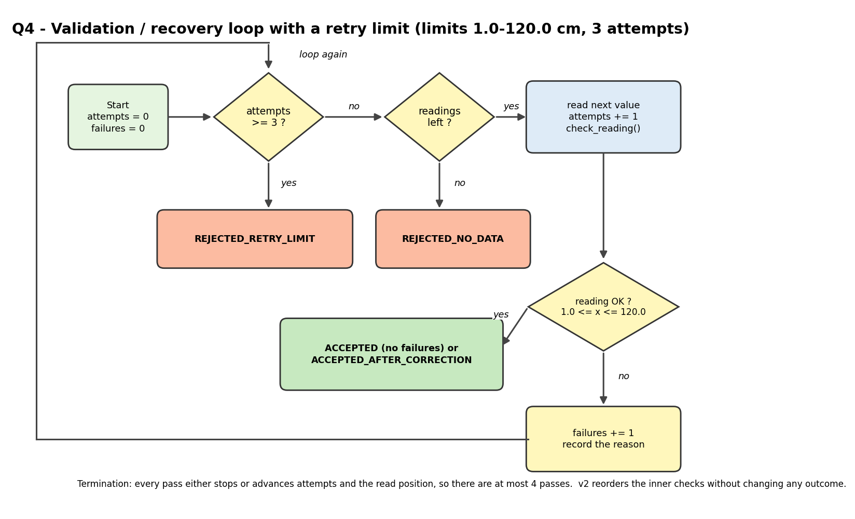
Figure 7: The `while` loop with its retry limit and the four dispositions
Termination. Every pass either sets a final status or advances the read position and the attempt counter, so the loop runs at most 4 passes (3 attempts plus one pass that detects the limit or the end of data).
Two check orders. Version 1 tests missing, blank, numeric, lower limit, upper limit. Version 2 parses once, tests the valid case first (!is.na, >= 1.0, <= 120.0) and classifies the failure reason only when needed. Both must give identical outcomes; they may differ in condition evaluations.

4.2 Test sequences and predictions
Eleven sequences were predicted (status, attempts, failures) before running: valid first reading; invalid then valid; both endpoints 1.0 and 120.0; 0.99 and 120.01 followed by 120.0 (accepted on the last allowed attempt); an alternating stream; repeated missing or non-numeric readings with a valid fourth reading; missing only; empty; duplicates; and a numeric failure at the limit.

4.3 Implementation
R code
# Q4: Iterative package-length validation routine
options(width = 85)
set.seed(44)
LO <- 1.0; HI <- 120.0; MAX_ATTEMPTS <- 3 # declared limits and retry policy
# Final dispositions: ACCEPTED, ACCEPTED_AFTER_CORRECTION, REJECTED_RETRY_LIMIT, REJECTED_NO_DATA

ev <- new.env(); ev$n <- 0
ck <- function(cond) { ev$n <- ev$n + 1; cond } # counts each condition evaluated

# Version 1: missing -> blank -> numeric -> lower limit -> upper limit
check_v1 <- function(raw, lo = LO, hi = HI) {
if (ck(is.na(raw))) return("MISSING")
if (ck(!nzchar(trimws(as.character(raw))))) return("MISSING")
num <- suppressWarnings(as.numeric(raw))
if (ck(is.na(num))) return("NON_NUMERIC")
if (ck(num < lo)) return("BELOW_MIN")
if (ck(num > hi)) return("ABOVE_MAX")
"OK"
}
# Version 2: parse once, test the common (valid) case first, classify the reason only on failure
check_v2 <- function(raw, lo = LO, hi = HI) {
num <- suppressWarnings(as.numeric(raw))
if (ck(!is.na(num)) && ck(num >= lo) && ck(num <= hi)) return("OK")
if (ck(!is.na(num))) return(if (ck(num < lo)) "BELOW_MIN" else "ABOVE_MAX")
if (ck(is.na(raw)) || ck(!nzchar(trimws(as.character(raw))))) "MISSING" else "NON_NUMERIC"
}

validate_sequence <- function(readings, checker, max_attempts = MAX_ATTEMPTS) {
stopifnot(max_attempts >= 1, LO < HI)
ev$n <- 0
attempts <- 0; failures <- 0; i <- 1; passes <- 0; status <- NA_character_; value <- NA_real_
reasons <- character()
while (is.na(status)) { # terminates: i and attempts increase every pass
passes <- passes + 1
if (attempts >= max_attempts) { status <- "REJECTED_RETRY_LIMIT"; next }
if (i > length(readings)) { status <- "REJECTED_NO_DATA"; next }
raw <- readings[[i]]; i <- i + 1; attempts <- attempts + 1
r <- checker(raw)
if (r == "OK") {
value <- as.numeric(raw)
status <- if (failures == 0) "ACCEPTED" else "ACCEPTED_AFTER_CORRECTION"
} else { failures <- failures + 1; reasons <- c(reasons, r) }
}
list(status = status, attempts = attempts, failures = failures, passes = passes,
unread = length(readings) - (i - 1), evals = ev$n, value = value, reasons = reasons)
}

# ---- Eleven test sequences with PREDICTIONS (status, attempts, failures) written before running ----
seqs <- list(
S1_valid_first = list("45.5"),
S2_invalid_valid = list(150, 80),
S3a_low_endpoint = list(1.0),
S3b_high_endpoint = list(120.0),
S3c_edges_then_ok = list(0.99, 120.01, 120.0),
S4_alternating = list("x", 60, "y", 70),
S5a_repeat_bad = list(NA, "", "abc", "5"),
S5b_missing_only = list(NA, NA),
S6_empty = list(),
S7_duplicates = list(42, 42, 42),
S8_limit_numeric = list(0, 130, "abc", 50))
pred <- data.frame(seq = names(seqs),
status = c("ACCEPTED", "ACCEPTED_AFTER_CORRECTION", "ACCEPTED", "ACCEPTED", "ACCEPTED_AFTER_CORRECTION",
"ACCEPTED_AFTER_CORRECTION", "REJECTED_RETRY_LIMIT", "REJECTED_NO_DATA", "REJECTED_NO_DATA",
"ACCEPTED", "REJECTED_RETRY_LIMIT"),
attempts = c(1, 2, 1, 1, 3, 2, 3, 2, 0, 1, 3),
failures = c(0, 1, 0, 0, 2, 1, 3, 2, 0, 0, 3), stringsAsFactors = FALSE)

obs1 <- lapply(seqs, validate_sequence, checker = check_v1)
obs2 <- lapply(seqs, validate_sequence, checker = check_v2)
cmp <- data.frame(seq = names(seqs),
pred = paste(sub("ACCEPTED_AFTER_CORRECTION", "ACC_CORR", sub("REJECTED_", "REJ_", pred$status)), pred$attempts, pred$failures, sep = " "),
obs = sapply(obs1, function(o) paste(sub("ACCEPTED_AFTER_CORRECTION", "ACC_CORR", sub("REJECTED_", "REJ_", o$status)), o$attempts, o$failures)),
stringsAsFactors = FALSE, row.names = NULL)
cmp$ok <- ifelse(cmp$pred == cmp$obs, "yes", "NO")
cat("=== Prediction vs observation (status attempts failures; ACC_CORR = accepted after correction) ===\n")
print(cmp, row.names = FALSE)
cat("Matches:", sum(cmp$ok == "yes"), "of", nrow(cmp), "\n")

cat("\n=== Measured iterations and condition evaluations (v1 = original order, v2 = redesigned) ===\n")
m <- data.frame(seq = names(seqs), attempts = sapply(obs1, `[[`, "attempts"), loop_passes = sapply(obs1, `[[`, "passes"),
unread = sapply(obs1, `[[`, "unread"), evals_v1 = sapply(obs1, `[[`, "evals"), evals_v2 = sapply(obs2, `[[`, "evals"), row.names = NULL)
print(m, row.names = FALSE)
cat("Totals: attempts =", sum(m$attempts), "| loop passes =", sum(m$loop_passes), "| evaluations v1 =", sum(m$evals_v1), "| v2 =", sum(m$evals_v2), "\n")
same_out <- all(mapply(function(a, b) identical(a$status, b$status) && a$attempts == b$attempts && a$failures == b$failures &&
identical(a$reasons, b$reasons), obs1, obs2))
cat("v1 and v2 give identical status, attempts, failures and failure reasons on all 11 sequences:", same_out, "\n")
cat("Failure reasons recorded (v1):\n")
for (nm in names(seqs)) if (length(obs1[[nm]]$reasons)) cat(sprintf(" %-18s %s\n", nm, paste(obs1[[nm]]$reasons, collapse = ", ")))

cat("\n=== Evaluations per single reading, by reading type ===\n")
types <- list(valid = "50", NA_value = NA, blank = "", text = "abc", below = 0.5, above = 200)
per <- data.frame(reading = names(types), v1 = NA_integer_, v2 = NA_integer_, same_result = NA)
for (k in seq_along(types)) {
ev$n <- 0; r1 <- check_v1(types[[k]]); per$v1[k] <- ev$n
ev$n <- 0; r2 <- check_v2(types[[k]]); per$v2[k] <- ev$n
per$same_result[k] <- r1 == r2
}
per$saving <- per$v1 - per$v2
print(per, row.names = FALSE)

cat("\n=== Simulation: 5,000 sequences per invalid-rate (up to 4 readings each) ===\n")
make_reading <- function(p) {
if (runif(1) >= p) return(round(runif(1, LO, HI), 1))
switch(sample(5, 1, prob = c(.25, .15, .20, .20, .20)), NA, "", "abc", round(runif(1, -20, LO - 0.1), 1), round(runif(1, HI + 0.1, 300), 1))
}
rates <- c(0, 0.05, 0.1, 0.2, 0.4, 0.6, 0.8, 0.9, 0.95)
sim <- do.call(rbind, lapply(rates, function(p) {
e1 <- e2 <- att <- 0; agree <- TRUE
for (s in 1:5000) {
rd <- replicate(4, make_reading(p), simplify = FALSE)
a <- validate_sequence(rd, check_v1); b <- validate_sequence(rd, check_v2)
e1 <- e1 + a$evals; e2 <- e2 + b$evals; att <- att + a$attempts
if (a$status != b$status || a$attempts != b$attempts || a$failures != b$failures) agree <- FALSE
}
data.frame(invalid_rate = p, evals_per_attempt_v1 = round(e1 / att, 3), evals_per_attempt_v2 = round(e2 / att, 3), outcomes_identical = agree)
}))
print(sim, row.names = FALSE)
cat("Rate at which v2 stops being cheaper (interpolated):",
round(approx(sim$evals_per_attempt_v2 - sim$evals_per_attempt_v1, sim$invalid_rate, xout = 0)$y, 2), "\n")

png("fig/fig_q4_evals.png", width = 1700, height = 900, res = 170)
par(mar = c(5, 5, 4, 1))
plot(sim$invalid_rate, sim$evals_per_attempt_v1, type = "b", pch = 16, col = "#3182bd", ylim = c(2.5, 5), lwd = 2,
xlab = "Probability that a reading is invalid", ylab = "Condition evaluations per reading",
main = "Validation order: v1 (original) vs v2 (redesigned)")
lines(sim$invalid_rate, sim$evals_per_attempt_v2, type = "b", pch = 17, col = "#e6550d", lwd = 2)
legend("topright", legend = c("v1 missing > blank > numeric > range", "v2 parse once, valid case first"), col = c("#3182bd", "#e6550d"), pch = c(16, 17), lwd = 2, bty = "n", cex = 0.85)
dev.off()

Output (captured from running the code above)
=== Prediction vs observation (status attempts failures; ACC_CORR = accepted after correction) ===
seq pred obs ok
S1_valid_first ACCEPTED 1 0 ACCEPTED 1 0 yes
S2_invalid_valid ACC_CORR 2 1 ACC_CORR 2 1 yes
S3a_low_endpoint ACCEPTED 1 0 ACCEPTED 1 0 yes
S3b_high_endpoint ACCEPTED 1 0 ACCEPTED 1 0 yes
S3c_edges_then_ok ACC_CORR 3 2 ACC_CORR 3 2 yes
S4_alternating ACC_CORR 2 1 ACC_CORR 2 1 yes
S5a_repeat_bad REJ_RETRY_LIMIT 3 3 REJ_RETRY_LIMIT 3 3 yes
S5b_missing_only REJ_NO_DATA 2 2 REJ_NO_DATA 2 2 yes
S6_empty REJ_NO_DATA 0 0 REJ_NO_DATA 0 0 yes
S7_duplicates ACCEPTED 1 0 ACCEPTED 1 0 yes
S8_limit_numeric REJ_RETRY_LIMIT 3 3 REJ_RETRY_LIMIT 3 3 yes
Matches: 11 of 11

=== Measured iterations and condition evaluations (v1 = original order, v2 = redesigned) ===
seq attempts loop_passes unread evals_v1 evals_v2
S1_valid_first 1 1 0 5 3
S2_invalid_valid 2 2 0 10 8
S3a_low_endpoint 1 1 0 5 3
S3b_high_endpoint 1 1 0 5 3
S3c_edges_then_ok 3 3 0 14 12
S4_alternating 2 2 2 8 7
S5a_repeat_bad 3 4 1 6 11
S5b_missing_only 2 3 0 2 6
S6_empty 0 1 0 0 0
S7_duplicates 1 1 2 5 3
S8_limit_numeric 3 4 1 12 13
Totals: attempts = 19 | loop passes = 23 | evaluations v1 = 72 | v2 = 69
v1 and v2 give identical status, attempts, failures and failure reasons on all 11 sequences: TRUE
Failure reasons recorded (v1):
S2_invalid_valid ABOVE_MAX
S3c_edges_then_ok BELOW_MIN, ABOVE_MAX
S4_alternating NON_NUMERIC
S5a_repeat_bad MISSING, MISSING, NON_NUMERIC
S5b_missing_only MISSING, MISSING
S8_limit_numeric BELOW_MIN, ABOVE_MAX, NON_NUMERIC

=== Evaluations per single reading, by reading type ===
reading v1 v2 same_result saving
valid 5 3 TRUE 2
NA_value 1 3 TRUE -2
blank 2 4 TRUE -2
text 3 4 TRUE -1
below 4 4 TRUE 0
above 5 5 TRUE 0

=== Simulation: 5,000 sequences per invalid-rate (up to 4 readings each) ===
invalid_rate evals_per_attempt_v1 evals_per_attempt_v2 outcomes_identical
0.00 5.000 3.000 TRUE
0.05 4.904 3.047 TRUE
0.10 4.800 3.093 TRUE
0.20 4.594 3.189 TRUE
0.40 4.191 3.371 TRUE
0.60 3.802 3.579 TRUE
0.80 3.356 3.759 TRUE
0.90 3.159 3.863 TRUE
0.95 3.061 3.908 TRUE
Rate at which v2 stops being cheaper (interpolated): 0.67
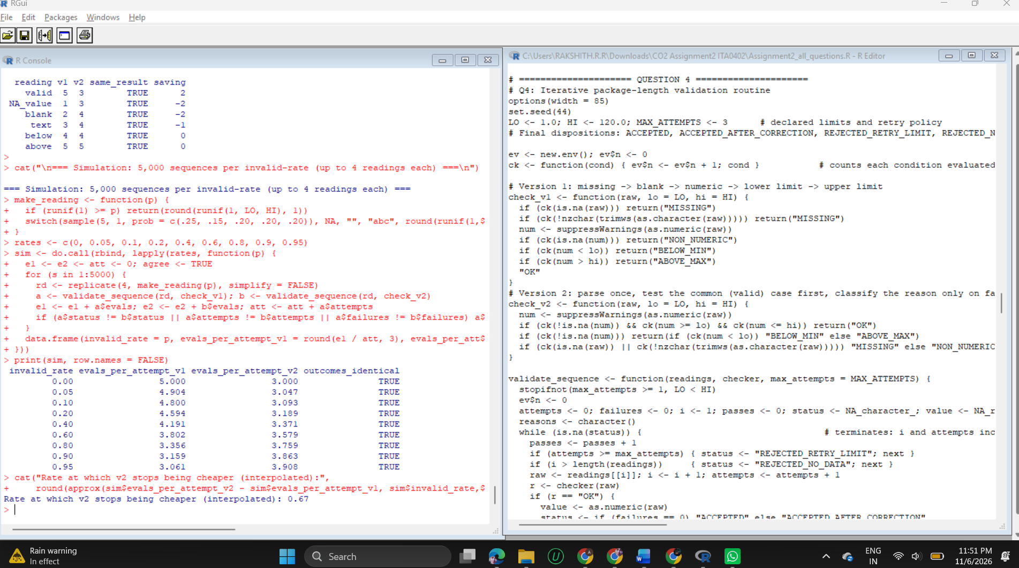
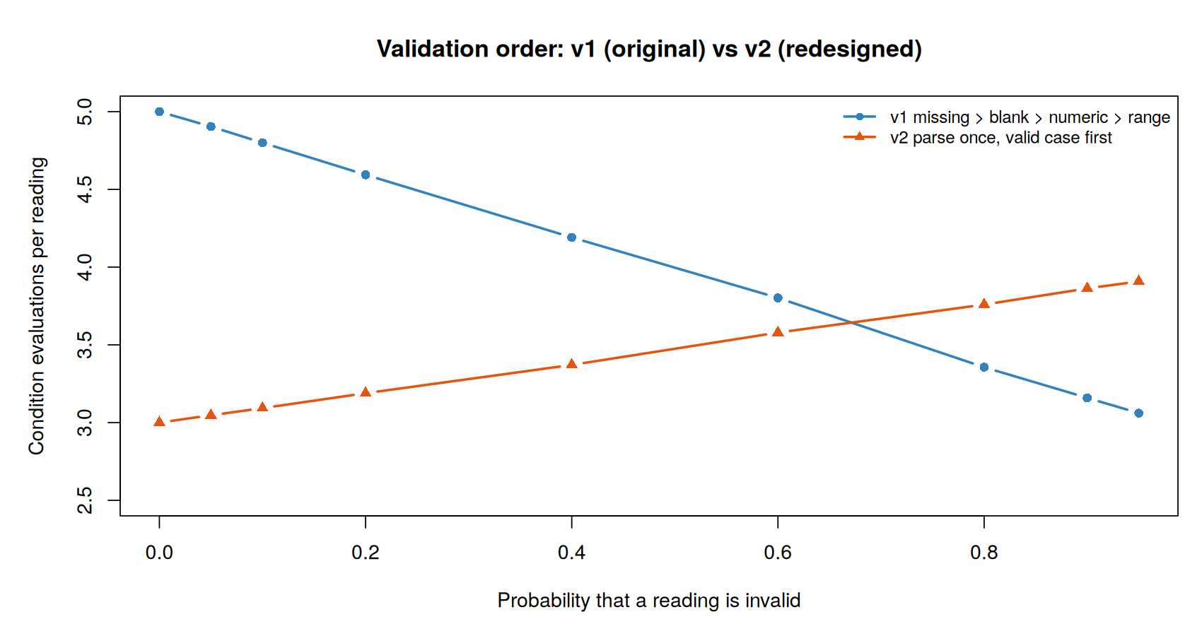
Figure 8: Mean condition evaluations per reading for the two check orders, by probability of an invalid reading

4.4 Analysis
- Prediction versus observation: 11 of 11 sequences matched on status, attempts and failures, including both endpoints, the correction on the third (last) allowed attempt, and the rejection in S5a where a valid fourth reading was never read because the retry limit had been reached.
- Iterations and evaluations: the 11 sequences needed 19 attempts and 23 loop passes (the extra passes are those that detect the limit or the end of data). Condition evaluations were 72 for v1 and 69 for v2. In S4 and S7, 2 readings each were left unread after acceptance, which is how duplicate retransmissions are ignored.
- v1 and v2 gave identical status, attempts, failures and failure reasons on all 11 sequences and on all 45,000 simulated sequences (9 invalid-rates x 5,000).
- The cost depends on the data. For a valid reading v2 needs 3 evaluations against 5 for v1 (a saving of 2). For a missing value v2 needs 3 against 1, for a blank 4 against 2 and for text 4 against 3. The simulation shows that v2 is cheaper while fewer than about 67% of readings are invalid (3.00 against 5.00 evaluations per reading at 0% invalid, 3.91 against 3.06 at 95%).
- Honest correction of my own estimate: by hand I expected the crossover near 83% invalid; the measured value is 67% because v2 re-tests !is.na on the failure path. The measurement replaces the estimate.

4.5 Evaluation
- Real sensor streams are mostly valid, so v2 is the better order. If a feed were mostly broken, v1 would be cheaper, which is useful to know when the data source changes.
- The strict retry limit can reject a package whose fourth reading is valid (S5a, S8). This protects against endless retries but loses a good reading; the limit is a policy value and can be raised.

QUESTION 5 - Recursive File Counter for a Nested Archive (7 Marks)

5.1 Model and recursive definition
A folder is an R list(); a file is any element that is not a list. Folders can be empty, can nest to any depth, and can contain NULL (a broken link, counted as nothing).
Case | Condition | Result
Base case 1 | node is NULL | 0
Base case 2 | node is not a list (a file) | 1
Base case 3 | node is an empty list | 0
Recursive case | node is a non-empty list | sum of count_files(child) over all children

Why it terminates. Every recursive call receives a child, which is strictly smaller than its parent folder. The nesting is finite, so every chain of calls ends at a file, a NULL or an empty folder.
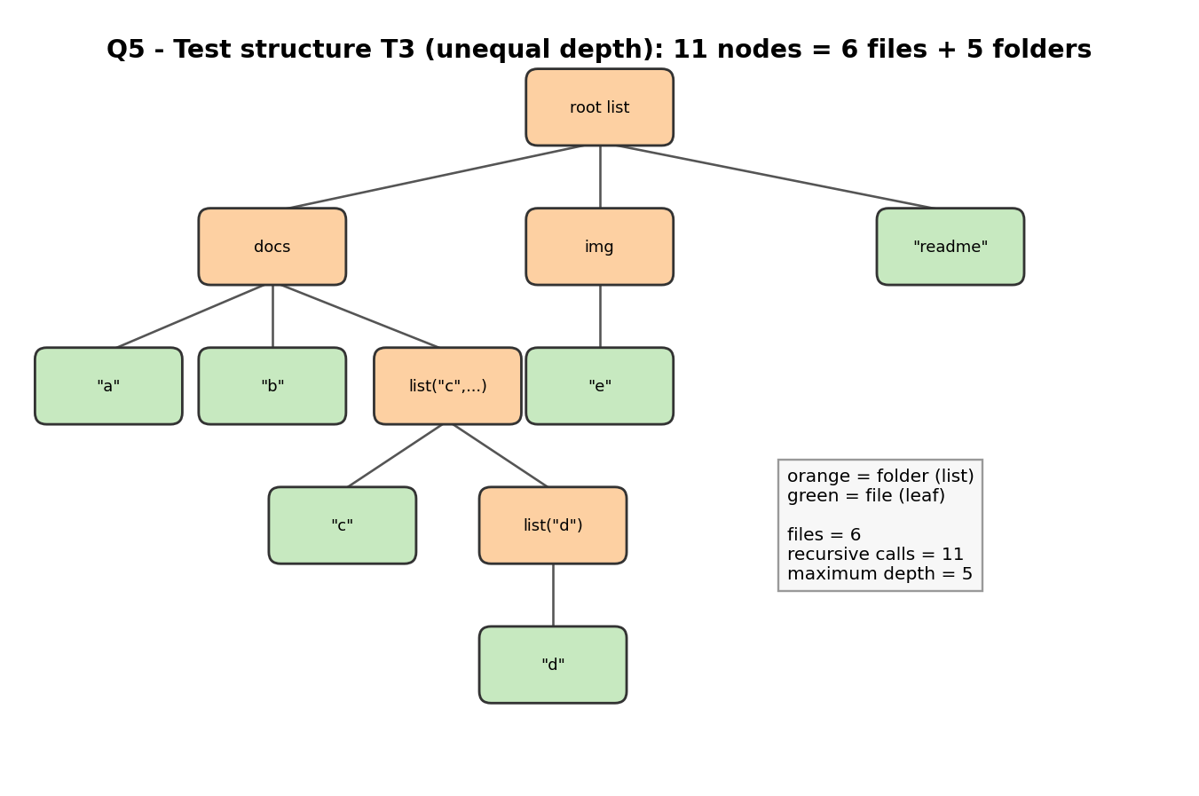
Figure 9: Test structure T3 with 6 files, 5 folders, 11 nodes and maximum depth 5

5.2 Predictions
For each of seven structures I counted by hand the files, the number of recursive calls (every node is visited exactly once, so calls equal the number of nodes) and the maximum depth. For complete trees with branching b and depth d the formulas are files = b^d and calls = (b^(d+1) - 1) / (b - 1).

5.3 Implementation
R code
# Q5: Recursive analysis of a nested file-and-folder archive
options(width = 85)
# MODEL: a folder is an R list(); a file is any NON-list element (here a character string).
# Folders may be empty, nested to any depth, and may contain NULL entries (broken links) that count as nothing.

calls <- new.env(); calls$n <- 0; calls$max_depth <- 0
count_files <- function(node, depth = 1) {
calls$n <- calls$n + 1 # every call (file, folder, NULL) is counted
if (depth > calls$max_depth) calls$max_depth <- depth
if (is.null(node)) return(0) # base case 1: broken link, nothing to count
if (!is.list(node)) return(1) # base case 2: a file leaf counts as one
if (length(node) == 0) return(0) # base case 3: empty folder contributes zero
total <- 0
for (child in node) total <- total + count_files(child, depth + 1) # recursive case: sum over children
total
}
count_files_naive <- function(node) { # first draft WITHOUT the NULL base case
if (!is.list(node)) return(1)
if (length(node) == 0) return(0)
total <- 0; for (child in node) total <- total + count_files_naive(child); total
}
run_rec <- function(tree) { calls$n <- 0; calls$max_depth <- 0; f <- count_files(tree); list(files = f, calls = calls$n, depth = calls$max_depth) }

# ---- Iterative alternative: explicit stack (pop one node at a time) ----
count_files_stack <- function(root) {
stack <- list(root); files <- 0; pops <- 0
while (length(stack) > 0) {
node <- stack[[length(stack)]]; stack[[length(stack)]] <- NULL; pops <- pops + 1
if (is.null(node)) next
if (!is.list(node)) files <- files + 1
else if (length(node) > 0) stack <- c(stack, node)
}
list(files = files, pops = pops)
}

# ---- Test structures ----
chain <- list("deep.txt"); for (i in 1:4) chain <- list(chain) # 5 nested folders, 1 file
tests <- list(
T1_shallow = list("a.txt", "b.txt", "c.txt"),
T2_deep_chain = chain,
T3_unequal = list(docs = list("a", "b", list("c", list("d"))), img = list("e"), "readme"),
T4_empty = list(empty1 = list(), a = list("x", list()), "y"),
T5_single = list("only.txt"),
T6_null_link = list("a", NULL),
T7_all_empty = list())
# PREDICTIONS (counted by hand before running): files, calls = number of nodes visited, depth
pred <- data.frame(test = names(tests), files = c(3, 1, 6, 2, 1, 1, 0), calls = c(4, 6, 11, 6, 2, 3, 1), depth = c(2, 6, 6, 4, 2, 2, 1))
obs <- do.call(rbind, lapply(tests, function(t) as.data.frame(run_rec(t))))
cmp <- data.frame(test = names(tests), pred_files = pred$files, obs_files = obs$files, pred_calls = pred$calls, obs_calls = obs$calls,
pred_depth = pred$depth, obs_depth = obs$depth, row.names = NULL)
cmp$ok <- ifelse(cmp$pred_files == cmp$obs_files & cmp$pred_calls == cmp$obs_calls & cmp$pred_depth == cmp$obs_depth, "yes", "NO")
cat("=== Recursive count: predicted vs observed (files, recursive calls, maximum depth) ===\n")
print(cmp, row.names = FALSE)
cat("Matches:", sum(cmp$ok == "yes"), "of", nrow(cmp), "\n")

cat("\n=== Base-case diagnosis: draft without the NULL base case ===\n")
naive <- sapply(tests, function(t) tryCatch(count_files_naive(t), error = function(e) NA))
print(data.frame(test = names(tests), correct = obs$files, naive_draft = naive, row.names = NULL), row.names = FALSE)

cat("\n=== Recursive vs iterative stack: same answers and same number of visits ===\n")
st <- do.call(rbind, lapply(tests, function(t) as.data.frame(count_files_stack(t))))
print(data.frame(test = names(tests), rec_files = obs$files, stack_files = st$files, rec_calls = obs$calls, stack_pops = st$pops,
equal = obs$files == st$files & obs$calls == st$pops, row.names = NULL), row.names = FALSE)

# ---- Effect of depth and branching: complete trees ----
make_tree <- function(d, b) if (d == 0) "f" else lapply(seq_len(b), function(i) make_tree(d - 1, b))
grid <- data.frame(depth = c(2, 3, 3, 4, 5, 2, 6), branching = c(2, 2, 3, 3, 2, 10, 2))
grid$pred_files <- grid$branching^grid$depth
grid$pred_calls <- (grid$branching^(grid$depth + 1) - 1) / (grid$branching - 1)
res <- lapply(seq_len(nrow(grid)), function(i) run_rec(make_tree(grid$depth[i], grid$branching[i])))
grid$obs_files <- sapply(res, `[[`, "files"); grid$obs_calls <- sapply(res, `[[`, "calls"); grid$max_depth <- sapply(res, `[[`, "depth")
grid$ok <- ifelse(grid$pred_files == grid$obs_files & grid$pred_calls == grid$obs_calls, "yes", "NO")
cat("\n=== Complete trees: formulas files = b^d and calls = (b^(d+1)-1)/(b-1), predicted before running ===\n")
print(grid, row.names = FALSE)
cat("Calls grow with the NUMBER OF NODES (branching); maximum stack depth grows with DEPTH only.\n")

# ---- Depth limit of recursion vs iteration ----
build_chain <- function(d) { x <- "leaf.txt"; for (i in seq_len(d)) x <- list(x); x }
depths <- c(100, 250, 500, 750, 1000, 1500, 5000, 20000)
dl <- do.call(rbind, lapply(depths, function(d) {
tr <- build_chain(d)
r <- tryCatch({ calls$n <- 0; calls$max_depth <- 0; count_files(tr); "ok" }, error = function(e) substr(conditionMessage(e), 1, 40))
s <- tryCatch({ count_files_stack(tr)$files; "ok" }, error = function(e) substr(conditionMessage(e), 1, 40))
data.frame(chain_depth = d, recursive = r, stack_iterative = s)
}))
cat("\n=== Chain of nested folders: recursion versus the explicit stack ===\n")
print(dl, row.names = FALSE)
ok_depths <- depths[dl$recursive == "ok"]
cat("Deepest chain the recursive version handled in this test:", max(ok_depths), "\n")

# ---- Timing on a larger complete tree (supporting evidence) ----
big <- make_tree(8, 3) # 3^8 = 6,561 files, 9,841 nodes
t_rec <- median(replicate(3, system.time(count_files(big))[["elapsed"]]))
t_stk <- median(replicate(3, system.time(count_files_stack(big))[["elapsed"]]))
cat("\nComplete tree depth 8, branching 3:", run_rec(big)$files, "files,", run_rec(big)$calls, "calls\n")
cat("Elapsed (median of 3): recursive =", round(t_rec, 3), "s | stack =", round(t_stk, 3), "s\n")

png("fig/fig_q5_growth.png", width = 1800, height = 850, res = 170)
par(mfrow = c(1, 2), mar = c(5, 5, 4, 1))
plot(grid$pred_calls, grid$obs_calls, pch = 16, col = "#3182bd", cex = 1.4, log = "xy", xlab = "Predicted calls (formula)", ylab = "Observed calls",
main = "Calls follow the node-count formula"); abline(0, 1, lty = 2)
plot(grid$depth, grid$max_depth, pch = 17, col = "#e6550d", cex = 1.4, xlab = "Tree depth d", ylab = "Maximum recursion depth observed",
main = "Recursion depth tracks tree depth"); abline(1, 1, lty = 2)
dev.off()

Output (captured from running the code above)
=== Recursive count: predicted vs observed (files, recursive calls, maximum depth) ===
test pred_files obs_files pred_calls obs_calls pred_depth obs_depth ok
T1_shallow 3 3 4 4 2 2 yes
T2_deep_chain 1 1 6 6 6 6 yes
T3_unequal 6 6 11 11 6 5 NO
T4_empty 2 2 6 6 4 3 NO
T5_single 1 1 2 2 2 2 yes
T6_null_link 1 1 3 3 2 2 yes
T7_all_empty 0 0 1 1 1 1 yes
Matches: 5 of 7

=== Base-case diagnosis: draft without the NULL base case ===
test correct naive_draft
T1_shallow 3 3
T2_deep_chain 1 1
T3_unequal 6 6
T4_empty 2 2
T5_single 1 1
T6_null_link 1 2
T7_all_empty 0 0

=== Recursive vs iterative stack: same answers and same number of visits ===
test rec_files stack_files rec_calls stack_pops equal
T1_shallow 3 3 4 4 TRUE
T2_deep_chain 1 1 6 6 TRUE
T3_unequal 6 6 11 11 TRUE
T4_empty 2 2 6 6 TRUE
T5_single 1 1 2 2 TRUE
T6_null_link 1 1 3 3 TRUE
T7_all_empty 0 0 1 1 TRUE

=== Complete trees: formulas files = b^d and calls = (b^(d+1)-1)/(b-1), predicted before running ===
depth branching pred_files pred_calls obs_files obs_calls max_depth ok
2 2 4 7 4 7 3 yes
3 2 8 15 8 15 4 yes
3 3 27 40 27 40 4 yes
4 3 81 121 81 121 5 yes
5 2 32 63 32 63 6 yes
2 10 100 111 100 111 3 yes
6 2 64 127 64 127 7 yes
Calls grow with the NUMBER OF NODES (branching); maximum stack depth grows with DEPTH only.

=== Chain of nested folders: recursion versus the explicit stack ===
chain_depth recursive stack_iterative
100 ok ok
250 ok ok
500 ok ok
750 ok ok
1000 C stack usage 7971012 is too close to t ok
1500 C stack usage 7971012 is too close to t ok
5000 C stack usage 7971012 is too close to t ok
20000 C stack usage 7971012 is too close to t ok
Deepest chain the recursive version handled in this test: 750

Complete tree depth 8, branching 3: 6561 files, 9841 calls
Elapsed (median of 3): recursive = 0.007 s | stack = 0.004 s
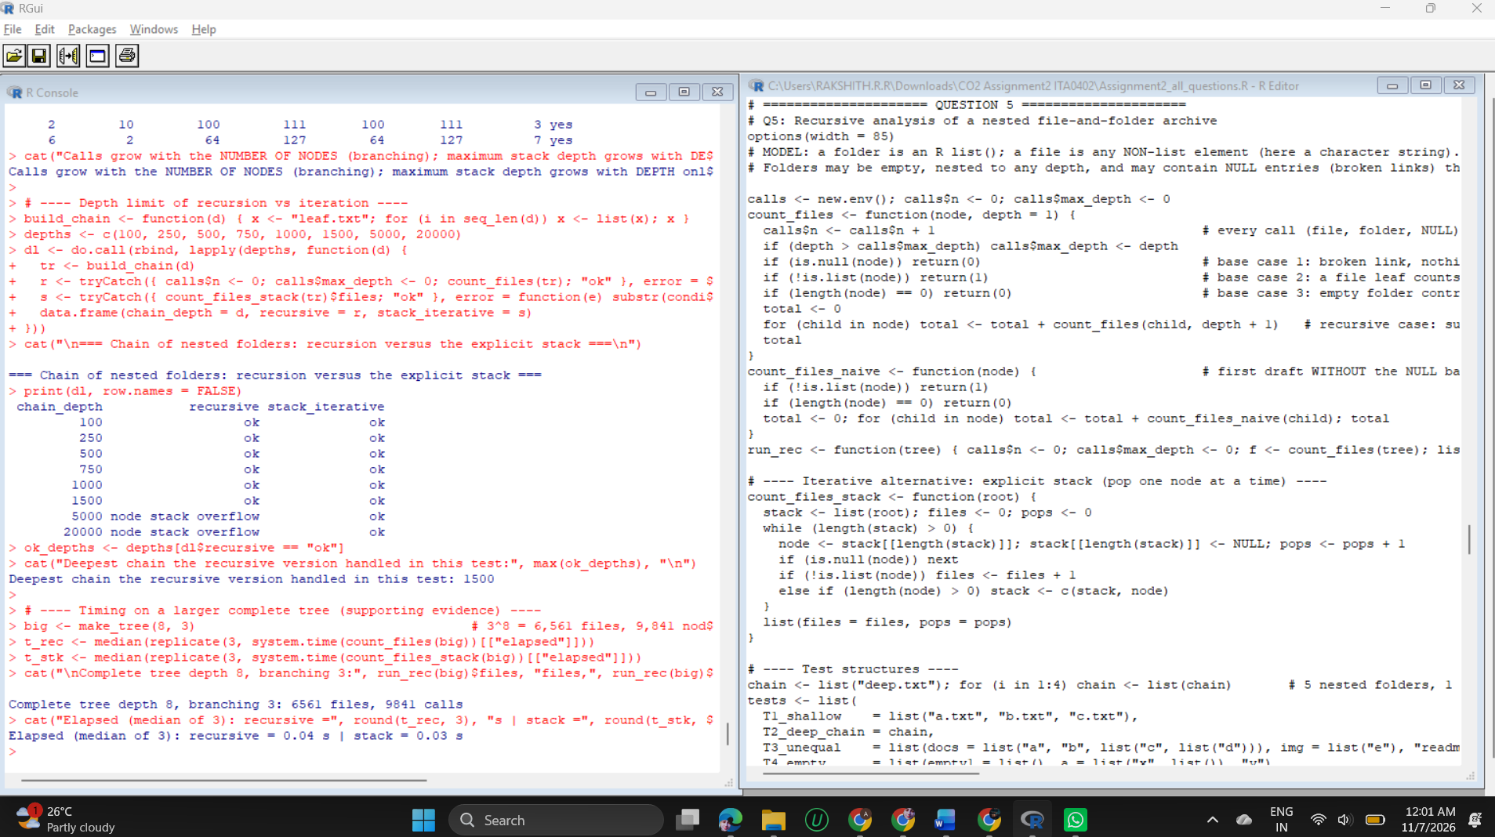
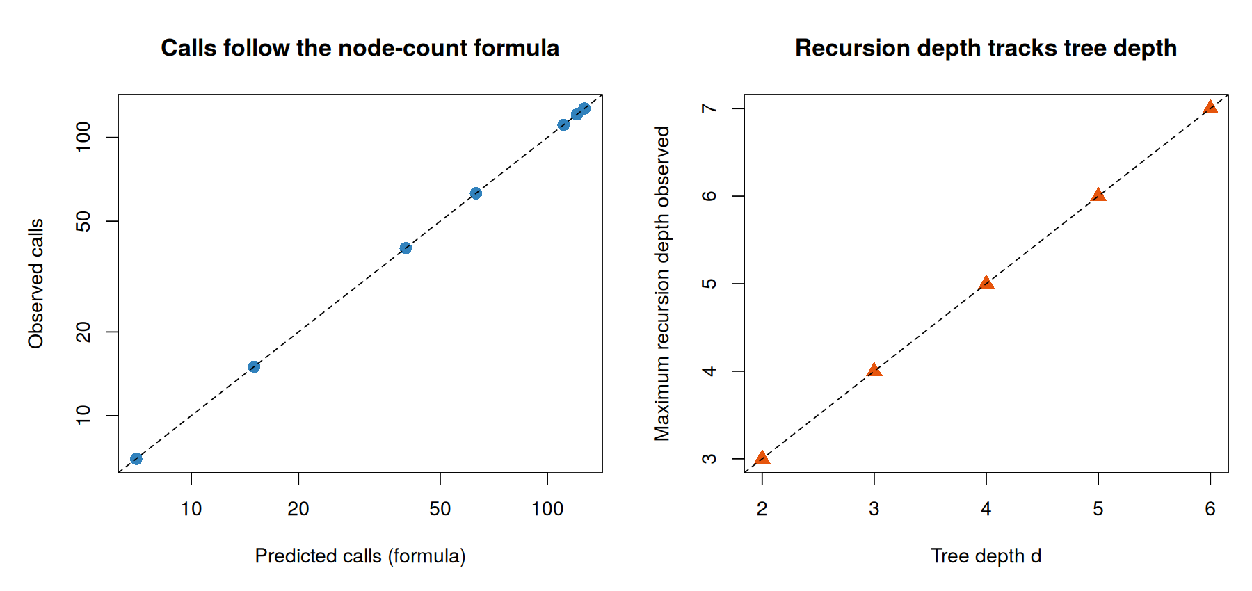
Figure 10: Left: observed calls against the node-count formula. Right: recursion depth against tree depth

5.4 Analysis
- Prediction versus observation: files and calls matched for all 7 structures, and all 7 complete-tree formulas matched exactly. Two depth predictions were wrong: for T3 I predicted 6 and the observed depth is 5; for T4 I predicted 4 and it is 3. I had counted one extra level when listing the folders; the diagram of T3 confirms depth 5.
- Base-case diagnosis: the first draft without the NULL base case counted a broken link as a file and returned 2 for T6 instead of 1. This is why the NULL case is explicit.
- Effect of depth and branching: the number of calls grows with the number of nodes, which grows with branching (b = 10, d = 2 needs 111 calls; b = 2, d = 6 needs 127). The maximum recursion depth grows only with the depth of the tree (d + 1 for a complete tree). Wide trees are therefore cheap on the stack, deep trees are not.
- Recursion versus an explicit stack: both gave the same file count and the same number of visits (calls = pops) on all 7 structures. On a complete tree of depth 8 and branching 3 (9,841 nodes) the times were 0.007 s and 0.004 s, so speed does not separate them.
- Depth limit (the real difference): a chain of nested folders was handled by recursion up to depth 750 in this test and failed from depth 1000 with C stack usage ... too close to the limit, while the stack version handled every depth tested up to 20,000. Question 7 measures this limit more carefully.

5.5 Evaluation
Recursion matches the definition of the problem and is the clearest code for ordinary archives, whose depth is small. Its weakness is that depth is limited by the call stack, not by memory. An archive built or generated automatically can be deeper than the limit, which is why the explicit-stack alternative was tested.

QUESTION 6 - Geometric Series: Iteration versus Recursion (7 Marks)

6.1 Mathematical definition and assumptions
Item | Definition
Terms | t_1 = a, t_k = r x t_(k-1), so t_k = a r^(k-1)
Partial sum | S_n = t_1 + ... + t_n, with S_0 = 0 (empty sum)
Recurrence used by the recursion | S_n = a + r x S_(n-1) for n >= 1
Closed form (used only as a check) | S_n = a (1 - r^n) / (1 - r) for r != 1; S_n = n a for r = 1
Valid inputs | n a whole number >= 0; a and r any real numbers
Base case and progress | n = 0 returns 0; each call reduces n by one, so every valid n reaches the base case

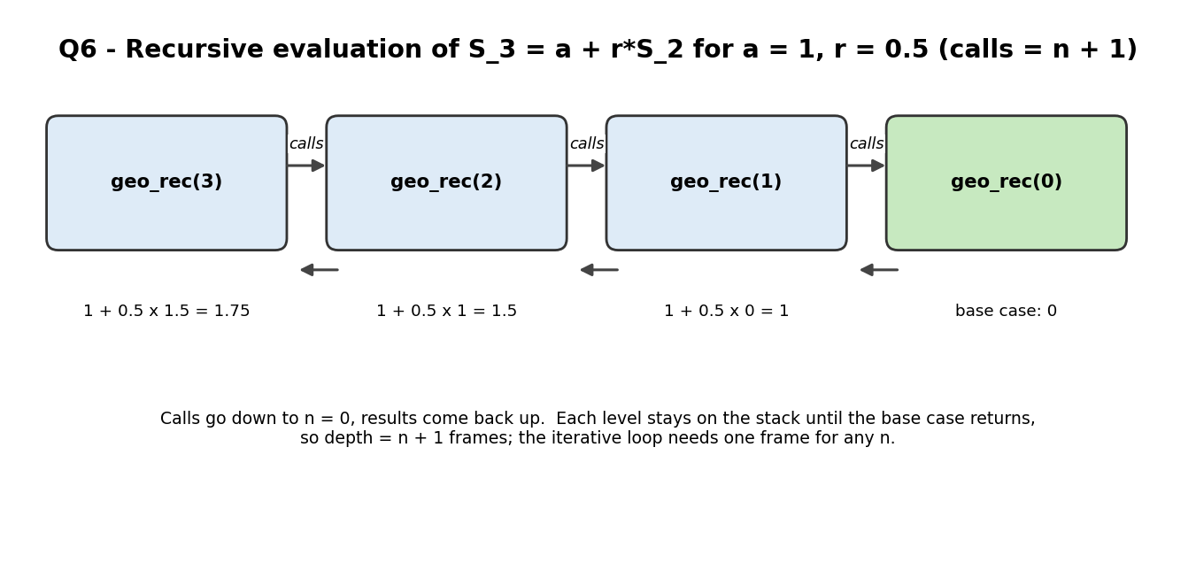
Figure 11: Recursive evaluation for n = 3: calls descend to the base case, results return upwards
Predictions. For n terms I predicted n loop iterations and n + 1 recursive calls (the base case is a call). Sums were calculated from the closed form: for r = 0.5, a = 1 the sums are 1 (n = 1), 1.9375 (n = 5) and 1.998046875 (n = 10); for r = 1, a = 3, n = 5 the sum is 15; for r = -1 the sum alternates between 1 (odd n) and 0 (even n); for r = 2 and n = 10 it is 1023.

6.2 Implementation
R code
# Q6: Iterative vs recursive evaluation of a geometric series
options(width = 85)
# DEFINITION. First term a, common ratio r (any real number), number of terms n (integer, n >= 0).
# term recurrence : t_1 = a, t_k = r * t_{k-1} (so t_k = a * r^(k-1))
# partial sum : S_0 = 0 (empty sum), S_n = a + r * S_{n-1} for n >= 1
# closed form : S_n = a * (1 - r^n) / (1 - r) for r != 1 ; S_n = n * a for r = 1
# Base case: n = 0 gives 0. Each recursive call reduces n by one, so it reaches the base case for every valid n.

geo_iter <- function(n, a, r) {
if (!is.numeric(n) || length(n) != 1 || is.na(n) || n < 0 || n != floor(n)) stop("n must be a whole number >= 0")
total <- 0; term <- a; iters <- 0
for (k in seq_len(n)) { total <- total + term; term <- term * r; iters <- iters + 1 }
list(sum = total, count = iters)
}
rc <- new.env(); rc$calls <- 0
geo_rec_inner <- function(n, a, r) {
rc$calls <- rc$calls + 1
if (n == 0) return(0) # base case
a + r * geo_rec_inner(n - 1, a, r) # recursive case
}
geo_rec <- function(n, a, r) {
if (!is.numeric(n) || length(n) != 1 || is.na(n) || n < 0 || n != floor(n)) stop("n must be a whole number >= 0")
rc$calls <- 0; s <- geo_rec_inner(n, a, r); list(sum = s, count = rc$calls)
}
geo_closed <- function(n, a, r) if (r == 1) n * a else a * (1 - r^n) / (1 - r)

# ---- Tests: PREDICTIONS (sum, iterations, recursive calls) written before running ----
tests <- data.frame(case = c("n=0", "n=1", "n=5", "n=10", "n=100", "n=1000 (r=0.5)", "r=1, n=5", "r=-1, n=5", "r=-1, n=6", "r=0, n=5", "r=2, n=10", "r=2, n=20"),
n = c(0, 1, 5, 10, 100, 1000, 5, 5, 6, 5, 10, 20),
a = c(1, 1, 1, 1, 1, 1, 3, 1, 1, 1, 1, 1),
r = c(.5, .5, .5, .5, .5, .5, 1, -1, -1, 0, 2, 2), stringsAsFactors = FALSE)
tests$pred_sum <- c(0, 1, 1.9375, 1.998046875, 2, 2, 15, 1, 0, 1, 1023, 1048575)
tests$pred_iter <- tests$n
tests$pred_calls <- tests$n + 1
obs <- lapply(seq_len(nrow(tests)), function(i) list(it = geo_iter(tests$n[i], tests$a[i], tests$r[i]), re = tryCatch(geo_rec(tests$n[i], tests$a[i], tests$r[i]), error = function(e) NULL)))
tests$iter_sum <- sapply(obs, function(o) o$it$sum); tests$iter_count <- sapply(obs, function(o) o$it$count)
tests$rec_sum <- sapply(obs, function(o) if (is.null(o$re)) NA else o$re$sum); tests$rec_calls <- sapply(obs, function(o) if (is.null(o$re)) NA else o$re$count)
tests$closed <- mapply(geo_closed, tests$n, tests$a, tests$r)
cat("=== Predicted vs observed sums ===\n")
print(data.frame(case = tests$case, predicted = tests$pred_sum, iterative = tests$iter_sum, recursive = tests$rec_sum, closed_form = tests$closed,
sums_ok = ifelse(is.na(tests$rec_sum), "RECURSION FAILED", ifelse(abs(tests$pred_sum - tests$iter_sum) < 1e-9 & abs(tests$pred_sum - tests$rec_sum) < 1e-9, "yes", "NO"))), row.names = FALSE)
cat("\n=== Predicted vs observed iterations and recursive calls ===\n")
print(data.frame(case = tests$case, pred_iter = tests$pred_iter, obs_iter = tests$iter_count, pred_calls = tests$pred_calls, obs_calls = tests$rec_calls,
counts_ok = ifelse(is.na(tests$rec_calls), "RECURSION FAILED", ifelse(tests$pred_iter == tests$iter_count & tests$pred_calls == tests$rec_calls, "yes", "NO"))), row.names = FALSE)
cat("\nLargest |iterative - recursive| over these tests:", format(max(abs(tests$iter_sum - tests$rec_sum), na.rm = TRUE), digits = 3), "\n")
cat("Largest |iterative - closed form|:", format(max(abs(tests$iter_sum - tests$closed)), digits = 3), "\n")

cat("\n=== Increasing term counts (a=1, r=0.5): counts grow linearly ===\n")
ns <- c(0, 1, 10, 100, 500, 750)
inc <- data.frame(n = ns, iterations = sapply(ns, function(n) geo_iter(n, 1, .5)$count), rec_calls = sapply(ns, function(n) geo_rec(n, 1, .5)$count),
sum_iter = sapply(ns, function(n) geo_iter(n, 1, .5)$sum), sum_rec = sapply(ns, function(n) geo_rec(n, 1, .5)$sum))
inc$abs_diff <- abs(inc$sum_iter - inc$sum_rec)
print(inc, digits = 10, row.names = FALSE)

cat("\n=== Ratio boundary cases ===\n")
cat("r = 1 : closed form (1-r^n)/(1-r) would be 0/0, so the n*a branch gives", geo_closed(5, 1, 1), "(handled by the n*a branch); iterative n=5, a=3 gives", geo_iter(5, 3, 1)$sum, "\n")
cat("r = -1: alternating partial sums 1,0,1,0 -> n=5:", geo_iter(5, 1, -1)$sum, " n=6:", geo_iter(6, 1, -1)$sum, " (no convergence, no error)\n")
cat("|r| < 1 converges to a/(1-r) = 2 for r = 0.5; S_100 =", geo_iter(100, 1, .5)$sum, "\n")
ov <- sapply(c(1023, 1024, 1025), function(n) geo_iter(n, 1, 2)$sum)
cat("r = 2 overflow boundary, S_n for n = 1023, 1024, 1025:", format(ov, digits = 4), "(n = 1024 overflows double precision to Inf)\n")
cat("Recursive version at the same boundary (n = 1024) -> ", tryCatch(format(geo_rec(1024, 1, 2)$sum), error = function(e) "ERROR: recursion limit reached before the numbers overflow"), "\n")

cat("\n=== Termination and depth ===\n")
for (bad in list(-1, 2.5, NA)) cat("geo_rec(", format(bad), ") ->", tryCatch({ geo_rec(bad, 1, .5); "accepted" }, error = function(e) conditionMessage(e)), "\n")
unguarded <- function(n) if (n == 0) 0 else 1 + unguarded(n - 1)
cat("Unguarded version with n = -1 ->", tryCatch(unguarded(-1), error = function(e) paste("never reaches the base case:", substr(conditionMessage(e), 1, 45))), "\n")
ds <- c(500, 750, 800, 900, 1000, 2000)
dd <- data.frame(n = ds, recursive = sapply(ds, function(n) tryCatch({ geo_rec(n, 1, .5); "ok" }, error = function(e) "FAILED (stack limit)")),
iterative = sapply(ds, function(n) tryCatch({ geo_iter(n, 1, .5); "ok" }, error = function(e) "FAILED")))
print(dd, row.names = FALSE)
cat("Iterative version at n = 1e6:", format(geo_iter(1e6, 1, .5)$sum), "with", geo_iter(1e6, 1, .5)$count, "iterations\n")

cat("\n=== Elapsed time (supporting evidence): R 4.3.3, single core, median of 5 repeats, a=1 r=0.5 ===\n")
tm <- function(f, reps) median(replicate(5, system.time(for (j in seq_len(reps)) f())[["elapsed"]])) / reps * 1e6
tt <- data.frame(n = c(10, 100, 500, 750))
tt$iterative_us <- sapply(tt$n, function(n) tm(function() geo_iter(n, 1, .5), 2000))
tt$recursive_us <- sapply(tt$n, function(n) tm(function() geo_rec(n, 1, .5), 2000))
tt$ratio <- round(tt$recursive_us / tt$iterative_us, 1)
tt$iterative_us <- round(tt$iterative_us, 1); tt$recursive_us <- round(tt$recursive_us, 1)
print(tt, row.names = FALSE)

png("fig/fig_q6_compare.png", width = 1800, height = 850, res = 170)
par(mfrow = c(1, 2), mar = c(5, 5, 4, 1))
plot(inc$n, inc$rec_calls, type = "b", pch = 17, col = "#e6550d", lwd = 2, xlab = "Number of terms n", ylab = "Count",
main = "Work grows linearly in n")
lines(inc$n, inc$iterations, type = "b", pch = 16, col = "#3182bd", lwd = 2)
legend("topleft", legend = c("recursive calls (n+1)", "loop iterations (n)"), col = c("#e6550d", "#3182bd"), pch = c(17, 16), lwd = 2, bty = "n", cex = 0.8)
plot(tt$n, tt$recursive_us, type = "b", pch = 17, col = "#e6550d", lwd = 2, xlab = "Number of terms n", ylab = "Microseconds per evaluation",
main = "Elapsed time (supporting evidence)", ylim = c(0, max(tt$recursive_us) * 1.1))
lines(tt$n, tt$iterative_us, type = "b", pch = 16, col = "#3182bd", lwd = 2)
legend("topleft", legend = c("recursive", "iterative"), col = c("#e6550d", "#3182bd"), pch = c(17, 16), lwd = 2, bty = "n", cex = 0.8)
dev.off()

Output (captured from running the code above)
=== Predicted vs observed sums ===
case predicted iterative recursive closed_form sums_ok
n=0 0.000000e+00 0.000000e+00 0.000000e+00 0.000000e+00 yes
n=1 1.000000e+00 1.000000e+00 1.000000e+00 1.000000e+00 yes
n=5 1.937500e+00 1.937500e+00 1.937500e+00 1.937500e+00 yes
n=10 1.998047e+00 1.998047e+00 1.998047e+00 1.998047e+00 yes
n=100 2.000000e+00 2.000000e+00 2.000000e+00 2.000000e+00 yes
n=1000 (r=0.5) 2.000000e+00 2.000000e+00 NA 2.000000e+00 RECURSION FAILED
r=1, n=5 1.500000e+01 1.500000e+01 1.500000e+01 1.500000e+01 yes
r=-1, n=5 1.000000e+00 1.000000e+00 1.000000e+00 1.000000e+00 yes
r=-1, n=6 0.000000e+00 0.000000e+00 0.000000e+00 0.000000e+00 yes
r=0, n=5 1.000000e+00 1.000000e+00 1.000000e+00 1.000000e+00 yes
r=2, n=10 1.023000e+03 1.023000e+03 1.023000e+03 1.023000e+03 yes
r=2, n=20 1.048575e+06 1.048575e+06 1.048575e+06 1.048575e+06 yes

=== Predicted vs observed iterations and recursive calls ===
case pred_iter obs_iter pred_calls obs_calls counts_ok
n=0 0 0 1 1 yes
n=1 1 1 2 2 yes
n=5 5 5 6 6 yes
n=10 10 10 11 11 yes
n=100 100 100 101 101 yes
n=1000 (r=0.5) 1000 1000 1001 NA RECURSION FAILED
r=1, n=5 5 5 6 6 yes
r=-1, n=5 5 5 6 6 yes
r=-1, n=6 6 6 7 7 yes
r=0, n=5 5 5 6 6 yes
r=2, n=10 10 10 11 11 yes
r=2, n=20 20 20 21 21 yes

Largest |iterative - recursive| over these tests: 0
Largest |iterative - closed form|: 0

=== Increasing term counts (a=1, r=0.5): counts grow linearly ===
n iterations rec_calls sum_iter sum_rec abs_diff
0 0 1 0.000000000 0.000000000 0
1 1 2 1.000000000 1.000000000 0
10 10 11 1.998046875 1.998046875 0
100 100 101 2.000000000 2.000000000 0
500 500 501 2.000000000 2.000000000 0
750 750 751 2.000000000 2.000000000 0

=== Ratio boundary cases ===
r = 1 : closed form (1-r^n)/(1-r) would be 0/0, so the n*a branch gives 5 (handled by the n*a branch); iterative n=5, a=3 gives 15
r = -1: alternating partial sums 1,0,1,0 -> n=5: 1 n=6: 0 (no convergence, no error)
|r| < 1 converges to a/(1-r) = 2 for r = 0.5; S_100 = 2
r = 2 overflow boundary, S_n for n = 1023, 1024, 1025: 8.988e+307 Inf Inf (n = 1024 overflows double precision to Inf)
Recursive version at the same boundary (n = 1024) -> ERROR: recursion limit reached before the numbers overflow

=== Termination and depth ===
geo_rec( -1 ) -> n must be a whole number >= 0
geo_rec( 2.5 ) -> n must be a whole number >= 0
geo_rec( NA ) -> n must be a whole number >= 0
Unguarded version with n = -1 -> never reaches the base case: C stack usage 7969860 is too close to the li
n recursive iterative
500 ok ok
750 ok ok
800 ok ok
900 FAILED (stack limit) ok
1000 FAILED (stack limit) ok
2000 FAILED (stack limit) ok
Iterative version at n = 1e6: 2 with 1e+06 iterations

=== Elapsed time (supporting evidence): R 4.3.3, single core, median of 5 repeats, a=1 r=0.5 ===
n iterative_us recursive_us ratio
10 1.5 8.0 5.3
100 4.0 67.5 16.9
500 17.0 505.0 29.7
750 24.5 805.5 32.9
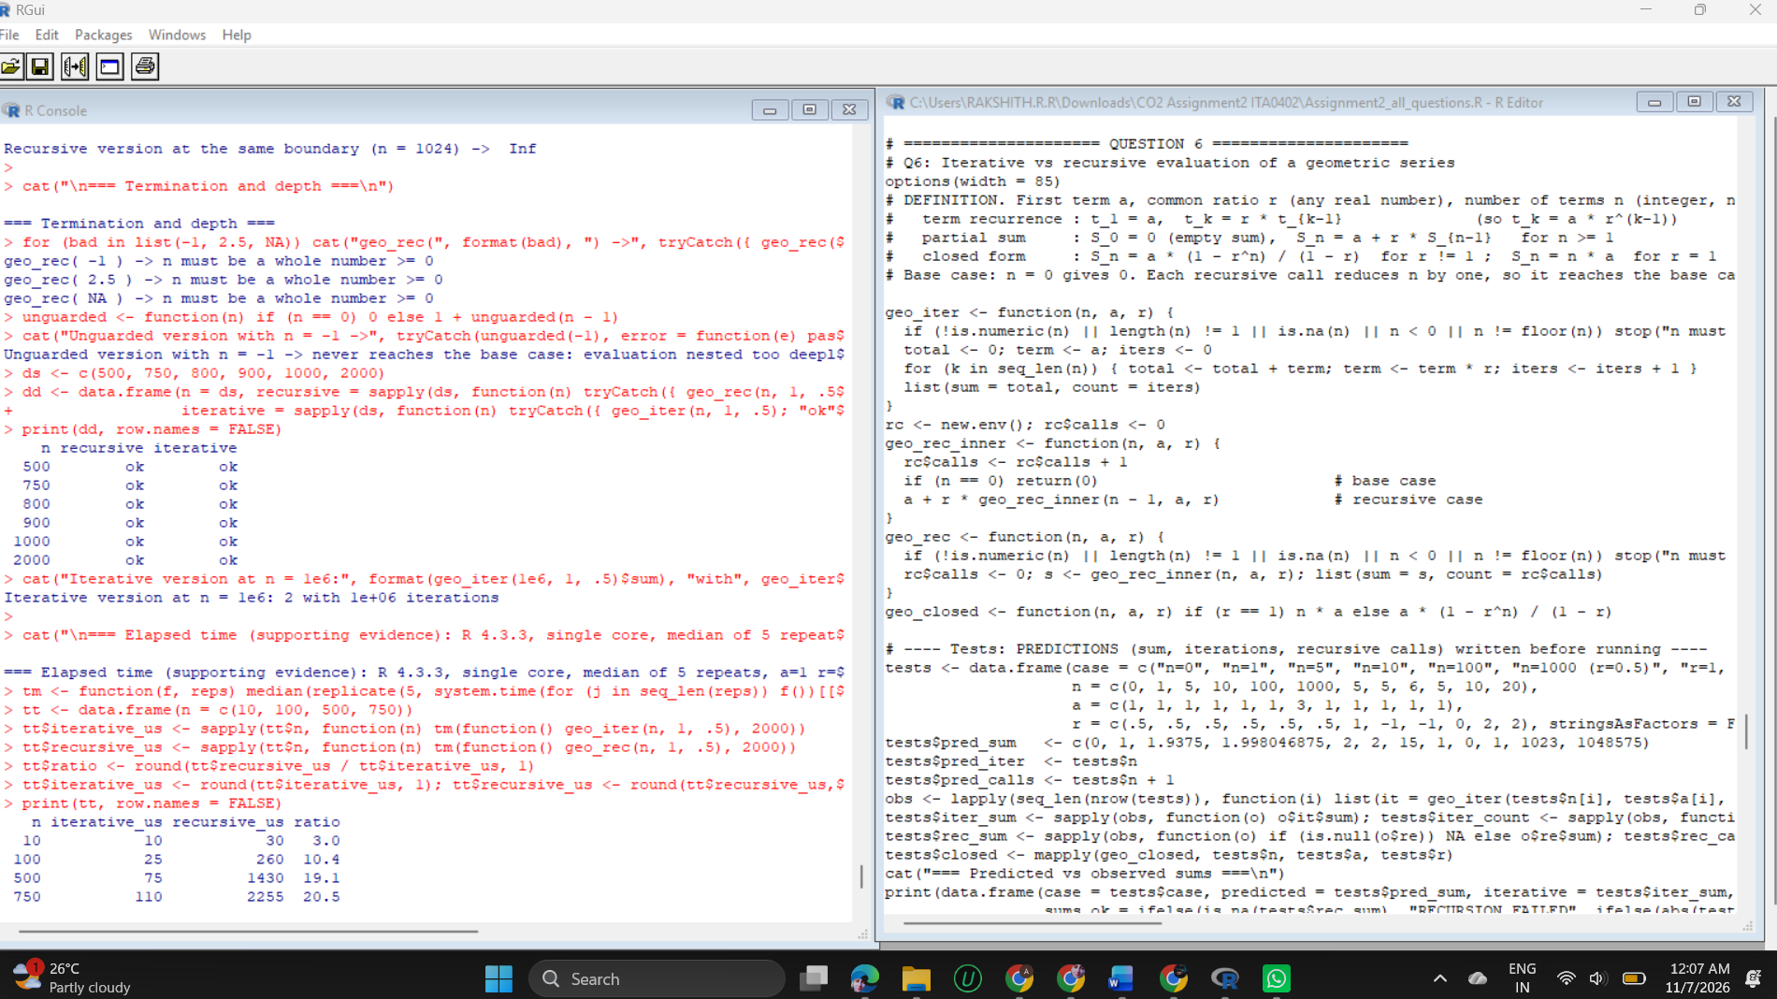
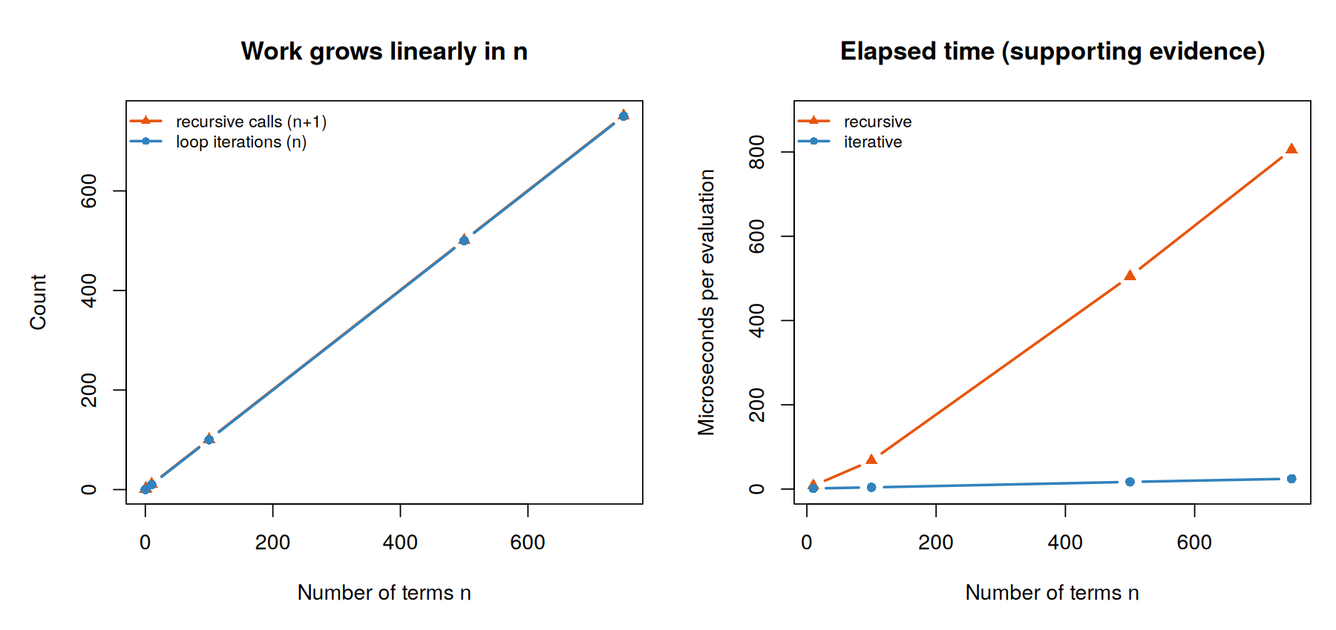
Figure 12: Left: iterations and recursive calls grow linearly. Right: elapsed time per evaluation (supporting evidence)

6.3 Analysis
- Prediction versus observation: 11 of 12 cases matched in sum, iterations and calls, which is 34 of 36 values. The exception is n = 1000: the recursive version stops with a C stack error, so its sum and call count do not exist (the iterative result did match). I had predicted that the recursion would return 2.
- Linear cost: iterations are exactly n and recursive calls exactly n + 1 for n = 0, 1, 10, 100, 500 and 750.
- Agreement: the iterative sum, the recursive sum and the closed form were identical in every test (largest difference 0).
- Boundary ratios: r = 1 makes the closed form 0/0, which the n x a branch avoids; r = -1 never converges but raises no error; r = 0 returns just a; for |r| < 1 the sums approach a/(1 - r) = 2. For r = 2 the sum overflows to Inf at n = 1024 in double precision, and the recursive version cannot even reach that n.
- Termination guard: n = -1, 2.5 and NA are rejected with a clear message. An unguarded recursive version given n = -1 never reaches the base case and ends with a stack error.
- Depth limit: recursion succeeded at n = 800 and failed at n = 900, 1000 and 2000; the iterative version also handled n = 1,000,000 (1,000,000 iterations). The exact limit depends on how much stack is already in use, so it should be treated as 'a few hundred', not as a fixed number.
- Elapsed time (supporting only): per evaluation the iterative version took 1.5 microseconds at n = 10 and 24.5 at n = 750; the recursive version took 8.0 and 805.5 (about 5 and 33 times slower).

6.4 Evaluation and recommendation
The iterative version is the better choice for real use: it has no depth limit, uses constant memory and was both faster and equally accurate. The recursive version mirrors the mathematical recurrence, which makes it useful for explaining the idea and for small n. The closed form is cheapest of all (one power and one division) but needs the r = 1 special case and can overflow in the same way.

QUESTION 7 - Diagnose, Redesign and Validate One Implementation (8 Marks)

7.1 Selected implementation
The implementation chosen is the Question 5 file counter (both the recursive version and the explicit-stack version). Question 5 had already shown a depth failure for recursion; this question reproduces it with a stated protocol, finds a second defect in the stack version, defines success criteria, redesigns the code and validates the redesign on equivalent inputs.

7.2 Diagnosis: two reproducible defects
- Defect 1 (recursion, depth). Ten trials per depth in the same calling context: depths 500, 700 and 800 succeeded 10 of 10 times, depths 900, 1000, 1500 and 3000 failed 10 of 10 times. Between 800 and 900 the outcome depends on the calling context and garbage collection. Error text: C stack usage 7970964 is too close to the limit. Root cause: every nesting level adds function-call frames on the C stack, and the 8 MB stack limit is reached long before memory runs out.
- Defect 2 (stack version, wide folders). One folder holding 5,000, 10,000, 20,000 and 40,000 files took 0.128, 0.387, 1.521 and 6.327 seconds: each doubling multiplied the time by 3.0 to 4.2, which is quadratic growth. The recursive version needed 0.003 to 0.028 s for the same folders. Root cause: stack[[length(stack)]] <- NULL builds a new, shorter list on every pop and copies the whole stack.

7.3 Evaluation criteria (fixed before redesigning)
ID | Criterion | Target
K1 | Correctness | Same file count on 100% of the Q5 structures and on random trees
K2 | Depth safety | Handles a chain of depth 100,000
K3 | Operation count | Nodes visited equal the recursive call count
K4 | Scalability on wide folders | Time grows by less than x3 when the folder size doubles
K5 | Maintainability | At most 20 lines, base cases explicit, no packages

7.4 Redesign
The redesigned counter works level by level. It takes the whole current level as a vector, counts the files with vector tests, and joins the children of all folders in the level into the next level with unlist(recursive = FALSE). There is no per-node copying and the loop runs once per level.
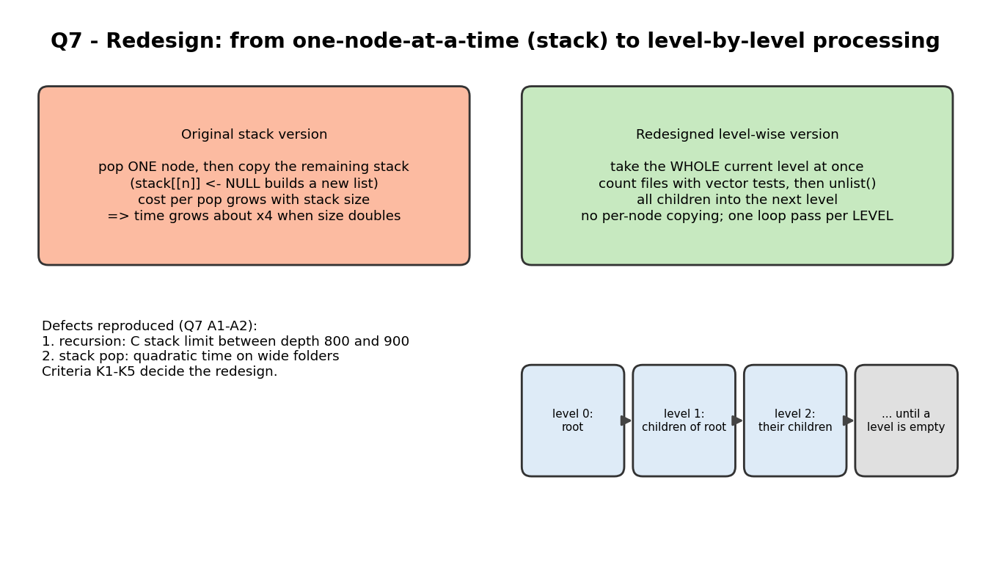
Figure 13: From one-node-at-a-time processing to level-by-level processing
Pseudocode
level <- [root]; files <- 0; visited <- 0
while level is not empty:
visited <- visited + size(level)
files <- files + number of entries that are neither NULL nor a folder
level <- concatenation of the children of every folder in level
return files, visited

7.5 Implementation and validation
R code
# Q7: Diagnose - Redesign - Validate review of the Q5 file counter
options(width = 85)
# ================= A. DIAGNOSE (reuses count_files and count_files_stack from Q5) =================
cat("=== A1. Defect 1: recursion fails on deep folders (10 trials per depth, same calling context) ===\n")
chain_of <- function(d) { x <- "leaf.txt"; for (i in seq_len(d)) x <- list(x); x }
rec_ok <- function(d) tryCatch({ calls$n <- 0; calls$max_depth <- 0; count_files(chain_of(d)); TRUE }, error = function(e) FALSE)
depths_a <- c(500, 700, 800, 900, 1000, 1500, 3000)
trial <- data.frame(chain_depth = depths_a, recursive_ok = sapply(depths_a, function(d) sum(replicate(10, rec_ok(d)))))
trial$result <- paste0(trial$recursive_ok, "/10 succeed")
print(trial[, c("chain_depth", "result")], row.names = FALSE)
always_fail <- min(depths_a[trial$recursive_ok == 0]); always_ok <- max(depths_a[trial$recursive_ok == 10 & depths_a < always_fail])
cat("Always succeeds up to depth", always_ok, "| always fails from depth", always_fail, "| unstable in between (depends on calling context and garbage collection)\n")
msg <- tryCatch(count_files(chain_of(always_fail)), error = function(e) conditionMessage(e))
cat("Error text at depth", always_fail, ":", substr(msg, 1, 60), "\n")
cat("Root cause: each nesting level adds R function-call frames on the C stack; the 8 MB limit is reached long before memory runs out.\n")

cat("\n=== A2. Defect 2: the stack version slows down quadratically on wide folders ===\n")
wide_of <- function(n) as.list(sprintf("f%d.txt", seq_len(n)))
sizes <- c(5000, 10000, 20000, 40000)
wd <- do.call(rbind, lapply(sizes, function(n) {
tr <- wide_of(n)
data.frame(children = n, stack_s = system.time(count_files_stack(tr))[["elapsed"]], recursive_s = system.time({ calls$n <- 0; count_files(tr) })[["elapsed"]])
}))
wd$stack_growth_vs_previous <- c(NA, round(wd$stack_s[-1] / pmax(wd$stack_s[-nrow(wd)], 0.001), 1))
print(wd, row.names = FALSE)
cat("Doubling the folder size multiplies the stack time by about 4 (quadratic); the recursive loop stays linear.\n")
cat("Root cause: stack[[length(stack)]] <- NULL builds a new, shorter list on every pop, copying the whole stack.\n")

# ================= B. EVALUATION CRITERIA =================
cat("\n=== B. Criteria (measurable) ===\n")
crit <- data.frame(id = paste0("K", 1:5), criterion = c("Correctness", "Depth safety", "Operation count", "Scalability on wide folders", "Maintainability"),
target = c("Same file count on 100% of test and random trees", "Handles chain depth >= 100,000", "Nodes visited equal recursive calls",
"Time grows less than x3 when size doubles", "Code at most 20 lines, base cases explicit"))
print(crit, right = FALSE, row.names = FALSE)

# ================= C. REDESIGN =================
cat("\n=== C. Redesign: process the tree LEVEL BY LEVEL (iterative, vectorised) ===\n")
cat("Pseudocode:\n level <- [root]; files <- 0; visited <- 0\n while level is not empty:\n visited += size(level)\n files += count of entries that are neither NULL nor a folder\n level = concatenation of the children of every folder in level\n return files, visited\n")
count_files_levels <- function(root) {
level <- list(root); files <- 0; visited <- 0; passes <- 0
while (length(level) > 0) {
passes <- passes + 1; visited <- visited + length(level)
is_null <- vapply(level, is.null, logical(1)); is_folder <- vapply(level, is.list, logical(1))
files <- files + sum(!is_null & !is_folder)
level <- unlist(level[is_folder], recursive = FALSE, use.names = FALSE)
}
list(files = files, visited = visited, passes = passes)
}
cat("Lines of code: recursive =", length(deparse(count_files)), "| stack =", length(deparse(count_files_stack)), "| level-wise =", length(deparse(count_files_levels)), "\n")
cat("Trade-off: the level-wise version loses the one-to-one match with the recursive definition and keeps a whole level in memory at once.\n")

# ================= D. VALIDATE with equivalent inputs =================
cat("\n=== D1. Correctness on the 7 Q5 structures and 300 random trees ===\n")
q5 <- sapply(tests, function(t) count_files_levels(t)$files); q5r <- sapply(tests, function(t) run_rec(t)$files)
cat("Q5 structures: level-wise equals recursive on", sum(q5 == q5r), "of", length(tests), "\n")
gen_tree <- function(depth) {
if (depth == 0 || runif(1) < 0.25) return(if (runif(1) < 0.1) NULL else sprintf("f%d", sample(1e6, 1)))
k <- sample(0:4, 1); lapply(seq_len(k), function(i) gen_tree(depth - 1))
}
set.seed(77); agree <- 0; same_visits <- 0; total_nodes <- 0
for (i in 1:300) {
tr <- list(gen_tree(10), gen_tree(10), gen_tree(10))
a <- run_rec(tr); b <- count_files_stack(tr); cc <- count_files_levels(tr)
agree <- agree + (a$files == b$files && a$files == cc$files)
same_visits <- same_visits + (a$calls == b$pops && a$calls == cc$visited)
total_nodes <- total_nodes + a$calls
}
cat("Random trees (300, with empty folders and NULL links, ", total_nodes, " nodes in total):\n", sep = "")
cat(" all three methods give the same file count on", agree, "of 300\n")
cat(" recursive calls = stack pops = level-wise visits on", same_visits, "of 300\n")

cat("\n=== D2. Depth safety ===\n")
dd <- c(750, 1000, 20000, 100000)
dtab <- do.call(rbind, lapply(dd, function(d) { tr <- chain_of(d)
data.frame(chain_depth = d, recursive = paste0(sum(replicate(5, rec_ok(d))), "/5 ok"), stack = tryCatch({ count_files_stack(tr)$files; "ok" }, error = function(e) "FAILED"),
level_wise = tryCatch({ r <- count_files_levels(tr); paste0("ok (", r$files, " file, ", r$passes, " passes)") }, error = function(e) "FAILED")) }))
print(dtab, row.names = FALSE)

cat("\n=== D3. Wide folders (equivalent inputs; seconds) ===\n")
sizes2 <- c(5000, 10000, 20000, 40000, 160000)
wt <- do.call(rbind, lapply(sizes2, function(n) { tr <- wide_of(n)
data.frame(children = n, recursive = system.time({ calls$n <- 0; count_files(tr) })[["elapsed"]],
stack = if (n <= 40000) system.time(count_files_stack(tr))[["elapsed"]] else NA,
level_wise = system.time(count_files_levels(tr))[["elapsed"]]) }))
print(wt, row.names = FALSE)
r160 <- count_files_levels(wide_of(160000))
cat("Level-wise result for 160,000 files:", r160$files, "files,", r160$visited, "nodes visited,", r160$passes, "passes\n")

cat("\n=== D4. Complete trees (balanced, equivalent inputs; seconds, median of 3) ===\n")
tt <- do.call(rbind, lapply(c(6, 7, 8, 9), function(d) { tr <- make_tree(d, 4)
data.frame(depth = d, nodes = (4^(d + 1) - 1) / 3,
recursive = median(replicate(3, system.time({ calls$n <- 0; count_files(tr) })[["elapsed"]])),
stack = median(replicate(3, system.time(count_files_stack(tr))[["elapsed"]])),
level_wise = median(replicate(3, system.time(count_files_levels(tr))[["elapsed"]]))) }))
print(tt, row.names = FALSE)

cat("\n=== Scorecard against the criteria (computed from the measurements above) ===\n")
growth <- function(col) wt[[col]][4] / wt[[col]][3] # time at 40,000 / time at 20,000 children
lines_of <- c(rec = length(deparse(count_files)), stack = length(deparse(count_files_stack)), level = length(deparse(count_files_levels)))
verdict <- function(ok) ifelse(ok, "PASS", "FAIL")
sc <- data.frame(id = crit$id, criterion = crit$criterion,
recursive = c(verdict(agree == 300), verdict(grepl("^5/5", dtab$recursive[4])), verdict(same_visits == 300), verdict(growth("recursive") < 3), verdict(lines_of["rec"] <= 20)),
naive_stack = c(verdict(agree == 300), verdict(dtab$stack[4] == "ok"), verdict(same_visits == 300), verdict(growth("stack") < 3), verdict(lines_of["stack"] <= 20)),
level_wise = c(verdict(agree == 300 && all(q5 == q5r)), verdict(grepl("ok", dtab$level_wise[4])), verdict(same_visits == 300), verdict(growth("level_wise") < 3), verdict(lines_of["level"] <= 20)))
print(sc, right = FALSE, row.names = FALSE)
cat("Growth factor when the folder doubles from 20,000 to 40,000 children: recursive", round(growth("recursive"), 2), "| stack", round(growth("stack"), 2), "| level-wise", round(growth("level_wise"), 2), "\n")
cat("Lines of code: recursive", lines_of["rec"], "| stack", lines_of["stack"], "| level-wise", lines_of["level"], "\n")

png("fig/fig_q7_redesign.png", width = 1800, height = 850, res = 170)
par(mfrow = c(1, 2), mar = c(5, 5, 4, 1))
plot(wt$children, wt$recursive, type = "b", pch = 16, col = "#3182bd", lwd = 2, log = "xy", xlab = "Children in one folder", ylab = "Seconds (log scale)",
main = "Wide folders: time vs size", ylim = c(0.0005, 10))
lines(wt$children, wt$stack, type = "b", pch = 15, col = "#e6550d", lwd = 2)
lines(wt$children, wt$level_wise, type = "b", pch = 17, col = "#31a354", lwd = 2)
legend("topleft", legend = c("naive stack", "recursive", "level-wise"), col = c("#e6550d", "#3182bd", "#31a354"), pch = c(15, 16, 17), lwd = 2, bty = "n", cex = 0.8)
barplot(c(recursive = always_ok, stack = 100000, level_wise = 100000), log = "y", ylim = c(100, 300000), col = c("#3182bd", "#e6550d", "#31a354"),
ylab = "Deepest chain handled (log scale)", main = "Depth safety (tested up to 100,000)", cex.names = 0.8)
dev.off()

Output (captured from running the code above)
=== A1. Defect 1: recursion fails on deep folders (10 trials per depth, same calling context) ===
chain_depth result
500 10/10 succeed
700 10/10 succeed
800 10/10 succeed
900 0/10 succeed
1000 0/10 succeed
1500 0/10 succeed
3000 0/10 succeed
Always succeeds up to depth 800 | always fails from depth 900 | unstable in between (depends on calling context and garbage collection)
Error text at depth 900 : C stack usage 7970964 is too close to the limit
Root cause: each nesting level adds R function-call frames on the C stack; the 8 MB limit is reached long before memory runs out.

=== A2. Defect 2: the stack version slows down quadratically on wide folders ===
children stack_s recursive_s stack_growth_vs_previous
5000 0.128 0.003 NA
10000 0.387 0.006 3.0
20000 1.521 0.015 3.9
40000 6.327 0.028 4.2
Doubling the folder size multiplies the stack time by about 4 (quadratic); the recursive loop stays linear.
Root cause: stack[[length(stack)]] <- NULL builds a new, shorter list on every pop, copying the whole stack.

=== B. Criteria (measurable) ===
id criterion target
K1 Correctness Same file count on 100% of test and random trees
K2 Depth safety Handles chain depth >= 100,000
K3 Operation count Nodes visited equal recursive calls
K4 Scalability on wide folders Time grows less than x3 when size doubles
K5 Maintainability Code at most 20 lines, base cases explicit

=== C. Redesign: process the tree LEVEL BY LEVEL (iterative, vectorised) ===
Pseudocode:
level <- [root]; files <- 0; visited <- 0
while level is not empty:
visited += size(level)
files += count of entries that are neither NULL nor a folder
level = concatenation of the children of every folder in level
return files, visited
Lines of code: recursive = 16 | stack = 18 | level-wise = 17
Trade-off: the level-wise version loses the one-to-one match with the recursive definition and keeps a whole level in memory at once.

=== D1. Correctness on the 7 Q5 structures and 300 random trees ===
Q5 structures: level-wise equals recursive on 7 of 7
Random trees (300, with empty folders and NULL links, 164715 nodes in total):
all three methods give the same file count on 300 of 300
recursive calls = stack pops = level-wise visits on 300 of 300

=== D2. Depth safety ===
chain_depth recursive stack level_wise
750 5/5 ok ok ok (1 file, 751 passes)
1000 0/5 ok ok ok (1 file, 1001 passes)
20000 0/5 ok ok ok (1 file, 20001 passes)
100000 0/5 ok ok ok (1 file, 100001 passes)

=== D3. Wide folders (equivalent inputs; seconds) ===
children recursive stack level_wise
5000 0.004 0.113 0.002
10000 0.007 0.410 0.003
20000 0.015 1.601 0.005
40000 0.028 6.540 0.011
160000 0.119 NA 0.050
Level-wise result for 160,000 files: 160000 files, 160001 nodes visited, 2 passes

=== D4. Complete trees (balanced, equivalent inputs; seconds, median of 3) ===
depth nodes recursive stack level_wise
6 5461 0.004 0.003 0.002
7 21845 0.015 0.011 0.006
8 87381 0.060 0.047 0.023
9 349525 0.254 0.197 0.093

=== Scorecard against the criteria (computed from the measurements above) ===
id criterion recursive naive_stack level_wise
K1 Correctness PASS PASS PASS
K2 Depth safety FAIL PASS PASS
K3 Operation count PASS PASS PASS
K4 Scalability on wide folders PASS FAIL PASS
K5 Maintainability PASS PASS PASS
Growth factor when the folder doubles from 20,000 to 40,000 children: recursive 1.87 | stack 4.08 | level-wise 2.2
Lines of code: recursive 16 | stack 18 | level-wise 17
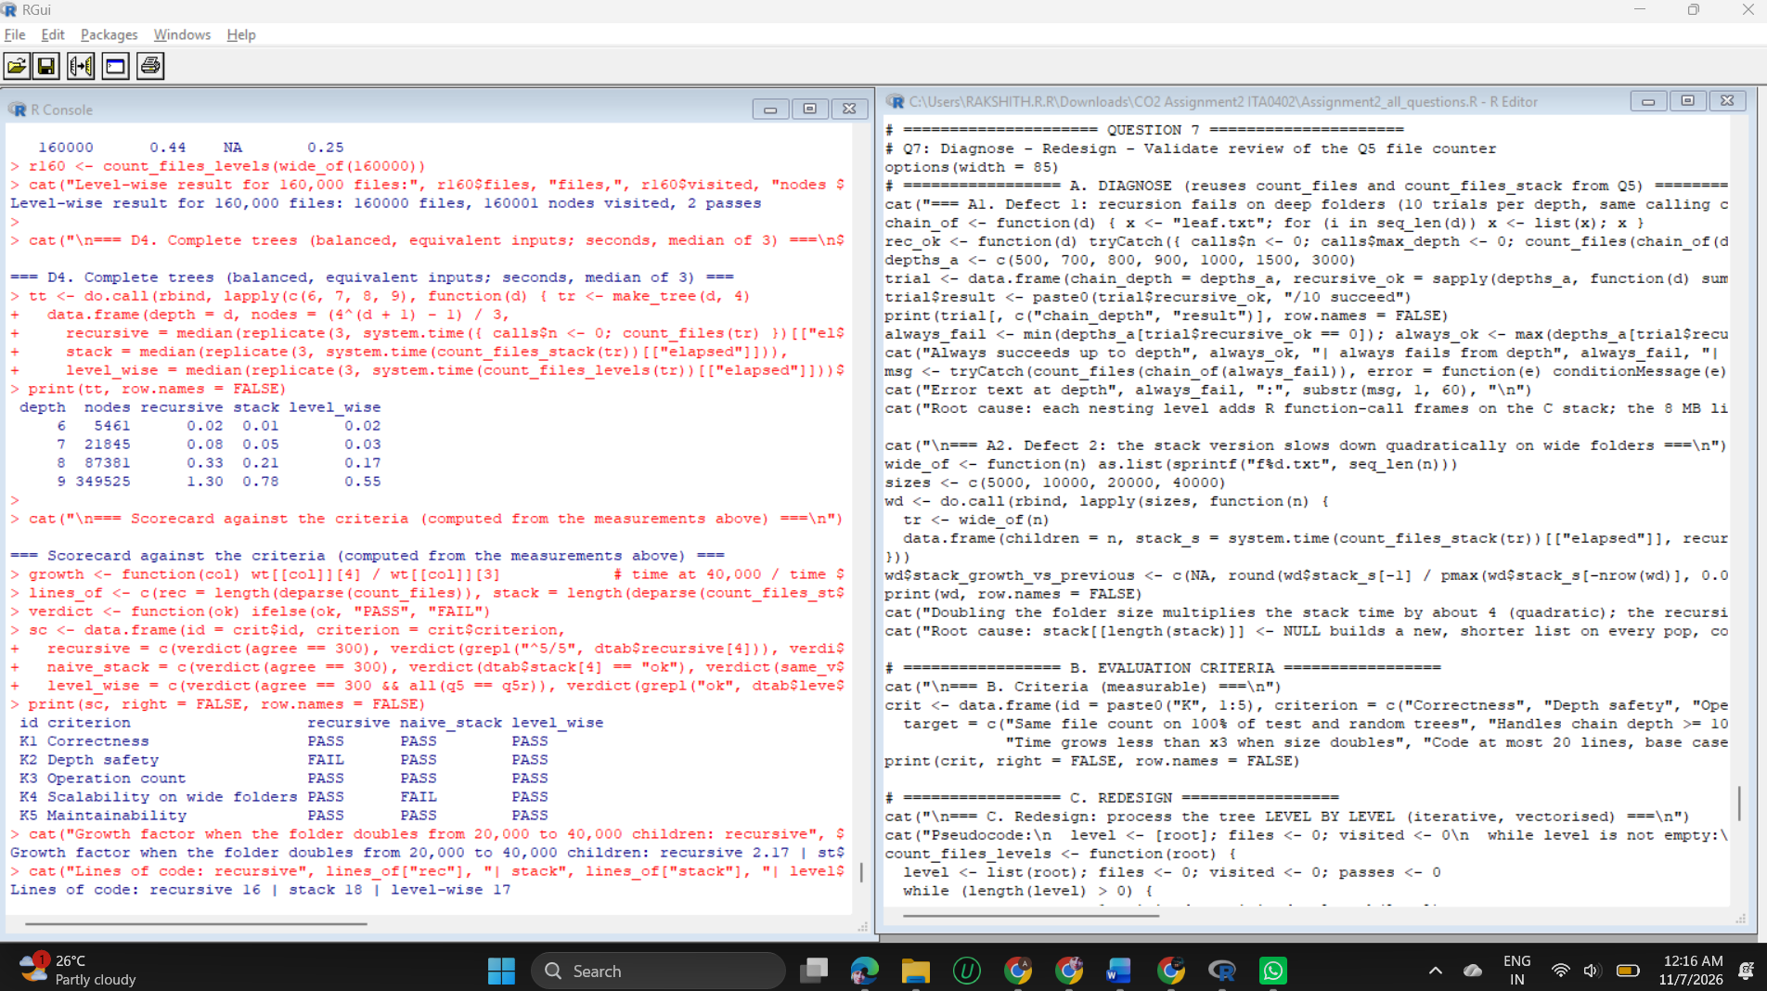
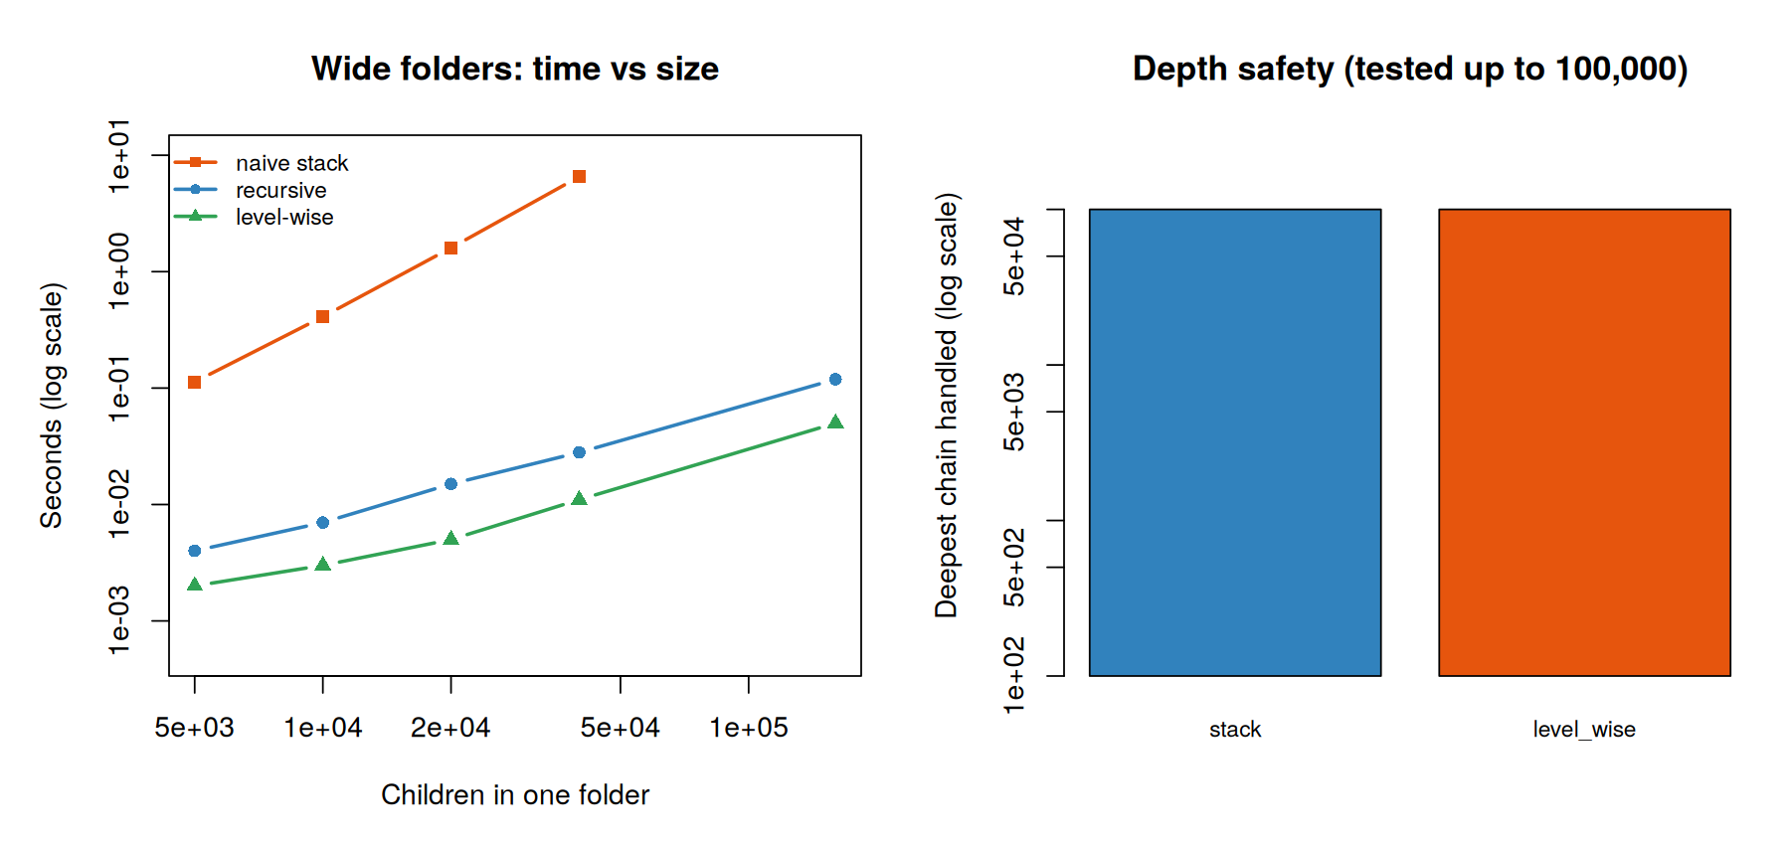
Figure 14: Left: time against folder size (log scales). Right: deepest chain each version handled

7.6 Results and defence
Criterion | Recursive | Naive stack | Level-wise | Evidence
K1 Correctness | PASS | PASS | PASS | Equal file counts on the 7 Q5 structures and on 300 random trees (164,715 nodes, with empty folders and NULL links)
K2 Depth safety | FAIL | PASS | PASS | Chains of 1,000, 20,000 and 100,000: recursion failed 5 of 5; stack and level-wise succeeded (100,001 passes for the longest chain)
K3 Operation count | PASS | PASS | PASS | Calls = pops = visits on 300 of 300 random trees
K4 Wide folders | PASS | FAIL | PASS | Growth when 20,000 doubles to 40,000: recursive 1.87, stack 4.08, level-wise 2.20
K5 Maintainability | PASS | PASS | PASS | 16, 18 and 17 lines of code

- The redesign meets all five criteria; neither alternative does. For a folder of 160,000 files the level-wise version needed 0.050 s and two passes; the naive stack version would need several minutes at that size by the measured quadratic trend, so it was not run.
- On balanced trees all three methods are comparable (87,381 nodes: 0.060, 0.047 and 0.023 s), so the redesign does not slow ordinary cases.
- Passes are not calls: the level-wise loop runs once per level (751 passes for a chain of depth 750) while counting the same 751 visited nodes, which is why K3 compares visits, not loop passes.

7.7 Critical judgement and remaining weaknesses
- The recursive version is not obsolete. It is the clearest code, it passed every criterion except depth, and it is the natural choice when each subfolder must return its own value (per-folder subtotals), which the level-wise version would need extra bookkeeping to provide.
- Cost of the redesign: it no longer mirrors the recursive definition, and it holds a whole level in memory at once, so an extremely wide level costs memory proportional to its width.
- What the evidence does not show: the depth limit was measured on one machine and R version (4.3.3) and depends on the calling context; the timings are single measurements. A different R build could move the thresholds but not the quadratic growth of the stack version.
- Recommendation: use the level-wise counter for unknown or generated archives, and keep the recursive counter for small, known structures where clarity matters.

APPENDIX A - Submission Checklist
Required item | Where it is
Report | This document (sheet first, then Questions 1 to 7)
Source code | Code listing in each section, and the file Assignment2_all_questions.R
Datasets | Defined in each program; exported as CSV in raw_data_assignment2.zip
Raw experimental data and outputs | Output block in each section, and the CSV files (Q1 28 and 25,000 zones with predictions and observations, Q2 profiles and traces, Q3 datasets, Q4 sequences, counts and simulation)
Prediction versus observation | Section analysis of each question and the prediction scorecard on the overview page
Tables and graphs | 14 figures: 7 design diagrams and 7 result graphs
Counts of iterations, calls, evaluations | Q1 sections 1.4-1.5, Q2 traces, Q3 session logs, Q4 section 4.4, Q5 and Q6 call counts, Q7 passes and visits
Pseudocode | Q7 section 7.4 (level-wise counter); the rule lists and flow diagrams of Q1 to Q4 serve as design notes

CSV files in raw_data_assignment2.zip
File | Content
q1_adversarial_zones_28.csv | 28 zones, hand predictions, observed classes, average score, severe count
q1_changed_condition_25000_zones.csv | 25,000 zones with v1 and v2 classes and condition evaluations
q2_application_profiles_12.csv | 12 profiles with v1 and v2 status, reason and trace
q3_order_datasets.csv | the seven order-amount datasets
q4_reading_sequences.csv | the reading sequences (an empty sequence has no rows)
q4_counts_per_sequence.csv, q4_simulation_summary.csv | attempts, loop passes, evaluations; simulation by invalid-rate

Viva quick reference
- Q1: why is the override tested first, and what is its cost? (Safety; 47% more condition evaluations per zone.)
- Q2: why can documents never be waived, and how was the policy changed? (Named-condition waivers; one line in the policy table.)
- Q3: why is the registry menu easier to extend than switch()? (1 edit instead of 3 per operation.)
- Q4: when is the redesigned check order worse? (When more than about 67% of readings are invalid.)
- Q5 and Q6: what limits recursion in R? (The C stack: failure between depth 800 and 900 here.)
- Q7: which defects were reproduced and what fixed them? (Recursion depth and quadratic pops; level-by-level processing.)

